
The ELI Weekly

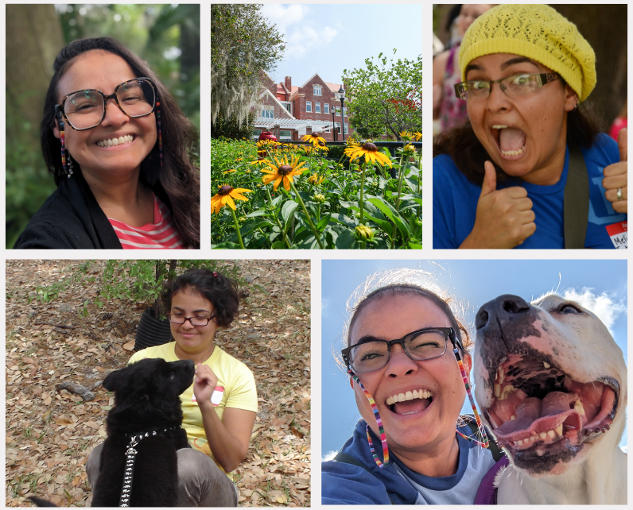
A Special Farewell from Melina

When I first started at the ELI, in Fall 2006, I was inexperienced and scared! At the end of the first week of class, I called my mami crying because I was worried that I wasn’t teaching my students well and they were just losing their money. My mami told me to stick with it and that little by little, I would improve, and it wouldn’t be so scary anymore. That advice helped me in those first few semesters, and it morphed into the learning and teaching philosophy with which I lead my classes.

In the 19 years that I have taught at the ELI, I have grown in this profession and as a person because of you, my students, my colleagues, and my friends. You have taught me patience, bravery, and grit. You have taught me to slow down and listen more than I talk. You have taught me to try new things even when it’s scary and I might fail. And you have taught me to keep persevering even when it’s hard and I’m tired and I just want to give up.

Thank you, my ELI family, for sharing so much of yourself and your time with me, for sharing your worries about your use of English and life in general, for sharing your family stories, and for sharing your dreams for yourself and your loved ones. They have shaped the person I am today, I couldn’t have asked for a better way to spend 19 years.

Spending this time at the ELI has helped me develop these important skills so I can continue to serve this university where I will be joining the UF Center for Teaching Excellence as an Instructional Assessment Coordinator. I will be collaborating with academic departments across the UF campus to impact the student learning experience and helping other professors and instructors develop their own teaching and learning.

May we meet again on this beautiful road and know that I carry you all inside my heart.

CIP Weekday Activities
 | Monday, October 6th – Coffee Talk – 6:30-9:00pm
 | Socialize with LAs and ELI friends at City Food Hall! Play games, speak English, and drink a coffee or get dinner at the food truck in the area! Take bus 6.  This semester, the location will change each week.  Address: 150 NW 13th St Suite 10, Gainesville, FL 32603
 | Tuesday, October 7th – Volleyball – 6:30-9:00pm
 | Play volleyball and hang out at Lexington Crossing Apartments Phase 2 Volleyball Courts with us! No experience necessary! You can also watch, socialize or play other games if you don’t want to play volleyball. Take bus 35.  Address: 3700 SW 27th St, Gainesville, FL 32608
 | Wednesday, October 8th – Soccer – 6:30 – 9:00pm
 | Come play Soccer on campus at Flavet Field on campus! No experience necessary! You can also watch, socialize or play other games if you don’t want to play soccer.  Address: Woodlawn Dr, Gainesville, FL 32603
 | Thursday, October 9th – GCM Food Fest at Celebration Point – 6:30 – 9:00pm
 | Explore the charming Celebration Pointe outdoor areas and shops during the annual GCM Food Fest. Local restaurants will have tons of booths set up for you to try all the good local food in Gainesville! Food tickets are 3 dollars a piece but entry into the area and festival is free! There will be live music and other activities in the area to enjoy with your ELI friends! See the event website to learn more about the event. Meet outside Kilwin’s Ice Cream at 6:30 sharp to then enter to food festival and explore together. Take bus 75.  Address: 4949 Celebration Pointe Ave ste 60, Gainesville, FL 32607
 | Friday, October 10th – Reitz Game Room – 6:30 – 9:00pm
 | Hang out with friends in the Reitz Game Room! You can go bowling, play pool, and play board games! Bring your Gator1 ID for cheaper rates. Many Fridays are Gator Nights so bring your ID to check in and see all the fun themed activities the Reitz may have planned for you this week in addition to the game room!  Address: 655 Reitz Union Drive, Gainesville, FL 32611

CIP Weekend Event: Welcome Picnic

Saturday, October 11th – B-term Welcome Picnic – 12:00 -2:45pm

All students are welcome to join instructors and staff in greeting and getting to know our new B-term students! Free food provided and lots of time for socializing with friends outside. Meet in front of Norman Hall.

You must sign up to attend this event. Sign up here!

CIP Photo of the Week: Game Room

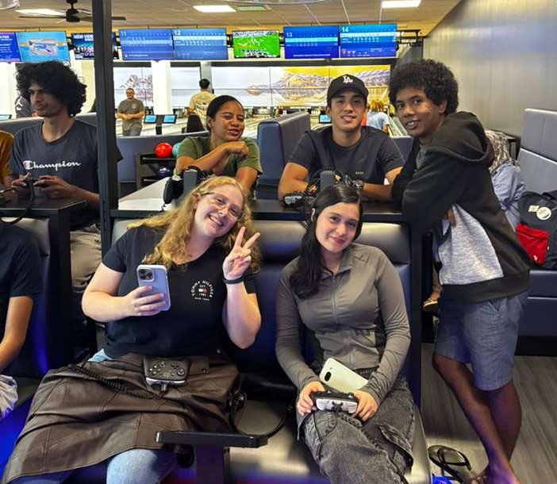

Other CIP Reminders

Conversation Partners (CPs)

Want to meet with a fluent English speaker and make a new friend? Sign up for a CP! If you choose to sign up, you must meet with your partner for one hour a week. It can take up to two weeks to get a partner from when you sign up. Sign up here!
Returning students, you will not automatically be paired again if you had a CP last semester. Please make sure to sign up again here for the Fall semester if you did not request a Fall partner in your end of term evaluation from last semester.
Please email Elijah at conversationpartners@eli.ufl.edu for any issues, questions or concerns or visit her in the CIP Office during office hours.

Don’t forget to get your CIP Passport hole punched from the activity leaders AT the event (not after). We don’t hole punch passports after the event. Redeem your completed passport for a small gift, a photo for the ELI Instagram, and your name published in the ELI weekly!
Need a new CIP Passport? Stop by the CIP Office!
Remember the CIP Pineapple is hidden in a new place every Monday in the CIP office. Stop by and find it for hole punches!

CIP Passports
Don’t forget to get your CIP Passport hole punched from the activity leaders at the event (not after). We don’t hole punch passports after the event. Redeem your completed passport for a small gift, a photo for the ELI Instagram, and your name published in the ELI weekly! | 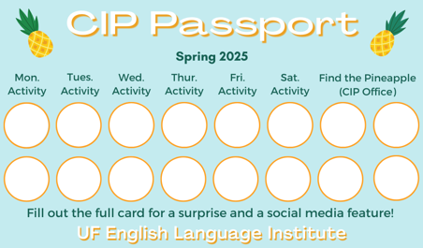

Need a new CIP Passport? Stop by the CIP Office.

Find the Pineapple
Remember the CIP Pineapple is hidden in a new place every Monday in the CIP office. Stop by and find it for hole punches!
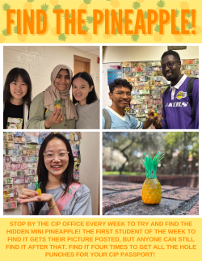

Notes from the Office
Backpacks in the Hallway: Please do not leave backpacks or any of your belongings in the hallway or in classrooms. Anything left unattended could easily get stolen.
B-Term Students: B-term students will be arriving this week! They will take their placement test on Wednesday and start classes on Monday, October 14th. Please help us welcome them to the ELI and give them any help you can as they settle in.
Homecoming: There will be no ELI or UF classes on Friday, October 17th in celebration of UF’s Homecoming.
Campus Protests: You may sometimes see student protests or demonstrations on campus. These gatherings are a normal part of free expression in the U.S. Here’s what to keep in mind:
- Stay Aware: If you encounter a protest, pay attention to your surroundings.
- Keep Calm: Avoid arguments or confrontations.
- Follow Directions: Listen to campus officials or police if they give instructions.
- Be Safe: If a situation feels tense or unsafe, step away.
- Respect Rules: Peaceful protest is protected, but blocking entrances, damaging property, or acting violently is not allowed.
- Reach Out: For emergencies, call UF Police at (352) 392-1111 or dial 911.

Birthdays!
Students |  | Staff
Norah Alharbi | October 11 | None this week!
Hoyeon Kim | October 13
 | 

Grammar

Q: Modals are so confusing. How can people remember all the rules about modals? It seems impossible to remember them all.

Modals are a very difficult part of English! Mastering modals is not impossible, but it does take time! You may have noticed that English has 9 modals: can, could, may, might, shall, should, will, would, must. These modals add a variety of meaning to a verb, and sometimes you only know which meaning the modal adds by looking at the context. For example:

The package should arrive by tomorrow. (expectation for a future event)

You should get more sleep. (advice)

To make things even more difficult, we have a lot of modal phrases that are not true modals but act like modals: have to, be going to, be able to, had better, used to, be supposed to. These modal phrases help us express meanings that modals can’t. For example,

All students must put their cellphones in their backpacks during the exam.

Yesterday, all students had to put their cellphones in their backpack during the exam.

My advice is to review the rules, practice using modals in your own writing and speaking, and listen for modals in conversations, movies, songs. Pay special attention to modals when you read. I know you can do it! You must practice! With effort, you will succeed!

Joke of the Week

Q: What do you say to comfort a sad English teacher?
A: There, their, they’re.


Student Voices
 | Every semester, we have amazing student writers, so we take your writing and publish it in an online collection called Student Voices. In past semesters, students have written paragraphs, essays, creative stories, recipes, letters, obituaries, poetry, and more. You can see past editions of Student Voices (https://eli.ufl.edu/news-publications/, scroll to the bottom of the page) for inspiration.

We encourage you to submit anything of your work that you wish to see published. It can be from any class or something you have written on your own but ask your teachers for help editing! You can email it to Olga Moody (omoody@ufl.edu) or to your teacher. Please include your name and class on your submission. The deadline for submissions is Friday, October 31st.

 | I need students, LAs, instructors, staff, and administrators to help me write the Weekly!  - Write a paragraph about your experiences this semester. You could write about an ELI activity, a Gainesville event, a fabulous local restaurant, or tell us about a place or event in your country that we should visit.  - You could also ask me to write about a topic that you are curious about  - Send me grammar questions for me to put in the Weekly.  - Send me manners and culture questions for me to put in the Weekly.  - Send me jokes to put in the Weekly.

Send your paragraphs and/or questions to Jen Ramos (jenramos@ufl.edu) Use the subject heading: ELI Weekly.

