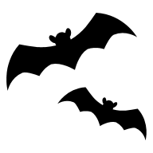
The ELI Weekly

Student Writing: YaHsuan Wang, RW 20

My Country: Taiwan

My country is very small in Asia and shaped like a sweet potato. It is very close to China, Japan and South Korea. It is Taiwan. Its population is 23.34 million and official languages are Traditional Chinese and Taiwanese. Many people also speak Hakka and some aboriginals speak their own language. It is a multicultural country. We were the first country in Asia to allow same-sex marriage. In terms of food, you can also taste food from different countries as well as local Taiwanese cuisine. Every town in Taiwan is beautiful and unique.

There is Taipei 101 in Taipei, Sun Moon Lake in Nantou, and Alishan in Chiayi. If you enjoy the seaside, every county and city offers a coastline for strolling. October 10th is our National day. There are ceremonies and performances during the day and fireworks in the evening. It is very lively. In conclusion, you can see the beauty of Taiwan, I really hope everyone has the opportunity to visit Taiwan. Thank you.

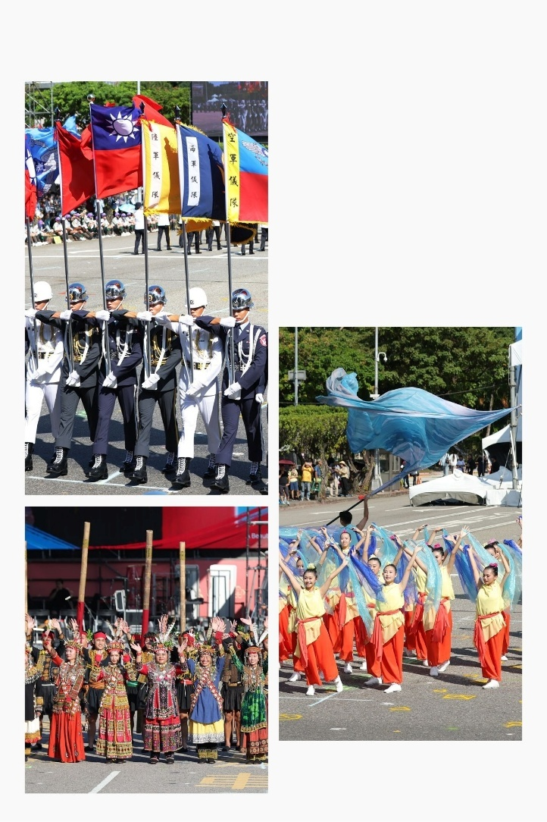


Welcome B-term Students!

This week, our B-term students will begin their classes. Please welcome them! If they are coming into your class, please be sure to help them integrate into the class.

Our B-term students represent the following places:
France
Guatemala
Korea (South)
Saudi Arabia
Spain
Taiwan
Turkey
United States of America
Venezuela
CIP Photo of the Week: Coffee Talk
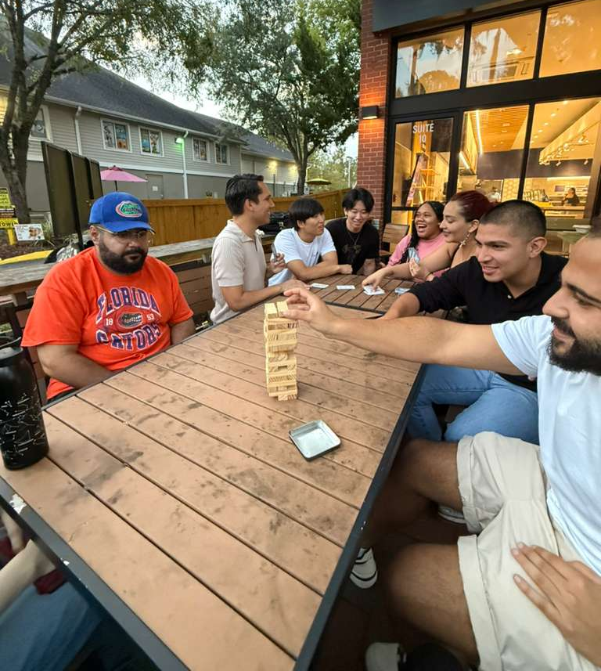

CIP Weekday Activities
 | Monday, October 13th – Coffee Talk – 6:30-9:00pm
 | Socialize with LAs and ELI friends at Enson Market! Play games, speak English, and drink a coffee or get dinner in the cafe area! Take bus 1.  This semester, the location will change each week.  Address: 3045 SW 34th St Ste 30, Gainesville, FL 32608
 | Tuesday, October 14th – Volleyball – 6:30-9:00pm
 | Play volleyball and hang out at Lexington Crossing Apartments Phase 2 Volleyball Courts with us! No experience necessary! You can also watch, socialize or play other games if you don’t want to play volleyball. Take bus 35.  Address: 3700 SW 27th St, Gainesville, FL 32608
 | Wednesday, October 15th – Soccer – 6:30 – 9:00pm
 | Come play Soccer on campus at Flavet Field on campus! No experience necessary! You can also watch, socialize or play other games if you don’t want to play soccer.  Address: Woodlawn Dr, Gainesville, FL 32603
 | Thursday, October 16th – Bragging Rights Arcade – 7:00 – 9:30pm
 | Enjoy a fun night of arcade games at Bragging Rights Arcade! After 7pm, all UF employees and students play unlimited games for $10 (with valid UF ID). Hang out, play games, and try out some classic arcade and carnival games! Take bus 15.  Address: 113 NW 8th Ave, Gainesville, FL 32601
SPECIAL EVENT!
Friday, October 17th– Homecoming Parade – 11:00am – 1:30pm

 | Celebrate the Gators with this UF tradition! Watch the parade with floats from all over town, decorated with Gator spirit in honor of the football season! Dress in orange and blue and cheer on UF with LAs and ELI friends! Meet at 11am in front of the Tigert Hall stairs for a great seat to watch the parade!  (No Game Night this week)

Campus Event: Delta Sigma Pairs

Delta Sigma Pi has invited ELI students to get to know them! Please see the information below:

Connect with a business student from Delta Sigma Pi for a evening exploring UF, sharing campus life, and making new friends! Our brothers are some of the most involved students all across campus so spaces are limited and offered first-come, first-served, so sign up today to experience UF from a local perspective! It will be Oct. 16th 6-8 PM at Heavener Room 150

Here is the google form to sign up!

https://forms.gle/HoBpTvfP6KfXtiHZ7



Other CIP Reminders

Conversation Partners (CPs)
Want to meet with a fluent English speaker and make a new friend? Sign up for a CP! If you choose to sign up, you must meet with your partner for one hour a week. It can take up to two weeks to get a partner from when you sign up. Sign up here!

Returning students, you will not automatically be paired again if you had a CP last semester. Please make sure to sign up again here for the Fall semester if you did not request a Fall partner in your end of term evaluation from last semester.
Please email Elijah at conversationpartners@eli.ufl.edu for any issues, questions or concerns or visit her in the CIP Office during office hours.

CIP Passports
Don’t forget to get your CIP Passport hole punched from the activity leaders at the event (not after). We don’t hole punch passports after the event. Redeem your completed passport for a small gift, a photo for the ELI Instagram, and your name published in the ELI weekly! | 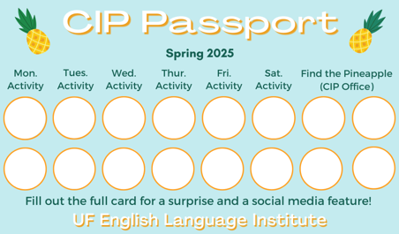

Need a new CIP Passport? Stop by the CIP Office.

Find the Pineapple
Remember the CIP Pineapple is hidden in a new place every Monday in the CIP office. Stop by and find it for hole punches!
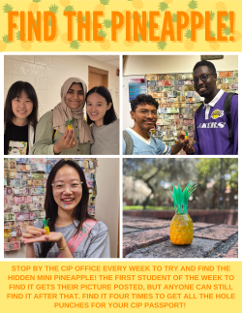

Notes from the Office
Homecoming: There will be no ELI or UF classes on Friday, October 17th in celebration of UF’s Homecoming. The ELI and UF offices will be closed.
College Informational Session: Representatives from the Santa Fe College and the College of Central Florida will speak to ELI students on Wednesday, October 15th, at 3:15pm in 214 Matherly Hall. This is great opportunity to learn about SF and CF and their admissions process. If you are thinking about enrolling in a community college, this is a great opportunity to get information and meet their International Student Services team.
Matherly Hall Maintenance: UF will be doing maintenance on the Matherly Hall heating system on Thursday, October 16th. This means the classrooms, hallways, and offices in Matherly might be even colder than usual. Be sure to bring an extra sweater on Thursday!
People Out: Daryl will be out of the office from October 21st to October 24th. Christine will be out of the office on October 20th. Please plan accordingly if you need to speak to them.

Birthdays!
Students |  | Staff
Hoyeon Kim | October 13 | None this week!
Yujin Kim | October 15
Aryam Alshammari | October 17  

Manners and Culture

Q: I have heard of Black Friday shopping deals. When is Black Friday and is it really a good shopping day?

Black Friday is the day after Thanksgiving. This year, Black Friday falls on November 28. This is the day that many stores offer special sales and promotions, and many times stores compete for the best deals on certain items. Black Friday is considered the beginning of the Christmas shopping season. Some people avoid shopping on this day because the stores tend to be very crowded. One thing is true—this is the single-most profitable day for stores!

Joke of the Week

Q: Why don’t mummies take vacations?
A: They don’t like to unwind!
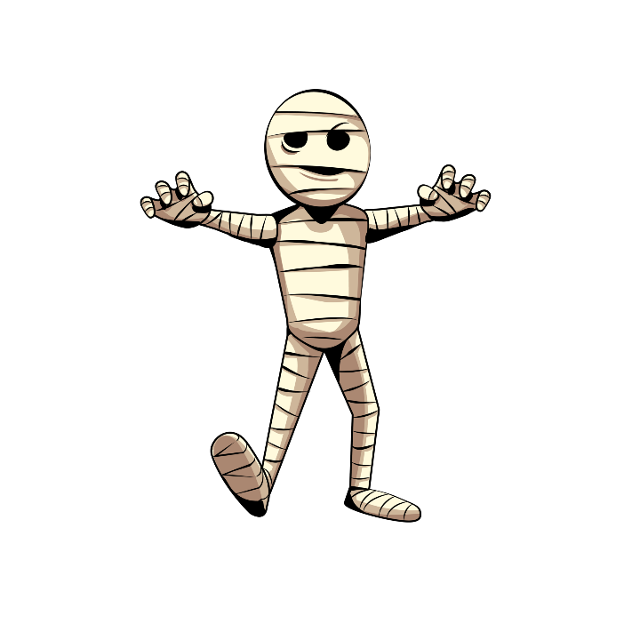

Student Voices
 | Every semester, we have amazing student writers, so we take your writing and publish it in an online collection called Student Voices. In past semesters, students have written paragraphs, essays, creative stories, recipes, letters, obituaries, poetry, and more. You can see past editions of Student Voices (https://eli.ufl.edu/news-publications/, scroll to the bottom of the page) for inspiration.

We encourage you to submit anything of your work that you wish to see published. It can be from any class or something you have written on your own but ask your teachers for help editing! You can email it to Olga Moody (omoody@ufl.edu) or to your teacher. Please include your name and class on your submission. The deadline for submissions is Friday, October 31st.

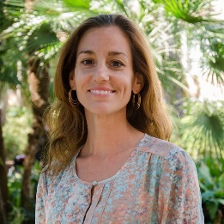 | I need students, LAs, instructors, staff, and administrators to help me write the Weekly!  - Write a paragraph about your experiences this semester. You could write about an ELI activity, a Gainesville event, a fabulous local restaurant, or tell us about a place or event in your country that we should visit.  - You could also ask me to write about a topic that you are curious about  - Send me grammar questions for me to put in the Weekly.  - Send me manners and culture questions for me to put in the Weekly.  - Send me jokes to put in the Weekly.

Send your paragraphs and/or questions to Jen Ramos (jenramos@ufl.edu) Use the subject heading: ELI Weekly.

