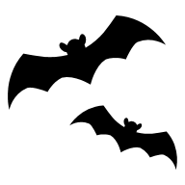
The ELI Weekly


Jack-O-Lanterns

Besides the candy, jack-o-lanterns are many people’s favorite part of our Halloween tradition! Have you ever wondered where the name jack-o-lantern came from? It has its roots in an Irish folktale about a man named Jack, who was stingy but also very tricky.

In the story, Jack invited the Devil to have a drink with him. But Jack didn’t want to pay for the drink. So, he tricked the Devil. Jack asked the Devil to turn into a coin to pay for the drinks. The Devil agreed. But Jack did not use the coin. Instead, he put it in his pocket next to a silver cross. The cross stopped the Devil from turning back into his real form.

Later, Jack let the Devil go, but only after making a deal. The Devil promised not to bother Jack for one year and not to take his soul when he died.

One year later, Jack tricked the Devil again. He asked the Devil to climb a tree to get a piece of fruit. When the Devil was in the tree, Jack carved a cross into the bark of the tree. The Devil could not come down until he made another promise. This time, the Devil promised not to bother Jack for ten more years.

Soon after, Jack died. But he could not go to heaven because he was not a good man. He also could not go to hell, because the Devil had promised not to take his soul. So, the Devil sent Jack away into the dark night. He gave Jack a piece of burning coal to light his way. Jack put the coal inside a carved turnip. Since then, Jack has been walking the Earth with his lantern.

People in Ireland started to call him “Jack of the Lantern,” or, in its shortened form: “Jack O’Lantern.”

In Ireland and Scotland, people made their own “Jack’s lanterns.” They carved scary faces into turnips and put them near doors or windows. They believed these lanterns would scare away Stingy Jack and other evil spirits.

When immigrants from these countries moved to the United States, they brought this tradition with them. In America, they found that pumpkins were easier to carve. Over time, carving pumpkins became a big part of Halloween in the U.S.

CIP Photo of the Week: Soccer

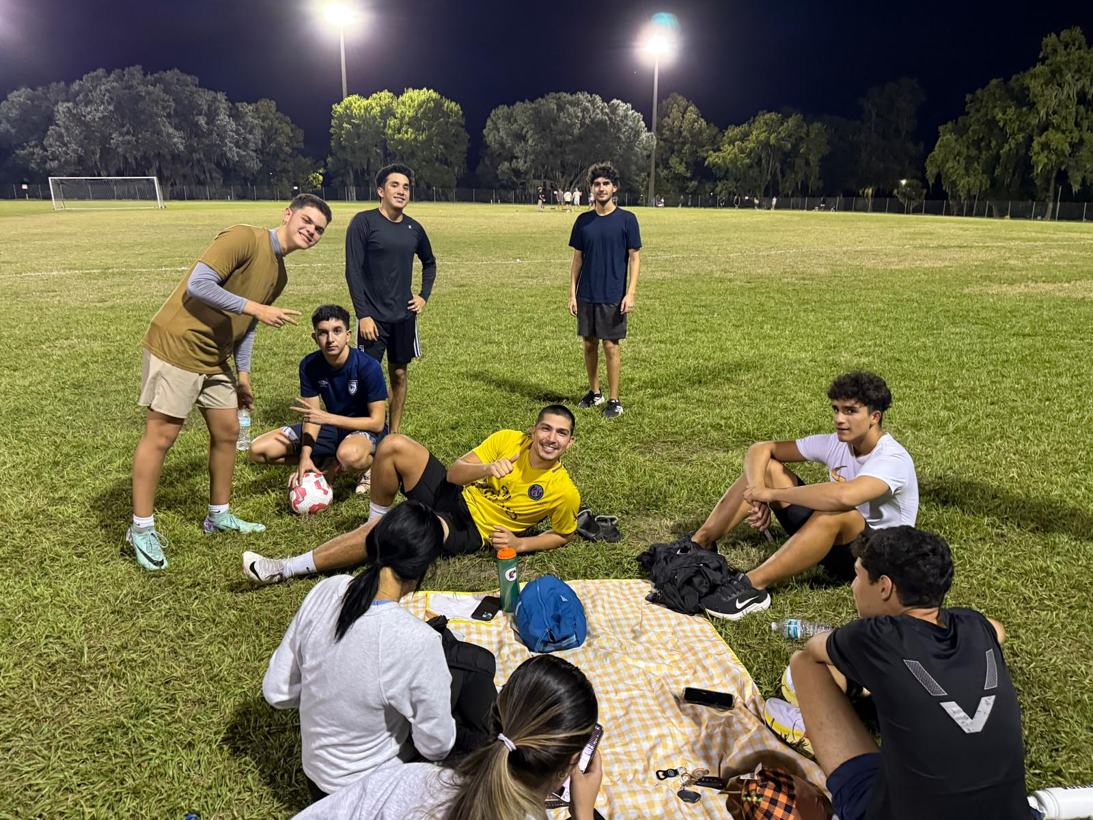

CIP Weekday Activities
 | Monday, October 20th – Coffee Talk – 6:30-9:00pm
 | Socialize with LAs and ELI friends at Kung Fu Tea!  Play games, speak English, and drink a coffee or get dinner in the cafe area! Take bus 1.  This semester, the location will change each week.  Address: 3102 SW 34th St, Gainesville, FL 32608
 | Tuesday, October 21st – Volleyball – 6:30-9:00pm
 | Play volleyball and hang out at Lexington Crossing Apartments Phase 2 Volleyball Courts with us! No experience necessary! You can also watch, socialize or play other games if you don’t want to play volleyball. Take bus 35.  Address: 3700 SW 27th St, Gainesville, FL 32608
 | Wednesday, October 22nd – Soccer – 6:30 – 9:00pm
 | Come play Soccer on campus at Flavet Field on campus! No experience necessary! You can also watch, socialize or play other games if you don’t want to play soccer.  Address: Woodlawn Dr, Gainesville, FL 32603
 | Thursday, October 23rd, Pumpkin Painting at the Bat Houses – 4:45 – 7:30pm
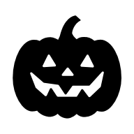 | Get in the Halloween spirit this Thursday! Paint mini pumpkins at beautiful Lake Alice with your ELI friends. At sunset, see the bats come out from their houses, a Gainesville tradition! Did you know bats are one of the many symbols of Halloween? Wear your Halloween costume or themed clothing for a perfect photo opportunity. Meet in front of the Bat Houses at 4:45. Make sure you come on time so you have lots of time with sunlight to paint your pumpkin. Take bus 20.  Address: 113 NW 8th Ave, Gainesville, FL 32601
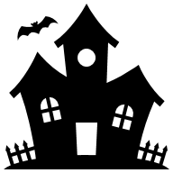 | Friday, October 24th– Haunted Houses at Kirby Farms – 6:15 – 10:00pm  Ready for more Halloween fun? Get ready to get scared at this annual Halloween event at Kirby farms. Go through several spooky, haunted houses and activities for a fun Halloween-themed experience at this farm! Tickets are 25 dollars online or at the gate. Meet at Norman Parking Garage.
 | You must sign up to attend this event. Sign up here!

Other CIP Reminders

Conversation Partners (CPs)
Want to meet with a fluent English speaker and make a new friend? Sign up for a CP! If you choose to sign up, you must meet with your partner for one hour a week. It can take up to two weeks to get a partner from when you sign up. Sign up here!

Returning students, you will not automatically be paired again if you had a CP last semester. Please make sure to sign up again here for the Fall semester if you did not request a Fall partner in your end of term evaluation from last semester.
Please email Elijah at conversationpartners@eli.ufl.edu for any issues, questions or concerns or visit her in the CIP Office during office hours.

CIP Passports
Don’t forget to get your CIP Passport hole punched from the activity leaders at the event (not after). We don’t hole punch passports after the event. Redeem your completed passport for a small gift, a photo for the ELI Instagram, and your name published in the ELI weekly! | 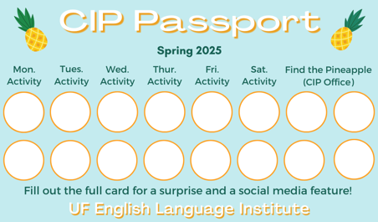

Need a new CIP Passport? Stop by the CIP Office.

Find the Pineapple
Remember the CIP Pineapple is hidden in a new place every Monday in the CIP office. Stop by and find it for hole punches!
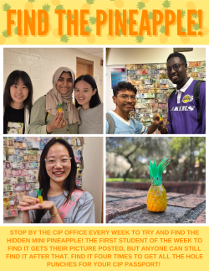

Notes from the Office
People Out: Daryl will be out of the office from October 21st to October 24th. Christine will be out of the office on October 20th. Please plan accordingly if you need to speak to them.
No ELI Classes: Monday, October 27 is an ELI Instructor Workday. There will be no ELI classes, but the ELI main office will be open.
Friends of the Library: Friends of the Library hosts a large used book sale each fall and spring. In addition to books, you can find art, comic books, manga, CDs, DVDs, vinyl, records, and more.
Here is the schedule and location information:
Saturday, October 25th 9 am-6 pm
Sunday, October 26th 12 pm-6 pm
Monday, October 27th 12 pm-6 pm
Tuesday, October 28th 12 pm-6 pm (1/2 price day)
Wednesday, October 29th 12 pm-6 pm (dime day)
Location: 430-B North Main Street, Gainesville, Florida 32601
Cost: free admission
Website: www.folacld.org
Proceeds go to the Alachua County Library District and area literacy programs


Birthdays!
Students |  | Staff
None this week! |  | None this week!

Grammar

Q: What does the word should mean in the following sentence: Should you have any question, please don’t hesitate to ask.

This is a conditional sentence and should is taking the place of the word if. It is common for people to end an email or other correspondence with this sentence, particularly if they are trying to provide information to the reader.

Joke of the Week

Q: What is a witch’s favorite subject in school?
A: Spelling!


Student Voices
 | Every semester, we have amazing student writers, so we take your writing and publish it in an online collection called Student Voices. In past semesters, students have written paragraphs, essays, creative stories, recipes, letters, obituaries, poetry, and more. You can see past editions of Student Voices (https://eli.ufl.edu/news-publications/, scroll to the bottom of the page) for inspiration.

We encourage you to submit anything of your work that you wish to see published. It can be from any class or something you have written on your own but ask your teachers for help editing! You can email it to Olga Moody (omoody@ufl.edu) or to your teacher. Please include your name and class on your submission. The deadline for submissions is Friday, October 31st.

 | I need students, LAs, instructors, staff, and administrators to help me write the Weekly!  - Write a paragraph about your experiences this semester. You could write about an ELI activity, a Gainesville event, a fabulous local restaurant, or tell us about a place or event in your country that we should visit.  - You could also ask me to write about a topic that you are curious about  - Send me grammar questions for me to put in the Weekly.  - Send me manners and culture questions for me to put in the Weekly.  - Send me jokes to put in the Weekly.

Send your paragraphs and/or questions to Jen Ramos (jenramos@ufl.edu) Use the subject heading: ELI Weekly.

