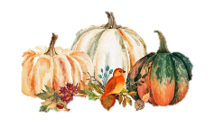
The ELI Weekly

Time Change: Standard Time Begins

Does the time change in your country twice a year? Here in the U.S., the time “falls back” one hour on the first Sunday of November to start the period of the year known as Standard Time. Why do we roll the clocks back one hour in November? It gives us more daylight during winter mornings.

The second period of the year is known as Daylight Saving Time. This period begins on the second Sunday in March. In 2026, we will “spring forward” one hour on Sunday, March 8, 2026. At 2 a.m. on this date, the time will spring forward to become 3 a.m. What do we get from losing this precious hour of sleep? More sunlight in the warm, summer evenings.

There is a lot of debate among Americans about time change in the U.S. Some people feel it is unnecessarily confusing. Others don’t like the disruption and complain that losing an hour of sleep is bad for our health. In fact, Hawaii and most of Arizona have decided not to change their clocks twice a year. While the rest of the country is in Daylight Saving Time, these two states remain in Standard Time.

The U.S. territories of American Samoa, Guam, Puerto Rico, the U.S. Virgin Islands and the Northern Mariana Islands also observe permanent standard time.

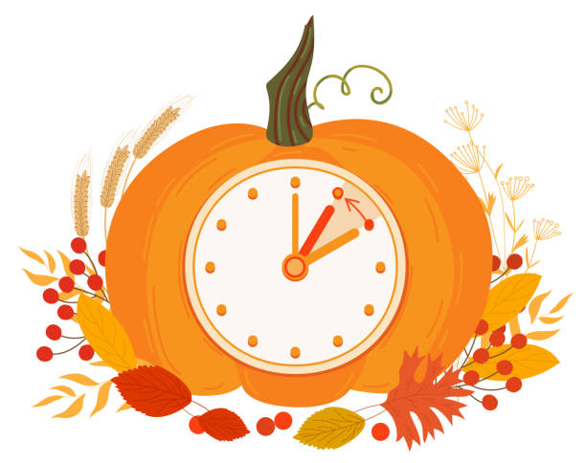

CIP Photo of the Week: Homecoming Parade

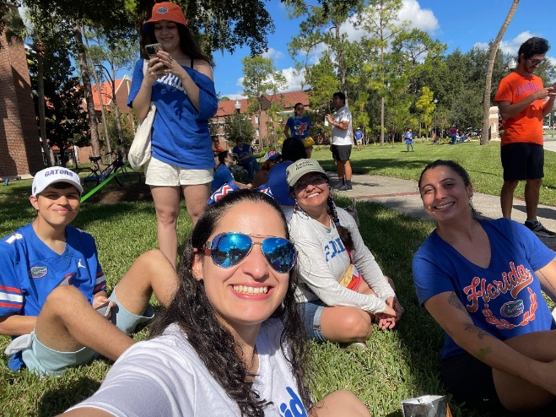

International Education Spirit Week at the ELI!

International Education Week 2025 is the week of November 17th and soon approaching! Get ready to celebrate international education at the ELI with a fun Spirit Week. Start planning and preparing now what you will be wearing to class on these special themed days:
Dress up for our themed days and wear your fun outfit to class and activities!

Monday, November 17th: Tourist Day – Dress like your idea of a tourist!

Tuesday, November 18th: Twin Day – Grab a friend and match for the day or dress up like your favorite teacher to be their surprise twin.

Wednesday, November 19th: Decades Day – Dress in the style of your favorite decade! The style can be from the US or from your home country.

Thursday, November 20th: Traditional/Country Clothing Day – Dress in the traditional dress from your country if you can. If you don’t have that clothing, wear something else to represent your country, like your flag’s colors or something else to show off your country pride. You can wear this at our annual Thanksgiving Potluck tonight!

Friday, November 21st: Character Day – Dress like your favorite celebrity, TV character, movie character, or book character.

Come to the main office before LS periods if you are dressed up for that day’s theme. We will take a picture of you and post all the pictures on our Instagram where our followers can vote for their favorite costume of the day. The winner for the day will get a small prize!

CIP Weekday Activities
 | Monday, November 2nd – Coffee Talk – 6:30-9:00pm
 | Socialize with LAs and ELI friends at Jeremiah’s Italian Ice! Play games, speak English, and try this Gainesville famous ice cream or get dinner nearby! Take bus .  This semester, the location will change each week.  Address: 3232 SW 35th Blvd, Gainesville, FL 32608
 | Tuesday, November 3rd – Volleyball – 6:30-9:00pm
 | Play volleyball and hang out at Lexington Crossing Apartments Phase 2 Volleyball Courts with us! No experience necessary! You can also watch, socialize or play other games if you don’t want to play volleyball. Take bus 35.  Address: 3700 SW 27th St, Gainesville, FL 32608
 | Wednesday, November 4th – Soccer – 6:30 – 9:00pm
 | Come play Soccer on campus at Flavet Field on campus! No experience necessary! You can also watch, socialize or play other games if you don’t want to play soccer.  Address: Woodlawn Dr, Gainesville, FL 32603
 | Thursday, November 6th – Thrifting & Germain’s Chicken – 5:00 – 7:30pm
 | A very popular activity in Gainesville and the US is thrifting! Buy gently used clothing from Flashback’s Recycled Fashion, a famous thrifting place in town. Use this time shopping with LAs and friends to plan your outfits for international education week coming up this month! After shopping, head next door to Germain’s to get dinner. They have some of the best chicken sandwiches in down and an amazing space to hang out! Bring some money for shopping and dinner. Meet inside Flashback’s.
 | Friday, November 7th – Reitz Game Room – 6:30 – 9:00pm  Hang out with friends in the Reitz Game Room! You can go bowling, play pool, and play board games! Bring your Gator1 ID for cheaper rates. Many Fridays are Gator Nights so bring your ID to check in and see all the fun themed activities the Reitz may have planned for you this week in addition to the game room!  Address: 655 Reitz Union Drive, Gainesville, FL 32611

Weekend Event

Saturday, November 1st – Micanopy Fall Festival – 11:30am to 2:30pm

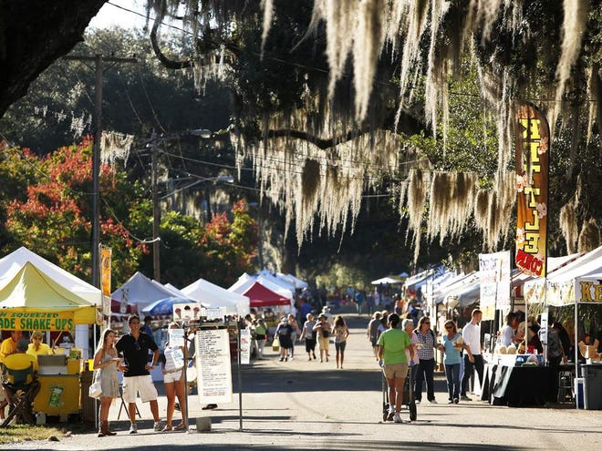

Celebrate and welcome the Fall season with this famous annual event in Micanopy, FL! Explore the historic, charming town of Micanopy right outside Gainesville as they host hundreds of vendors selling seasonal crafts, foods, and more! Entrance is free but make sure to bring some spending money if you would like to purchase some items and explore the stores.

You must sign up to attend this event. Sign up here!

Other CIP Reminders

Conversation Partners (CPs)
Want to meet with a fluent English speaker and make a new friend? Sign up for a CP! If you choose to sign up, you must meet with your partner for one hour a week. It can take up to two weeks to get a partner from when you sign up. Sign up here!

Returning students, you will not automatically be paired again if you had a CP last semester. Please make sure to sign up again here for the Fall semester if you did not request a Fall partner in your end of term evaluation from last semester.
Please email Elijah at conversationpartners@eli.ufl.edu for any issues, questions or concerns or visit her in the CIP Office during office hours.

CIP Passports
Don’t forget to get your CIP Passport hole punched from the activity leaders at the event (not after). We don’t hole punch passports after the event. Redeem your completed passport for a small gift, a photo for the ELI Instagram, and your name published in the ELI weekly! | 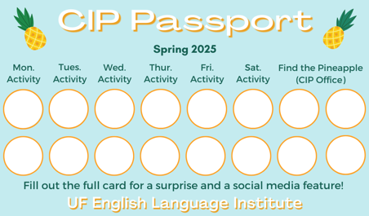

Need a new CIP Passport? Stop by the CIP Office.

Find the Pineapple
Remember the CIP Pineapple is hidden in a new place every Monday in the CIP office. Stop by and find it for hole punches!
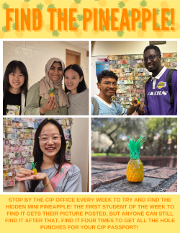

Notes from the Office
Time Change: The U.S. will observe the end of Daylight Saving Time on Sunday, November 3rd, 2025. Clocks will be set back one hour at 2:00 AM local time. Your phones and computers will automatically adjust but be sure to change your clocks.
Entering ELI Classrooms: Please use your best judgement on entering ELI classrooms to visit with friends in other classes. If you are entering a classroom during RW, please be sure that the class is on a break. Not every RW class takes their break at the same time and some RW classes don’t take a break at all. If you are unsure, you can politely ask the instructor in the classroom.
People Out: Christine will be out of the office November 3rd – November 5th. Please plan accordingly.
ELI Class Photo: On Thursday, October 30th, we will be taking a group photo of everyone at the ELI at the bronze Gator sculpture outside the Southwest entrance of Matherly Hall. The sculpture is known as Gator Ubiquity (see photo). Your Listening/Speaking teachers or LAs will walk you over there between the two L/S periods on Thursday. If it rains, we will take the photo on Tuesday, November 4th at the same time.

Commencement Info: Our ELI Commencement ceremony will take place at 10am on December 5th in the University Auditorium.

Students |  | Staff
Mawaddah Hamza | October 30 | Chrstine Voight | October 30
 | 

Birthdays!

Manners

Q: What does it mean to say “ma’am”? Is it like saying “man”?

Actually, those words are very different! Ma’am is a polite way to address a woman, particularly if you do not know her name but still want to be respectful. It’s similar to saying sir for a man. The term ma’am is short for madam.

Man is used informally, usually as a greeting---like “Hey, man!” among friends.

Riddle

Big, dark eyes, and a body white,

Floating by on Halloween night.

I enter a house without a key

Can you guess who I might be?



Student Voices
 | Every semester, we have amazing student writers, so we take your writing and publish it in an online collection called Student Voices. In past semesters, students have written paragraphs, essays, creative stories, recipes, letters, obituaries, poetry, and more. You can see past editions of Student Voices (https://eli.ufl.edu/news-publications/, scroll to the bottom of the page) for inspiration.

We encourage you to submit anything of your work that you wish to see published. It can be from any class or something you have written on your own but ask your teachers for help editing! You can email it to Olga Moody (omoody@ufl.edu) or to your teacher. Please include your name and class on your submission. The deadline for submissions is Friday, October 31st.

 | I need students, LAs, instructors, staff, and administrators to help me write the Weekly!  - Write a paragraph about your experiences this semester. You could write about an ELI activity, a Gainesville event, a fabulous local restaurant, or tell us about a place or event in your country that we should visit.  - You could also ask me to write about a topic that you are curious about  - Send me grammar questions for me to put in the Weekly.  - Send me manners and culture questions for me to put in the Weekly.  - Send me jokes to put in the Weekly.

Send your paragraphs and/or questions to Jen Ramos (jenramos@ufl.edu) Use the subject heading: ELI Weekly.

