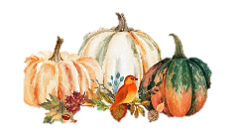
The ELI Weekly

Thanksgiving in the U.S.


Most Americans learn that Thanksgiving started in 1621 when the people of the Wampanoag tribe in Plymouth, Massachusetts, shared a meal with a group of British colonists, known as the Pilgrims. The meal included lobster, clams, vegetables, dried fruits, and turkey. This celebration gave thanks for a good harvest, which provided the local people with enough food for a long, difficult winter season. This tradition of “giving thanks” continued each year in the New England states.
It wasn’t until 1863 that Abraham Lincoln made a proclamation that Thanksgiving would become a national holiday to be celebrated each year on the fourth Thursday of November. Over the years that followed, Thanksgiving turned into a unique American tradition, with many people traveling to share this special day with family. Thanksgiving also includes parades, children’s activities in school, football games, and a traditional menu of turkey “with all the trimmings.”

Because so many people spend Thanksgiving with their extended families, no matter how far they are, Thanksgiving has become the busiest travel time of year. For this reason, many schools, like UF, are closed for the full week.

This year, Thanksgiving is on Thursday, November 27th. Where will you spend this special holiday?

CIP Photo of the Week: Micanopy Fall Festival

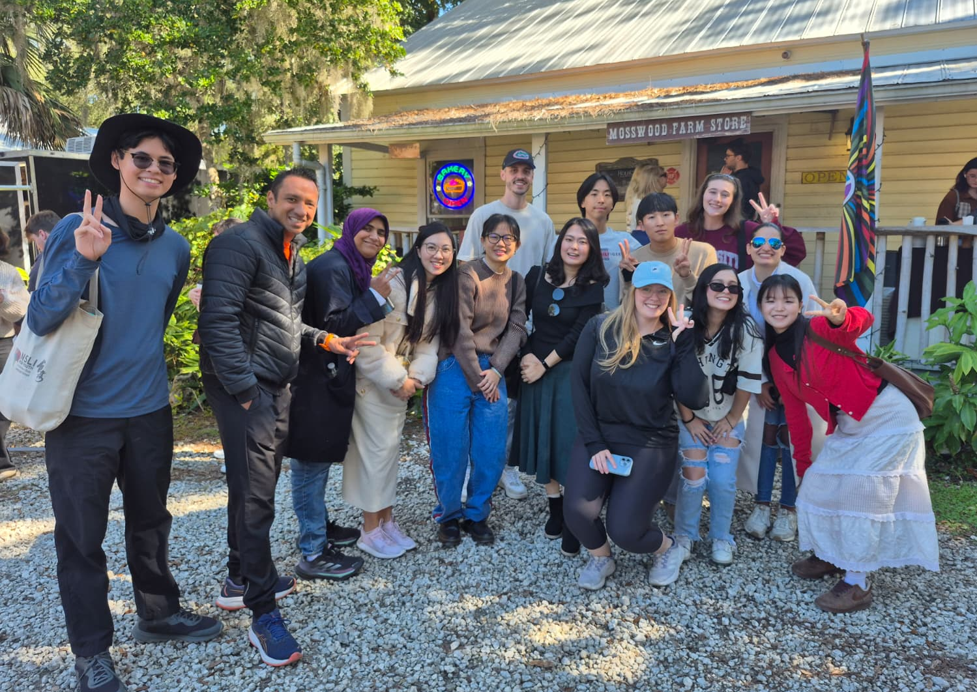

CIP Passport Completers:
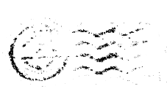
Congratulations to the students who completed the CIP passport!
Thanks so much for being so involved at the CIP!
Rafaela da Rocha | YaHsuan Wang
Fahad Sumait | Leo Delgado
AD Murshid | Lucia Pozos Royz
Zennure Arga

Coming Soon: International Education Spirit Week at the ELI!

International Education Week 2025 is the week of November 17th and soon approaching! Get ready to celebrate international education at the ELI with a fun Spirit Week. Start planning and preparing now what you will be wearing to class on these special themed days:
Dress up for our themed days and wear your fun outfit to class and activities!

Monday, November 17th: Tourist Day – Dress like your idea of a tourist!

Tuesday, November 18th: Twin Day – Grab a friend and match for the day or dress up like your favorite teacher to be their surprise twin.

Wednesday, November 19th: Decades Day – Dress in the style of your favorite decade! The style can be from the US or from your home country.

Thursday, November 20th: Traditional/Country Clothing Day – Dress in the traditional dress from your country if you can. If you don’t have that clothing, wear something else to represent your country, like your flag’s colors or something else to show off your country pride. You can wear this at our annual Thanksgiving Potluck tonight!

Friday, November 21st: Character Day – Dress like your favorite celebrity, TV character, movie character, or book character.

Come to the main office before LS periods if you are dressed up for that day’s theme. We will take a picture of you and post all the pictures on our Instagram where our followers can vote for their favorite costume of the day. The winner for the day will get a small prize!

CIP Weekday Activities
 | Monday, November 10th – Coffee Talk – 6:30-9:00pm
 | Socialize with LAs and ELI friends at Le Macaron in Celebration Pointe! Play games, speak English, and try this Gainesville famous ice cream or get dinner nearby! Take bus 75.  This semester, the location will change each week.  Address: 4949 Celebration Pointe Ave Suite 80, Gainesville, FL 32608
 | No Activity—Veterans Day
 | Wednesday, November 12th – Skate Station – 6:00 – 9:00pm
 | Roller-skate with the ELI! Listen to good music and roller-skate together, or just watch if you don’t want to! There are arcade games, go-karts, and more. Bring 7 dollars to skate, and a little bit more if you want to do other activities or get snacks. Meet us inside at Skate Station. Take bus 23 and walk a few minutes or use a rideshare/carpooling. Skate Station requires everyone under the age of 18 to leave at 8pm.  Address: 1311 NW 76th Blvd, Gainesville, FL 32606
 | Thursday, November 13th – Volleyball – 6:30 – 9:00pm
 | Play volleyball and hang out at Lexington Crossing Apartments Phase 2 Volleyball Courts with us! No experience necessary! You can also watch, socialize, or play other games if you don’t want to play volleyball. Take bus 35.  Address: 3700 SW 27th St, Gainesville, FL 32608
 | Friday, November 14th – Reitz Game Room – 6:30 – 9:00pm  Hang out with friends in the Reitz Game Room! You can go bowling, play pool, and play board games! Bring your Gator1 ID for cheaper rates. Many Fridays are Gator Nights so bring your ID to check in and see all the fun themed activities the Reitz may have planned for you this week in addition to the game room!  Address: 655 Reitz Union Drive, Gainesville, FL 32611

Weekend Event

Saturday, November 15th– Sweetwater Wetlands Nature Walk – 10:30 to 12:45pm

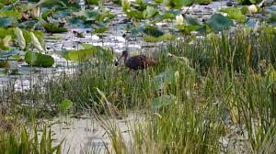

Florida nature is calling! On this light hike, we might see gators, snakes, flowers, beautiful old trees, and many more animals. See who can spot the most gators on the walk! The wetlands are a classic and picturesque Florida habitat that you won’t want to miss. Make sure to bring water and snack if you’d like and wear good walking shoes! Meet at 10:30am at Norman Garage.

You must sign up to attend this event: Sign up here!

Other CIP Reminders

Conversation Partners (CPs)
Want to meet with a fluent English speaker and make a new friend? Sign up for a CP! If you choose to sign up, you must meet with your partner for one hour a week. It can take up to two weeks to get a partner from when you sign up. Sign up here!

Returning students, you will not automatically be paired again if you had a CP last semester. Please make sure to sign up again here for the Fall semester if you did not request a Fall partner in your end of term evaluation from last semester.
Please email Elijah at conversationpartners@eli.ufl.edu for any issues, questions or concerns or visit her in the CIP Office during office hours.

CIP Passports
Don’t forget to get your CIP Passport hole punched from the activity leaders at the event (not after). We don’t hole punch passports after the event. Redeem your completed passport for a small gift, a photo for the ELI Instagram, and your name published in the ELI weekly! | 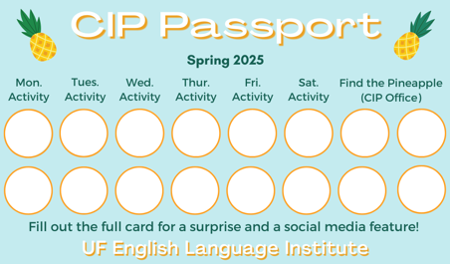

Need a new CIP Passport? Stop by the CIP Office.

Find the Pineapple
Remember the CIP Pineapple is hidden in a new place every Monday in the CIP office. Stop by and find it for hole punches!
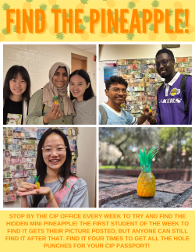

Notes from the Office
Upcoming Holidays: UF and the ELI will be closed and there will be no classes on Tuesday, November 11, in observation of Veterans Day. UF and the ELI will also be closed for Thanksgiving break from November 24th to November 29th. There are no classes during Thanksgiving break.
EOT Evaluations: Soon we will be doing our final course evaluations. This is your opportunity to provide feedback for how the class went this semester. Please go to this link https://bit.ly/4048gmH to review the evaluations so that you know how to fill them out when they are distributed in class. ELI administrators will review them and share the results with your teachers and Language Assistants to help them plan the class for next semester.
UF Emergency Test: The University of Florida will conduct on Friday, Nov. 14 a test of the UF Alert system, which is used to provide information to the campus community during emergency situations. During the test, individuals can expect to receive the notifications via text, email, and through the GatorSafe app. The test will also be broadcast through speakers in classrooms and those mounted on select Blue Light Phones around campus.
Check your I-20s: If you are traveling during the break (for example, leaving the US and coming back), make sure your I-20 is signed. Also check the expiration date. You can make an appointment with Daryl to sign your I-20 or to renew your I-20 before it expires.
As a reminder, all people in the US on a visa should always have their I-94 with them. The I-94 is proof that you are a registered alien in the US and shows that you are here on a non-immigrant visa. You can access your I-94 at https://i94.cbp.dhs.gov/home. Contact Daryl if you cannot access your I-94.
Also, have access to copies of other important documents, like your I-20, visa, passport, letter from USCIS, or other government issued documents related to your status in the U.S.
Financial Guarantees for Spring: Do you have a scholarship from your country or company to study at the ELI? If you will be continuing your studies in spring, you will need a new financial guarantee letter for the Spring semester. Be sure to request it early. If you need an enrollment letter or if you have any questions, please talk to Min or Megan in the main office.
Apartment Leases: As the semester draws to a close, keep in mind that your lease might be ending soon. It is important to know the exact date that your apartment lease ends so you can make plans. If you’re not sure when it ends, ask your apartment office. If you need help finding a hotel to stay in short-term (you should ask your friends first!), someone to take over your lease, or a new apartment, talk to Christine in Matherly 223.

Revision of ELI Policy on Satisfactory Progress: The accreditation site review team that visited the ELI in September noticed that the ELI does not have an official policy on the maximum amount of time a student can study at the ELI. So, we have added a paragraph to the policy to say the maximum amount of time a student can study at the ELI is 6 years. Here is the full ELI Satisfactory Progress Policy with the new paragraph:

The English Language Institute expects students to make satisfactory progress toward mastering the objectives for each of their classes. At midterm, students are informed of their grades, areas of success, as well as any areas in which they need to improve. The grades are submitted to the main office for the Associate Director to review.

Students who stay in the same level for one or more courses for three semesters are not allowed to return the following semester. Replacement electives (such as Grammar for Writing, Advanced Informal English, and Business English) count towards a semester in the current level for all students. Exceptions can be made for students who are in levels 10 through 50 who have been promoted at the end of the third semester.

Most students study at the ELI for 1-2 semesters. A student who begins the ELI with no knowledge of English, starting at the lowest level (level 10) and who is promoted at the end of each level can complete the full program (level 10 – level 60) in two years (6 semesters). Students who stay in the same level for three semesters for every level at the ELI (10-60) will not be allowed to continue studying in the program. Therefore, the maximum amount of time a student can study at the ELI is 6 years total (one year in each level).

Students |  | Staff
None this week |  | Talia Bock | November 16
 | 

Birthdays!

Manners

Q: What traditional foods do people eat on Thanksgiving?
It might vary a little by region, but I can tell you about my traditional New England Thanksgiving menu!

Turkey and gravy
Mashed potatoes
Stuffing
Sweet potatoes
Cranberry sauce
Green beans
Corn
Turnips

And of course, for dessert: Pumpkin pie

Joke of the Week

Q: How do you tell the difference between an alligator and a crocodile?

It depends on whether you see it later or after a while!

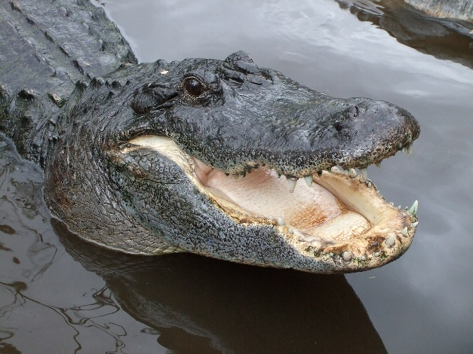

Student Voices
 | Every semester, we have amazing student writers, so we take your writing and publish it in an online collection called Student Voices. In past semesters, students have written paragraphs, essays, creative stories, recipes, letters, obituaries, poetry, and more. You can see past editions of Student Voices (https://eli.ufl.edu/news-publications/, scroll to the bottom of the page) for inspiration.

We encourage you to submit anything of your work that you wish to see published. It can be from any class or something you have written on your own but ask your teachers for help editing! You can email it to Olga Moody (omoody@ufl.edu) or to your teacher. Please include your name and class on your submission.

The deadline for submissions has been extended to Friday, November 14th.

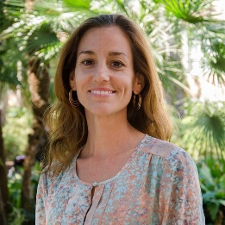 | I need students, LAs, instructors, staff, and administrators to help me write the Weekly!  - Write a paragraph about your experiences this semester. You could write about an ELI activity, a Gainesville event, a fabulous local restaurant, or tell us about a place or event in your country that we should visit.  - You could also ask me to write about a topic that you are curious about  - Send me grammar questions for me to put in the Weekly.  - Send me manners and culture questions for me to put in the Weekly.  - Send me jokes to put in the Weekly.

Send your paragraphs and/or questions to Jen Ramos (jenramos@ufl.edu) Use the subject heading: ELI Weekly.

