The ELI Weekly

Out and About: UF Bat House


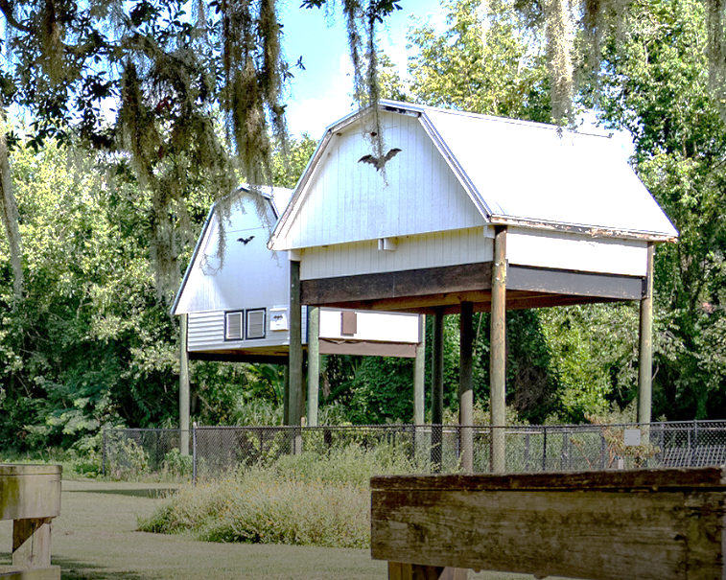

With the Halloween season around the corner, it’s a good time to talk about bats! Along with witches, ghosts, and pumpkins, bats are synonymous with Halloween. So, if you are interested in getting into the Halloween spirit, take a visit to the UF Bat Houses, located across from Lake Alice. You can watch these spooky creatures emerge from the bat houses around 15 minutes after sunset, particularly on warm evenings, when the temperature is about 65º F (18 º C).

You might be interested to know why UF has bat houses. It began with a colony of bats that had been living in an old building on UF campus, Johnson Hall. When Johnson Hall burned down in 1987, the bats took up residence in the bleachers of Pressley Stadium, where people sit to watch track meets. UF decided they needed to get the bats out of the stadium, so they built a bat house. They captured all the bats and released them into the newly built bat house, but the bats flew out of the house at night and never came back.

People thought the bat house was a big failure. It stood vacant for 3 years until a new colony of bats moved in. If fact, so many bats came to the bat house that it started to collapse inside due to all the weight. So, a new bat house was built in 2022. An estimated 500,000 bats now call that bat house their home!

Click here to learn more about the UF bat houses: https://youtu.be/UOACyFFlhOs?si=_ZRm476Z9FNtgm3J

CIP Weekday Activities
 | Monday, September 29th – Coffee Talk – 6:30-9:00pm– Activity Still Happening on Instructor Work Day!
 | Socialize with LAs and ELI friends at the Panera on Archer Road! Play games, speak English, and drink a coffee or get dinner at the food truck in the area! Take bus 6.  This semester, the location will change each week.  Address: 3443 SW Archer Rd Suite 1A, Gainesville, FL 32608
 | Tuesday, September 30th – Volleyball – 6:30-9:00pm
 | Play volleyball and hang out at Lexington Crossing Apartments Phase 2 Volleyball Courts with us! No experience necessary! You can also watch, socialize or play other games if you don’t want to play volleyball. Take bus 35.  Address: 3700 SW 27th St, Gainesville, FL 32608
 | Wednesday, October 1st – Depot Park & Karaoke – 7:00 – 9:30pm
 | Spend time at beautiful Depot Park at sunset and explore the fun outdoor space with your ELI friends! Then head over to the Boxcar where there will be free Karaoke! Bring some money if you would like to buy food at the burger restaurant, Goldie’s! Meet in front of the Boxcar, park side.  Address: 201 SE Depot Ave, Gainesville, FL 32601
 | Thursday, October 2nd – Soccer – 6:30 – 9:00pm
 | Come play Soccer on campus at Flavet Field on campus! No experience necessary! You can also watch, socialize or play other games if you don’t want to play soccer.  Address: Woodlawn Dr, Gainesville, FL 32603
 | Friday, October 3rd – Reitz Game Room – 6:30 – 9:00pm
 | Hang out with friends in the Reitz Game Room! You can go bowling, play pool, and play board games! Bring your Gator1 ID for cheaper rates. Many Fridays are Gator Nights so bring your ID to check in and see all the fun themed activities the Reitz may have planned for you this week in addition to the game room!  Address: 655 Reitz Union Drive, Gainesville, FL 32611

CIP Photos of the Week

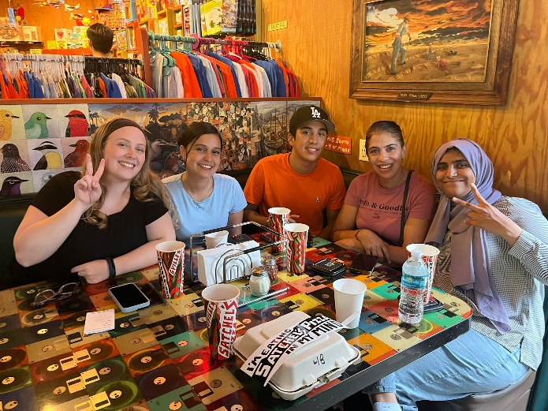
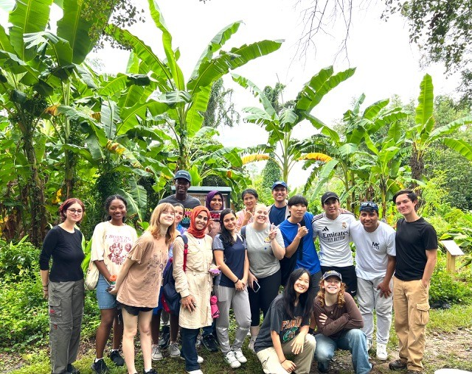

Other CIP Reminders

Conversation Partners (CPs)

Want to meet with a fluent English speaker and make a new friend? Sign up for a CP! If you choose to sign up, you must meet with your partner for one hour a week. It can take up to two weeks to get a partner from when you sign up. Sign up here!
Returning students, you will not automatically be paired again if you had a CP last semester. Please make sure to sign up again here for the Fall semester if you did not request a Fall partner in your end of term evaluation from last semester.
Please email Elijah at conversationpartners@eli.ufl.edu for any issues, questions or concerns or visit her in the CIP Office during office hours.

Don’t forget to get your CIP Passport hole punched from the activity leaders AT the event (not after). We don’t hole punch passports after the event. Redeem your completed passport for a small gift, a photo for the ELI Instagram, and your name published in the ELI weekly!
Need a new CIP Passport? Stop by the CIP Office!
Remember the CIP Pineapple is hidden in a new place every Monday in the CIP office. Stop by and find it for hole punches!

CIP Passports
Don’t forget to get your CIP Passport hole punched from the activity leaders at the event (not after). We don’t hole punch passports after the event. Redeem your completed passport for a small gift, a photo for the ELI Instagram, and your name published in the ELI weekly! | 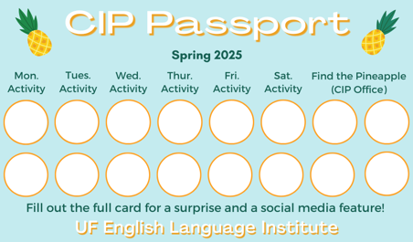

Need a new CIP Passport? Stop by the CIP Office.

Find the Pineapple
Remember the CIP Pineapple is hidden in a new place every Monday in the CIP office. Stop by and find it for hole punches!
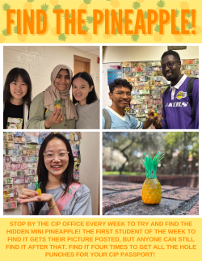

Birthdays!
Students |  | Staff
 | October 4 | None this week!
  Juliana Montealegre Ruiz
 | 

Manners & Culture

Q: I always called my ELI teachers teacher, but my friend told me this is not a common thing in the U.S. Will my teacher think I’m rude if I call her by her first name?

Your friend is correct! It is not common to use the word teacher as a form of address. Sometimes little kids do this when they can’t remember their teacher’s name! In general, however, kids in the U.S. call the teacher miss/missus/mister + last name. For example, I would be Mrs. Ramos. At the ELI, we are less formal, so teachers don’t mind being called by their first name and probably prefer that over something more formal.

Joke of the Week

Q: Did you know bats aren’t big planners?
A: That’s right. They prefer to just wing it!
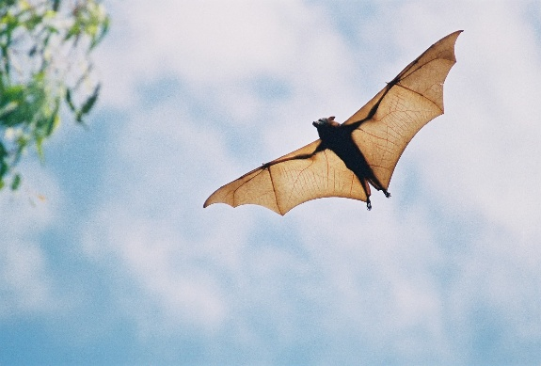

 | I need students, LAs, instructors, staff, and administrators to help me write the Weekly!  - Write a paragraph about your experiences this semester. You could write about an ELI activity, a Gainesville event, a fabulous local restaurant, or tell us about a place or event in your country that we should visit.  - You could also ask me to write about a topic that you are curious about  - Send me grammar questions for me to put in the Weekly.  - Send me manners and culture questions for me to put in the Weekly.  - Send me jokes to put in the Weekly.

Send your paragraphs and/or questions to Jen Ramos (jenramos@ufl.edu) Use the subject heading: ELI Weekly.



