The ELI Weekly

Where in the World

This semester the ELI welcomes students from 21 different places spanning 5 continents! You can learn a lot about the world from your classmates.

What is one interesting fact you can share about your country?

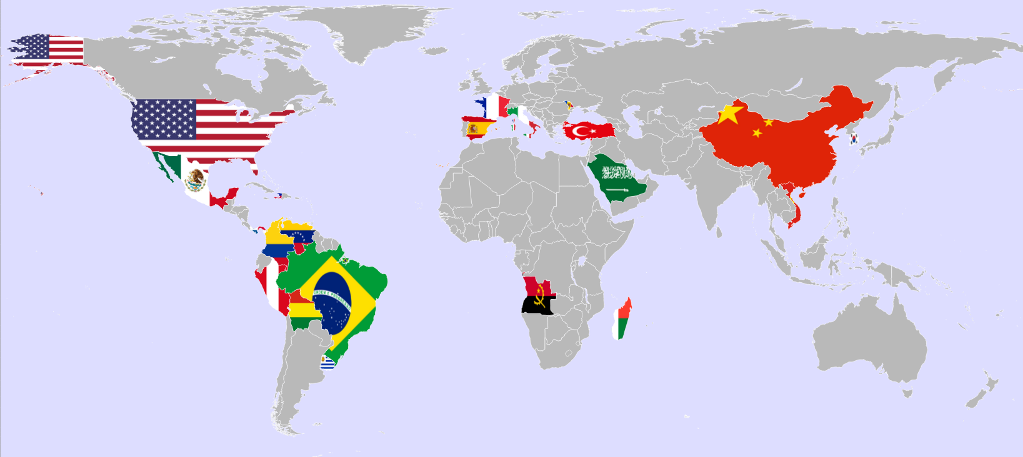

Countries Represented by Spring 2026 Students
Angola | Haiti | Panama | Uruguay
Bolivia | Italy | Peru | Venezuela
Brazil | Korea | Saudi Arabia | Vietnam
China | Madagascar | Spain
Colombia | Mexico | Turkey
France | Moldova | United States

CIP Weekday Activities
 | Monday, January 19th —No activity — Marthin Luther King Jr. Day
 | 
 | Tuesday, January 20th – Volleyball – 6:30-9:00pm
 | Play volleyball and hang out at Lexington Crossing Apartments Phase 2 Volleyball Courts with us! No experience necessary! You can also watch, socialize or play other games if you don’t want to play volleyball. Take bus 35.  Address: 3700 SW 27th St, Gainesville, FL 32608
 | Wednesday, January 21st– Soccer – 6:30-9:00pm
 | Come play Soccer on campus at Flavet Field on campus! No experience necessary! You can also watch, socialize or play other games if you don’t want to play soccer.  Address: Woodlawn Dr, Gainesville, FL 32603
 | Thursday, January 22nd – Menchie’s Froyo & Shopping – 6:30 – 9:30pm
   | Get some delicious frozen yogurt with LAs and then go shopping for your apartment needs at Walmart with their help! If you don’t need shopping help, you can still come for froyo and socializing! Bring some money for Menchie’s and spending for shopping you would like to do. Take bus 1 or 12. Meet outside Menchie’s.  Address: 2905 SW 42nd St #20, Gainesville, FL 32608
 | Friday, January 23rd – Reitz Game Room – 6:30 – 9:00pm
 | Hang out with friends in the Reitz Game Room! You can go bowling, play pool, and play board games! Bring your Gator1 ID for cheaper rates. Many Fridays are Gator Nights so bring your ID to check in and see all the fun themed activities the Reitz may have planned for you this week in addition to the game room!  Address: 655 Reitz Union Drive, Gainesville, FL 32611

Weekend Event: Hoggetowne Medieval Faire
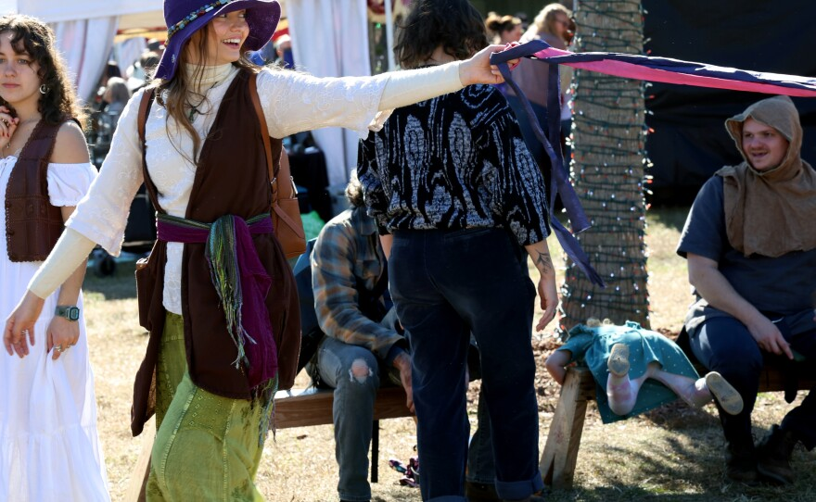

Saturday, January 24th – Hoggetowne Medieval Faire - 9:45am – 1:00pm

Travel back in time to the medieval era at this cultural event! Come see magic performed by actors and musicians as we journey back to the days of old! Watch King Arthur’s Knights of the Round Table, see more than 160 artists show their skills in blacksmithing, weaving, leatherworking, woodcarving, pottery and much more. Eat a feast fit for a king in the food court, where you can find sweet potato fries, bloomin’ onions and giant turkey legs. Admission is free and accessible by bus! Remember to bring spending money for food and shopping.
The ELI will meet at Rosa Parks Transfer Station at 9:45, which is across from Depot Park. Please meet us here AT 9:45 before enjoying the festivities. The park will be very busy with visitors, so it may be difficult to find LAs throughout the day. If you need help, contact Paola or your LA to try to locate friends!

Sign up here so we can know to expect you!

CIP Photo of the Week: Campus Tour
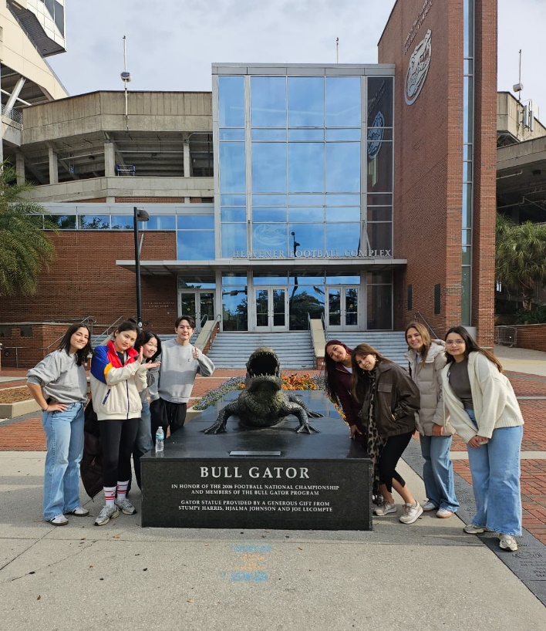

Other CIP Reminders

Selling Tickets for the 1/30 Gators Gymnastics Meet

Watch the Gators compete in gymnastics against Arkansas! Get in the school spirit and wear orange and blue, and support the Gators while they perform amazing gymnastic feats you won’t want to miss.

You must purchase a ticket from Tate in Matherly 211 between 9am and 1:30pm for 5 dollars exact cash Tuesday through Thursday. ELI tickets are limited, so buy them before they sell out! It takes several minutes to set up your Gator ticket account so please account for some time when coming in to purchase. Your ticket IS your signup.

On January 30th, we will all gather at 6:45 in the Reitz Union outside of the Subway. Then, we will walk over to the O’Connell Center to watch the start of the game!

Please note: Do NOT bring any bags or backpacks. Keep your wallet, keys, etc. in your pockets. Bring some extra spending money if you would like to buy food at the stadium.

Conversation Partners

Want to meet with a fluent English speaker and make a new friend? Sign up for a CP! If you choose to sign up, you must meet with your partner for one hour a week. It can take up to two weeks to get a partner from when you sign up. Please sign up here!

Returning students, you will not automatically be paired again if you had a CP last semester. Please make sure to sign up again here for the Spring semester if you did not request a Spring partner in your end of term evaluation from last semester.

Please email Elijah at conversationpartners@eli.ufl.edu for any issues, questions or concerns or visit her in the CIP Office during office hours.

Other CIP Reminders

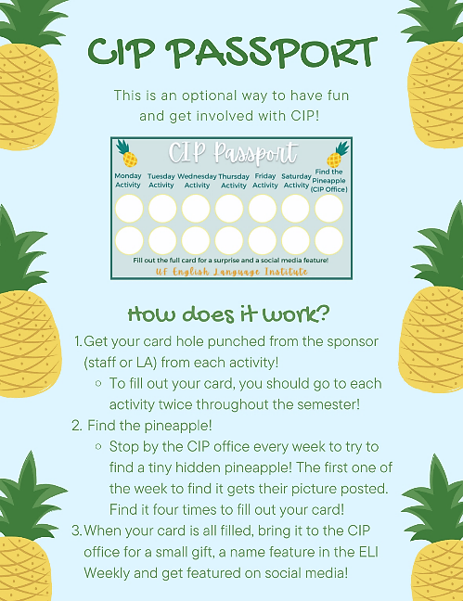
Don’t forget to get your CIP Passport hole punched from the activity leaders AT the event (not after). We don’t hole punch passports after the event. Redeem your completed passport for a small gift, a photo for the ELI Instagram, and your name published in the ELI weekly!

Need a new CIP Passport? Stop by the CIP Office!

Remember the CIP Pineapple is hidden in a new place every Monday in the CIP office. Stop by and find it for hole punches!

Need a new CIP Passport? Stop by the CIP Office!

Find the Pineapple
Remember the CIP Pineapple is hidden in a new place every Monday in the CIP office. Stop by and find it for hole punches!
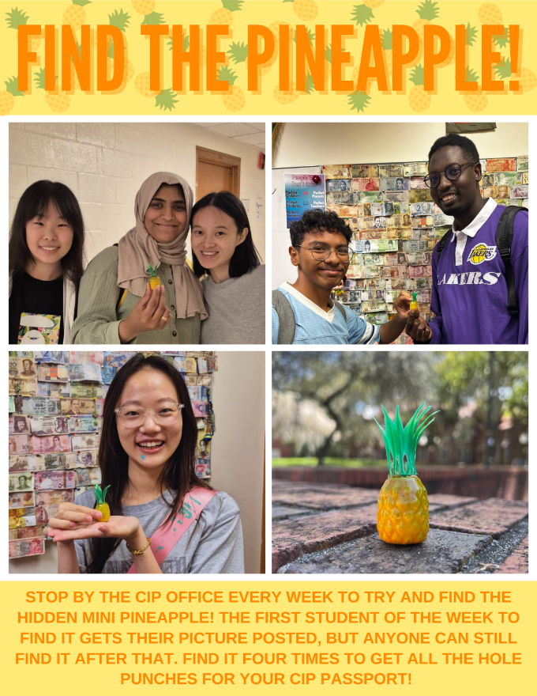

Notes from the Office
Class Attendance: Your attendance is important. Your teachers are taking note of both your absences and your tardies in every class every day. Please remember that this also includes time spent in the hallway instead of the classroom.
Lost and Found: Have you lost your car keys, student ID card, driver’s license, wallet, or some other important item? Many times, when people find an item, they bring it to the office for safe keeping. When you lose something, please come by the ELI Main Office (MAT223) and see if it is in the lost and found.
Student Addresses: It is important that the ELI has each student’s address. If you have an F or J visa, you should report a change of address within 10 days of any change. You can update your address in myELI using the ‘Basic Information’ tab in your ‘My Profile’ page. If you need help updating your address in myELI, please contact Daryl at studyenglish@eli.ufl.edu.
Deadlines: The deadline to drop or add a class, pay tuition, submit proof of insurance and immunizations, and turn in a signed waiver of liability is Thursday, January 22nd. If you miss any of these deadlines, you could be removed from classes or charged a late fee! If you have questions about paying tuition or submitting a financial guarantee, email at fiscal@eli.ufl.edu. If you have questions about insurance or immunizations, email Christine Voigt at christinevoigt@ufl.edu.
Withdrawing: Students who withdraw from a course or from the ELI after the drop/add deadline (Thursday, January 22nd) will not be able to receive a refund or credit for their courses. Their transcript will have a grade of W (withdraw).

Birthdays!
Students |  | Staff
None this week! |  | Lynne Clark | January 24


Culture

Q: It’s much colder here in Gainesville than I expected! Will it be this cold all semester?
A: We have definitely been having some cold nights this month. In fact, there has even been snow in parts of Florida’s panhandle.

The winter months in Gainesville are characterized by cool days, often with clear blue skies, and chilly nights. You will definitely need a jacket when you go out at night—and sometimes even gloves and a hat!

Typically, the winter weather will give way to spring in mid-March. The official first day of spring is March 20th.



Grammar

Q: Do I use “much” or “many” with money?
A: We use the word “much” with things that cannot be counted and “many” with plural count nouns. The word “money” is non-count, so we use “much.” It seems strange to say you can’t count money, but grammatically speaking, it’s true!
Here are some examples:

- I don’t have much money.

- How much money is in your bank account?

However, if we are talking about units of money (coins, bills, dollars, etc.) then we will use “many.”
- How many five-dollar bills do you have in your wallet?
- She asked me for many coins from my country for her world coin collection.

Joke of the Week

Q: Why can’t the alligator hang out with his buddies today?
A: No time—he’s swamped!


Notes from the Editor
 | Welcome to Spring 2026 Semester! I would like to invite all students to contribute to the Weekly! Here are some ways to contribute:  - Write a paragraph about your experiences this semester. You could write about an ELI activity, a Gainesville event, a fabulous local restaurant, or tell us about a place or event in your country that we should visit.  - Send me grammar questions for me to put in the Weekly.  - Send me manners and culture questions for me to put in the Weekly.  - Send me jokes to put in the Weekly.

Send your paragraphs and/or questions to Jen Ramos (jenramos@ufl.edu) Use the subject heading: ELI Weekly.



