The ELI Weekly

Collegiate Sports

Even if you are a new student, you may have already noticed that sports are an important part of American culture. It’s not just professional sports like the NFL or NBA that get all the attention! Collegiate sports have a huge fanbase and attract national media attention.


Most people know that the athletic teams of the University of Florida are known as the Florida Gators. But did you also know that the University of Florida is considered a Division 1 school by the National Collegiate Athletic Association (NCAA)? Division 1 schools have the best athletic facilities, the largest athletic budgets, attract the best athletes, and give out the most athletic scholarships.

This Friday, January 30th, ELI students can participate in Division 1 sports by watching UF Gator gymnastics! The Gators have one of the top gymnastic teams in the country. Come out and show your Gator spirit!

Do you want to learn more about UF Women’s Gymnastics? Check out this video, entitled “Unbreakable”: https://youtu.be/wBNHEvUx6xI?si=DPJ-ENUT98VSJ9kc

CIP Weekday Activities
 | Monday, January 26th —Coffee Talk— 6:30-9:00pm
 | Socialize with LAs and ELI friends at Panera on Archer Road! Play games, speak English, and try this Gainesville famous ice cream or get dinner nearby! Take bus .  The location will change each week.  Address: 3443 SW Archer Rd Suite 1A, Gainesville, FL 32608
 | Tuesday, January 27th – Volleyball – 6:30-9:00pm
 | Play volleyball and hang out at Lexington Crossing Apartments Phase 2 Volleyball Courts with us! No experience necessary! You can also watch, socialize or play other games if you don’t want to play volleyball. Take bus 35.  Address: 3700 SW 27th St, Gainesville, FL 32608
 | Wednesday, January 28th– Soccer – 6:30-9:00pm
 | Come play Soccer on campus at Flavet Field on campus! No experience necessary! You can also watch, socialize or play other games if you don’t want to play soccer.  Address: Woodlawn Dr, Gainesville, FL 32603
 | Thursday, January 29th – Reitz Game Room – 6:30 – 9:00pm  Hang out with friends in the Reitz Game Room! You can go bowling, play pool, and play board games! Bring your Gator1 ID for cheaper rates. Many Fridays are Gator Nights so bring your ID to check in and see all the fun themed activities the Reitz may have planned for you this week in addition to the game room!  Address: 655 Reitz Union Drive, Gainesville, FL 32611
 | Friday, January 30th – Reitz Game Room – 6:45 – 9:15pm
 | Watch the Gators compete in gymnastics against Arkansas! Get in the school spirit and wear orange and blue, and support the Gators while they perform amazing gymnastic feats you won’t want to miss.  You must purchase a ticket from Tate in Matherly 211 between 9am and 1:30pm for 5 dollars exact cash Tuesday through Thursday. ELI tickets are limited, so buy them before they sell out! It takes several minutes to set up your Gator ticket account so please account for some time when coming in to purchase. Your ticket IS your signup.  On January 30th, we will all gather at 6:45pm in the Reitz Union outside of the Subway near the Game Room. Then, we will walk over to the O’Connell Center to watch the start of the game!  Please note: Do NOT bring any bags or backpacks. Keep your wallet, keys, etc. in your pockets. Bring some extra spending money if you would like to buy food at the stadium. Make sure you have your eticket ready to scan.

Call Tate or Paola if you have any issues finding the ELI at an activity. Their numbers can be found on the signups.

Weekend Event: Silver Springs Boat Tours

Saturday, January 31st – Silver Springs Boat Tours - 8:30am – 1:00pm

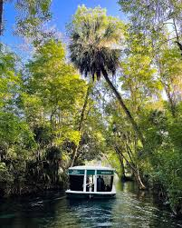
Join us at the beautiful Silver Springs State Park to enjoy real Florida nature! The springs are some of Florida's most popular attractions. Enjoy a trip on a glass bottom boat tour to see a perfect view under the crystal water and learn about the springs or kayak around these beautiful springs where you may be able to see gators, manatees, fish, and even monkeys!

Bring about $20 to cover the cost of a ticket for a boat ride. Budget around $35 for kayaking/canoeing/paddleboarding.

Bring your own lunch or buy food from small menu of food and enjoy a picnic on the grounds! There is no swimming at this spring, but plenty of views and trails to explore while you wait for your boat tour to start. Meet at Norman Parking garage and please do not be late.

You must sign up to attend. Sign up here and make sure to comment if you would prefer the glass bottom boat or the kayak.

CIP Team Recommendations

Get different recommendations from your LAs and CIP friends each week!
This week we feature book recommendations:

Aurora: The Selection novellas series by Kiera Cass
Elijah: The Stranger by Albert Camus
Kemarah: the Earthseed series by Octavia Butler
Lexa: The Name of the Wind by Patrick Rothfuss
Paola: The Housemaid by Frieda McFadden
Sam: All the Light We Cannot See by Anthony Doerr
Shawn: Elephant Run by Roland Smith
Tate: Mistborn by Brandon Sanderson

Talk to LAs and the CIP Office to learn more about their favorite books and share yours with them

Conversation Partners

Want to meet with a fluent English speaker and make a new friend? Sign up for a CP! If you choose to sign up, you must meet with your partner for one hour a week. It can take up to two weeks to get a partner from when you sign up. Please sign up here!

Returning students, you will not automatically be paired again if you had a CP last semester. Please make sure to sign up again here for the Spring semester if you did not request a Spring partner in your end of term evaluation from last semester.

Please email Elijah at conversationpartners@eli.ufl.edu for any issues, questions or concerns or visit her in the CIP Office during office hours.

Other CIP Reminders

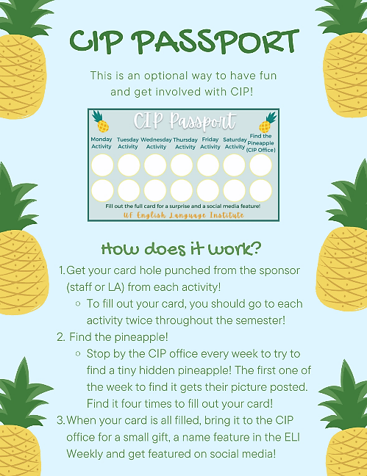
Don’t forget to get your CIP Passport hole punched from the activity leaders AT the event (not after). We don’t hole punch passports after the event. Redeem your completed passport for a small gift, a photo for the ELI Instagram, and your name published in the ELI weekly!

Need a new CIP Passport? Stop by the CIP Office!

Remember the CIP Pineapple is hidden in a new place every Monday in the CIP office. Stop by and find it for hole punches!

Need a new CIP Passport? Stop by the CIP Office!

Find the Pineapple
Remember the CIP Pineapple is hidden in a new place every Monday in the CIP office. Stop by and find it for hole punches!
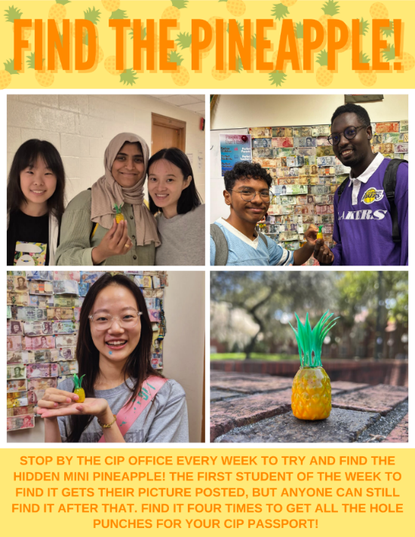

Notes from the Office
Getting Extra Help in the Classroom (Accommodations)
Do you have special learning needs due to a personal medical condition? If you do, it is important that you get in touch with Christine (christinevoigt@ufl.edu) as soon as possible so we know how to help you. Christine will help you talk to the UF Disabilities Resource Center about accommodations for your classes.
Some examples of accommodations include the following:
- extra time on exams due to a reading disability
- providing PowerPoint Presentations to students who need more reading time
- permission to leave the classroom to take medication
- eating or drinking in class for a specific medical condition
- an audio version of a textbook for students who have limited vision
We want this to be a great learning experience for all our students!

Staying Safe on Campus
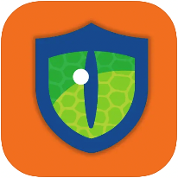 | Here are a few safety reminders for staying safe on campus:  - Gatorsafe: You should download the Gatorsafe App on your phone so you can get UF alerts. Gatorsafe has useful safety information about weather, a quick link to UFPD, and other safety services.
- Personal belongings: Do not leave backpacks, computers, phones or other personal belongings in the classrooms or hallways when you are not there. Also, if you use a mobility device like a bike, electric scooter, or skateboard, you should lock it outside at one of the racks. Take the time to register your property with UFPD, especially your mobility devices.
- ELI Emergency Cell Phone and 911: The ELI has a special phone number that you can use if you have a medical or legal emergency outside of normal office hours. The ELI emergency phone number is 352-672-0144 that is available from 4:30pm-8:00am when the ELI office is closed. You should store this number in your phone in case you have an emergency. An example of an emergency is if an ELI student needs to go to the hospital or gets arrested. Please do not use the emergency number for anything that can wait to be answered by email or when the office is open. If you need the police, fire department, or an ambulance for an extreme emergency, call 911 before you call the ELI emergency number.

Birthdays!
Students |  | Staff
Mona Alharbi | January 27 | Tate Quiñones | January 26


Culture

Q: I’ve noticed some very young people driving in Florida. How old do you have to be to drive here?
A: Driving age in the U.S. is relatively younger than in some other countries. Here in Florida, a 15-year-old can get a learner’s license, which means they always need to have an adult in the car with them while they drive. A 16-year-old can get a driver’s license, but they will still have some restrictions on nighttime driving after 11:00pm.

Joke of the Week
Q: What do you call an alligator who’s good at giving directions?
A: a navi-gator!
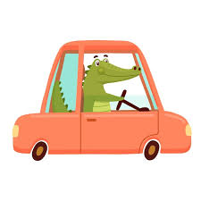

Notes from the Editor
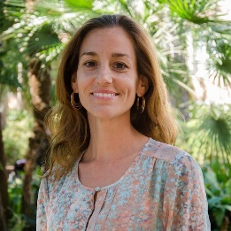 | Hope you’re enjoying your semester! I would like to invite all students to contribute to the Weekly! Here are some ways to contribute:  - Write a paragraph about your experiences this semester. You could write about an ELI activity, a Gainesville event, a fabulous local restaurant, or tell us about a place or event in your country that we should visit.  - Send me grammar questions for me to put in the Weekly.  - Send me manners and culture questions for me to put in the Weekly.  - Send me jokes to put in the Weekly.

Send your paragraphs and/or questions to Jen Ramos (jenramos@ufl.edu) Use the subject heading: ELI Weekly.



