The ELI Weekly

Gator Giving Day 2026

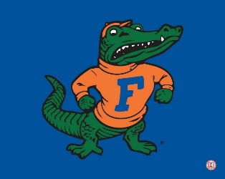

Stand Up and Holler: Gator Nation Giving Day is a 24-hour fundraising event to raise money for UF and all its programs. This 24-houir period calls for all University of Florida
alumni, students, faculty, staff, families and friends to contribute to the university and recognize all the positive impacts UF has on our state, nation, and the world. The event starts at 12am on February 19th and concludes at 11:59pm.

Want to know more? Here is the homepage of Stand Up and Holler: Gator Nation Giving Day: https://givingday.ufl.edu/pages/save-the-date-9

See how the ELI is celebrating this day:

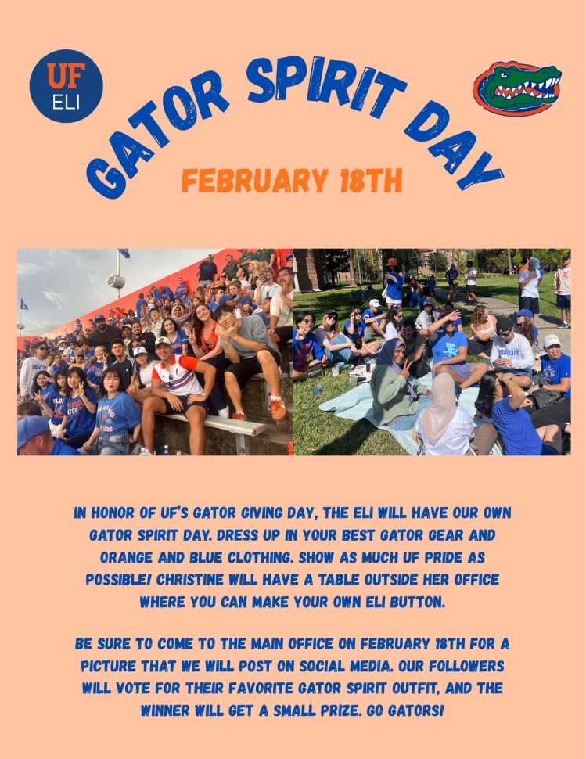

CIP Photo of the Week: Soccer

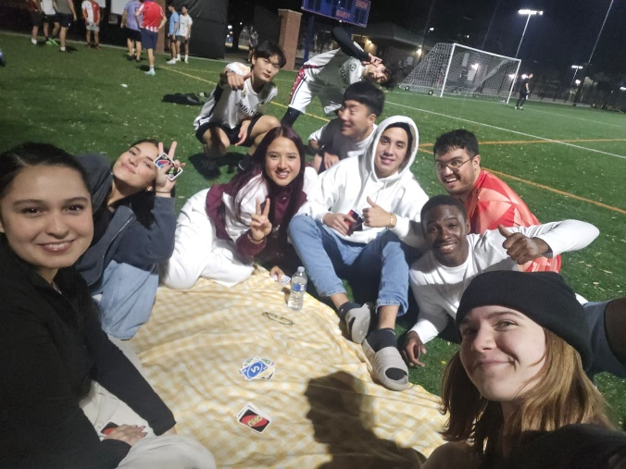

CIP Recommendations:
Get different recommendations from your LAs and CIP friends each week! This week is TV series:

TV Series

Aurora: New Girl

Elijah: Steven Universe

Kemarah: From

Lexa: Pride and Prejudice (1995)

Paola: One Tree Hill

Sam: Lost

Shawn: The Office

Tate: Over the Garden Wall



Talk to LAs and the CIP Office to learn more about their favorite shows and tell them about yours!
Spring B Starting Soon

Spring B students will be arriving next week! They will take their placement test on Wednesday, February 25th and start classes on Monday, March 2nd. Please help us welcome them to the ELI and give them any help you can as they settle in.

CIP Weekday Activities
 | Monday, February 16th – Coffee Talk – 6:00-8:30pm HAPPENING ON INSTRUCTOR WORKDAY
 | Socialize with LAs and ELI friends at Tea Stori! Play games, speak English, and try bubble tea, mochi or get dinner nearby! Take bus 1 or 37.  The location will change each week.  Address: 3550 SW 34th St, Gainesville, FL 32608
 | Tuesday, February 17th – Volleyball – 5:30-8:00pm
 | Play volleyball and hang out at Lexington Crossing Apartments Phase 2 Volleyball Courts with us! No experience necessary! You can also watch, socialize or play other games if you don’t want to play volleyball. Take bus 35.  Address: 3700 SW 27th St, Gainesville, FL 32608
 | Wednesday, February 18th – Depot Park Soccer and Karaoke – 6:30 – 9:00pm NEW TIME and LOCATION
 | Explore Depot Park with ELI friends every Wednesday! Play soccer, check out the restaurants and then end the night with free karaoke at the Boxcar! Meet in the grassy area in front of the Boxcar.  Address: 201 SE Depot Ave, Gainesville, FL 32601
 | Thursday, February 19th– Thrifting and Germain’s – 5:00 – 7:30pm
 | Thrift for fun used clothes and other vintage items at Flashback’s for the first hour of this activity (Flashback’s closes at 6pm)! Then go right next door to get Germain’s famously delicious chicken sandwiches! Explore other fun spots in this charming area like the record store. Take bus 15.  Address: 220 NW 8th Ave #20, Gainesville, FL 32601
 | Friday, February 20th– Reitz Game Room – 6:30 – 9:00pm  Hang out with friends in the Reitz Game Room! You can go bowling, play pool, and play board games! Bring your Gator1 ID for cheaper rates. Some Fridays, the Reitz plans Gator Nights! Check out the fun themed activities they may have this week.  Address: 655 Reitz Union Drive, Gainesville, FL 32611
 | Call Tate or Paola if you have any issues finding the ELI at an activity. Their numbers can be found on the signups.

NO WEEKEND EVENT - Study for Midterms

Conversation Partners (CPs)
Want to meet with a fluent English speaker and make a new friend? Sign up for a CP! If you choose to sign up, you must meet with your partner for one hour a week. It can take up to two weeks to get a partner from when you sign up. Sign up here!

Returning students, you will not automatically be paired again if you had a CP last semester. Please make sure to sign up again here for the Fall semester if you did not request a Fall partner in your end of term evaluation from last semester.
Please email Elijah at conversationpartners@eli.ufl.edu for any issues, questions or concerns or visit her in the CIP Office during office hours.

CIP Passports
Don’t forget to get your CIP Passport hole punched from the activity leaders at the event (not after). We don’t hole punch passports after the event. Redeem your completed passport for a small gift, a photo for the ELI Instagram, and your name published in the ELI weekly! | 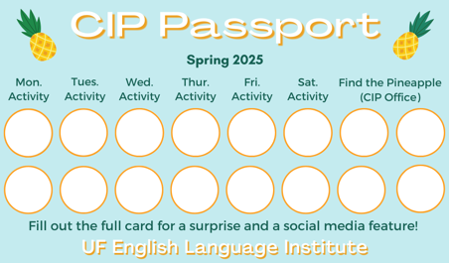

Need a new CIP Passport? Stop by the CIP Office.

Find the Pineapple
Remember the CIP Pineapple is hidden in a new place every Monday in the CIP office. Stop by and find it for hole punches!
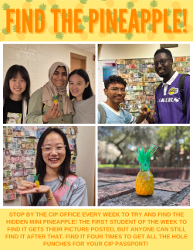

Notes from the Office
People Out: Christine will be out of the office on Friday, February 20th.
Course Evaluations: Soon we will be doing midterm course evaluations. This is your opportunity to provide feedback for your classes. Please go to this link https://bit.ly/4048gmH to review the evaluations so that you know how to fill them out when they are distributed in class. Your teachers and Language Assistants will use this information to plan the class for the rest of the semester.
Florida International Leadership Conference (FILC): Christine volunteers with an organization that does a student leadership conference. This year, she wants to get ELI students involved! FILC is a 3-day summer-camp style retreat. You can find details here: https://faie.org/2026-filc/
International and US study abroad students attending Florida colleges or universities are able to participate. We will go to Camp Geneva to participate in leadership sessions, networking, and fun camp activities. The cost for the camp, including food and lodging in a shared cabin, is $195. Talk to Christine by February 23 if you are interested or have questions!
UF Federal Tax forms for International Students: Were you in the U.S. in 2025 on an F or V visa? If yes, you have a responsibility to file tax forms with the U.S. Internal Revenue Service (IRS). Tax forms are due on April 15th this year. They are filed for the previous calendar year, which in this case is 2025.
You must provide required tax forms even if you did not earn any money in the U.S. in 2025. All F and J visa students (including dependents) who were in the US last year must submit IRS form 8843. You can get the form 8843 from the ELI main office.
You cannot submit this document electronically. You must physically mail it to this address by April 15th:
Department of the Treasury
Internal Revenue Service Center
Austin, TX 73301-0215

Because you are at UF and have an active Gatorlink, you have free access to Sprintax, a web-based tax preparation software designed for non-resident aliens, including international students, scholars, and visa holders in the U.S. Sprintax can help with filling in form 8843, but you will need to print and mail the document yourself. Contact Daryl or Christine to receive:
- the UF student Sprintax link
- help filling out form 8843
- information about how to mail form 8843 to the IRS address in Texas
If you had on-campus employment in 2025 as an international student, you will receive a form from your employer reporting your income and tax withholdings called a W-2. Because you earned reportable income, you must submit a federal tax return to file your W-2. Talk to Daryl if you had on-campus employment last year and have questions about filling your taxes.

Birthdays!
Students |  | Staff
None this week! |  | None this week!

Culture:

Q: Why do Americans say “yeah” or “oh my gosh” every five seconds when I’m talking to them?

There is actually a name for this feature of conversation: backchanneling. American conversational style includes a lot of backchanneling, which are these small words or phrases that you noticed that signal we are engaged with you are saying. For people who are not used to this, it seems very weird. In some cultures, silence while someone is speaking is more respectful. But for us, we like to hear the listener speak periodically so we know they are interested.



Joke of the Week

Q: What kind of cat should you never trust?
A: Cheetah!


Student Voices
 | Every semester, we have amazing student writers, so we take your writing and publish it in an online collection called Student Voices. In past semesters, students have written paragraphs, essays, creative stories, recipes, letters, obituaries, poetry, and more. You can see past editions of Student Voices (https://eli.ufl.edu/news-publications/, scroll to the bottom of the page) for inspiration.

We encourage you to submit anything of your work that you wish to see published. It can be from any class or something you have written on your own but ask your teachers for help editing! You can email it to Olga Moody (omoody@ufl.edu) or to your teacher. Please include your name and class on your submission. The deadline for submissions is Friday, March 27th.

 | I need students, LAs, instructors, staff, and administrators to help me write the Weekly!  - Write a paragraph about your experiences this semester. You could write about an ELI activity, a Gainesville event, a fabulous local restaurant, or tell us about a place or event in your country that we should visit.  - You could also ask me to write about a topic that you are curious about  - Send me grammar questions for me to put in the Weekly.  - Send me manners and culture questions for me to put in the Weekly.  - Send me jokes to put in the Weekly.

Send your paragraphs and/or questions to Jen Ramos (jenramos@ufl.edu) Use the subject heading: ELI Weekly.

