The ELI Weekly

Spring Break Traditions

University of Florida’s 2026 Spring Break is March 16th – March 20th. Many college students travel during this time, often to beach destinations. Spring Break has an interesting history. Fort Lauderdale, FL, was the original spring break destination. The tradition of traveling to Fort Lauderdale during spring break began sometime in the mid-1930s, when a swimming coach from Colgate University in upstate New York decided to take his team down to Florida for warm-weather training in an Olympic-sized outdoor pool. Soon, other college coaches caught on, and spring training became an annual tradition for swimmers from the northern colleges. This spring break migration down to Florida started to spread beyond swim teams, as popularized by the 1960 movie, “Where the Boys Are,” about 4 female college students who travel to Fort Lauderdale for romance and adventure.



These days, students don’t limit themselves to Florida for their spring break adventures! Mexico and the Caribbean have become popular destinations, as well.

Different schools have different spring break dates, but most occur during the month of March.

It's one week at most U.S. colleges, though some schools schedule a two-week break.

Looing for beach ideas for 2026 Spring Break? Here is a list of the top 10 beaches in FL, according US News and World Report:
- Siesta Key
- Anna Maria Island
- Santa Rosa Beach
- Delray Beach
- Sanibel Island
- Destin
- Palm Beach
- Marco Island
- Fort Walton Beach
- St. George Island

CIP Photo of the Week: Coffee talk

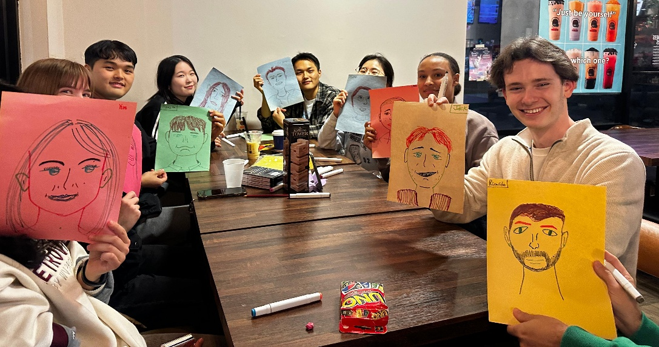
CIP Recommendations:

Get different recommendations from your LAs and CIP friends each week! This week is useful apps!

Aurora: Taboo, A fun word association game where you try to guess as many words as possible.

Elijah: Airbuds, You can see what your friends are listening to in real time and send reactions!

Kemarah: Pinterest, You can find photo inspiration for various things including recipes, outfits, or whatever else!

Lexa: Tap of War, It’s a fun easy game to play with a friend.

Paola: Snapchat, I like to see pics of what my friends are doing all day!

Sam: Shazam, Identify the music playing around you so you can save songs to your playlists that you like but don’t know yet!

Shawn: Reverso Contexto, Great app for language learning; my favorite part is that it doesn’t just translate the word you enter, it gives it to you in a sentence that actually shows you how it is used.

Tate: Finch, A self-care pet that you take care of by doing tasks to promote your mental health. So cute, fun, and helpful!

Talk to LAs and the CIP Office to learn more about their favorite apps and tell them about yours!

Welcome Spring B students!

If you see Spring B students in your classes this week, please give them a warm welcome!

CIP Weekday Activities
 | Monday, March 2nd – Coffee Talk – 6:00-8:30pm
 | Socialize with LAs and ELI friends at Enson Market! Play games, speak English, and try bubble tea, or get dinner at their cafe! You can also get some groceries and snacks if you would like to shop. Take bus 1 or 38.  The location will change each week.  Address: 3102 SW 34th St, Gainesville, FL 32608
 | Tuesday, March 3rd – Volleyball – 5:30-8:00pm
 | Play volleyball and hang out at Lexington Crossing Apartments Phase 2 Volleyball Courts with us! No experience necessary! You can also watch, socialize or play other games if you don’t want to play volleyball. Take bus 35.  Address: 3700 SW 27th St, Gainesville, FL 32608
 | Wednesday, March 4th – Depot Park Soccer and Karaoke – 6:30 – 9:00pm
 | Explore Depot Park with ELI friends every Wednesday! Play soccer, check out the restaurants and then end the night with free karaoke at the Boxcar! Meet in the grassy area in front of the Boxcar.  Address: 201 SE Depot Ave, Gainesville, FL 32601
 | Thursday, March 5th– Bragging Rights Arcade – 7:00 – 9:30pm
 | Enjoy a fun night of arcade games at Bragging Rights Arcade! After 7pm, all UF students play unlimited games for $10 (with valid UF ID). Hang out, play games, and try out some classic arcade and carnival games! Take bus 15.  Address: 113 NW 8th Ave, Gainesville, FL 32601
 | Friday, March 6th– Reitz Game Room – 6:30 – 9:00pm  Hang out with friends in the Reitz Game Room! You can go bowling, play pool, and play board games! Bring your Gator1 ID for cheaper rates. Some Fridays, the Reitz plans Gator Nights! Check out the fun themed activities they may have this week.  Address: 655 Reitz Union Drive, Gainesville, FL 32611
 | Call Tate or Paola if you have any issues finding the ELI at an activity. Their numbers can be found on the signups.

WEEKEND EVENT – Haile Market and Strawberry Picking



Saturday, March 7th - Haile Market and Strawberry Picking – 9:00am – 12:45pm

This weekend, explore the cute and quaint Haile neighborhood! Their Saturday market has plenty of homemade goods, crafts, and local produce for sale. Bring some money to spend if you would like to shop!

After the market, we will head to the Bryer Patch farm to explore and pick strawberries. Bring money to purchase strawberries you pick ($4 per pound). You can also spend extra to do various farm activities like hayrides, though it is not required. Meet at Norman Parking Garage.

You must sign up to attend this activity: Sign up here!

CIP Passport Completers

Congratulations on completing your passport and being so involved in the CIP!

Leo Delgado

Lucia Pozos

Conversation Partners (CPs)
Want to meet with a fluent English speaker and make a new friend? Sign up for a CP! If you choose to sign up, you must meet with your partner for one hour a week. It can take up to two weeks to get a partner from when you sign up. Sign up here!

Returning students, you will not automatically be paired again if you had a CP last semester. Please make sure to sign up again here for the Spring semester if you did not request a /spring partner in your end of term evaluation from last semester.
Please email Elijah at conversationpartners@eli.ufl.edu for any issues, questions or concerns or visit him in the CIP Office during office hours.

CIP Passports
Don’t forget to get your CIP Passport hole punched from the activity leaders at the event (not after). We don’t hole punch passports after the event. Redeem your completed passport for a small gift, a photo for the ELI Instagram, and your name published in the ELI weekly! | 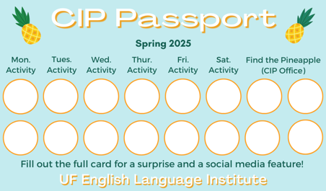

Need a new CIP Passport? Stop by the CIP Office.

Find the Pineapple
Remember the CIP Pineapple is hidden in a new place every Monday in the CIP office. Stop by and find it for hole punches!
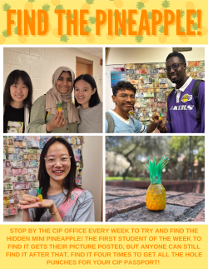

Notes from the Office
Time Change: Daylight Savings Time begins on Sunday, March 8th at 2am. This means we set the clocks ahead one hour, resulting in later sunrises and sunsets. Your cell phone and most other digital devices will automatically make this change.
UF Federal Tax forms for International Students: Were you in the U.S. in 2025 on an F or V visa? If yes, you have a responsibility to file tax forms with the U.S. Internal Revenue Service (IRS). Tax forms are due on April 15th this year. They are filed for the previous calendar year, which in this case is 2025.
You must provide required tax forms even if you did not earn any money in the U.S. in 2025. All F and J visa students (including dependents) who were in the US last year must submit IRS form 8843. You can get the form 8843 from the ELI main office.
You cannot submit this document electronically. You must physically mail it to this address by April 15th:
Department of the Treasury
Internal Revenue Service Center
Austin, TX 73301-0215
Because you are at UF and have an active Gatorlink, you have free access to Sprintax, a web-based tax preparation software designed for non-resident aliens, including international students, scholars, and visa holders in the U.S. Sprintax can help with filling in form 8843, but you will need to print and mail the document yourself. Contact Daryl or Christine to receive:
- the UF student Sprintax link
- help filling out form 8843
- information about how to mail form 8843 to the IRS address in Texas
If you had on-campus employment in 2025 as an international student, you will receive a form from your employer reporting your income and tax withholdings called a W-2. Because you earned reportable income, you must submit a federal tax return to file your W-2. Talk to Daryl if you had on-campus employment last year and have questions about filling your taxes.

Birthdays!
Students |  | Staff
Yeonwoo Shin, March 3 |  | None this week!
 | 

US Culture:

Q: What could I do for spring break if I don’t like the beach?

A: If you don’t like the beach, there’s still plenty to do during spring break! You could visit the beautiful city of Savannah, Georgia or travel up to the Blue Ridge Mountains. You could even have a stay-cation and enjoy Gainesville while it empties out for the week!

Joke of the Week

Q: How does a penguin build its house?
A: Igloos it together!


Student Voices
 | Every semester, we have amazing student writers, so we take your writing and publish it in an online collection called Student Voices. In past semesters, students have written paragraphs, essays, creative stories, recipes, letters, obituaries, poetry, and more. You can see past editions of Student Voices (https://eli.ufl.edu/news-publications/, scroll to the bottom of the page) for inspiration.

We encourage you to submit anything of your work that you wish to see published. It can be from any class or something you have written on your own but ask your teachers for help editing! You can email it to Olga Moody (omoody@ufl.edu) or to your teacher. Please include your name and class on your submission. The deadline for submissions is Friday, March 27th.

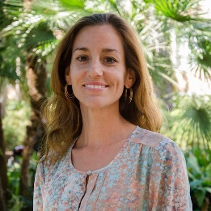 | I need students, LAs, instructors, staff, and administrators to help me write the Weekly!  - Write a paragraph about your experiences this semester. You could write about an ELI activity, a Gainesville event, a fabulous local restaurant, or tell us about a place or event in your country that we should visit.  - You could also ask me to write about a topic that you are curious about  - Send me grammar questions for me to put in the Weekly.  - Send me manners and culture questions for me to put in the Weekly.  - Send me jokes to put in the Weekly.

Send your paragraphs and/or questions to Jen Ramos (jenramos@ufl.edu) Use the subject heading: ELI Weekly.

