The ELI Weekly

St. Augustine, Florida: the Oldest City in the United States!

On April 4th, ELI students have the opportunity to visit the beautiful coastal city of St. Augustine, FL! This historic city is a favorite for visitors for a variety of reasons: its beaches, colonial architecture, rich history, cultural heritage, great restaurants, shopping, and all around good vibes!

Do you want to know a little more about St. Augustine before you visit? Here is a short history:

St. Augustine is the oldest, continuously inhabited settlement in the United States. On September 8, 1565, the Catholic feast day of St. Augustine, Pedro Menéndez de Avilés claimed St. Augustine for the Spanish crown, and it remained a base for the Spanish military and Catholic missionaries for 200 years, after which it was conquered by the British. With Britain in charge, nearly all Spanish residents and soldiers evacuated to Cuba.

British rule of St. Augustine lasted only 20 years, from 1763 to 1783, but many changes occurred during this time. The British established plantations, declared Protestantism the official religion, and divided the Florida territory into two parts: East Florida, with St. Augustine as the capital, and West Florida, with Pensacola as the capital. When the American Revolutionary War broke out, British loyalists in the 13 colonies fled to St. Augustine.

After the American colonies defeated the British, St. Augustine returned to Spanish control. However, Spain ceded St. Augustine to the United States in 1819, as part of a treaty that allowed Spain to maintain control over Texas.

During the American civil war, St. Augustine was the only city in the southern United States to order an immediate release of all slaves when Abraham Lincoln signed the Emancipation Proclamation. All slaves in St. Augustine became free citizens and established a community known as Lincolnville, in honor of Abraham Lincoln. Lincolnville became became a central site for the Civil Rights Movement in the 1960s.

Today, St. Augustine is popular tourist spot, which combines its fascinating history with its natural beauty.

CIP Photo of the Week: Depot Park

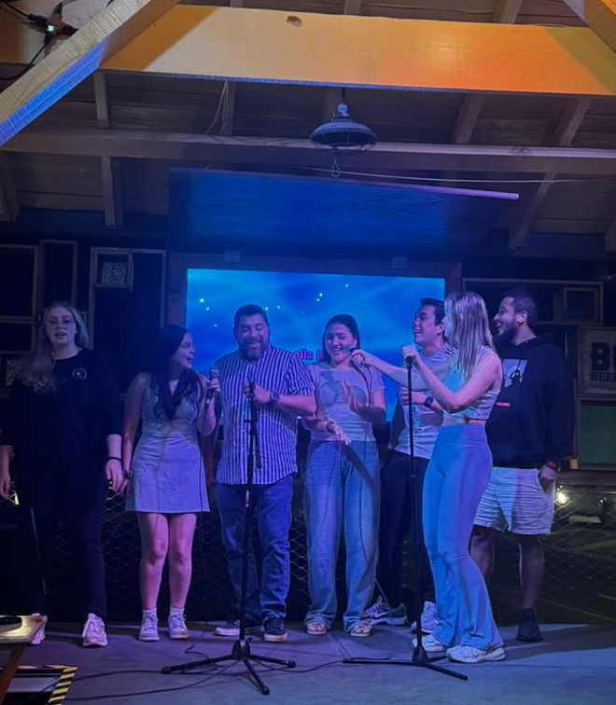
CIP Recommendations:
Get different recommendations from your LAs and CIP friends each week! This week is places to visit on a short road trip!

Road Trip Weekend Getaways

Aurora: St. Augustine – The oldest city in the US! It is walkable, historic, and has beautiful buildings. And the beach is a plus!

Elijah: Destin – Beautiful beaches, CLEAR and warm water and nice little shops. Make sure to visit Rosemary Beach for some European town vibes.

Kemarah: Fort Lauderdale, FL – Sunshine, beaches, good food, and plenty of spots to take pictures!

Lexa: Tarpon Springs, FL- Great if you want to eat good Greek food, shop, and walk around the piers!

Paola: St. Pete, FL – Beach and city vibes. The perfect mix!

Sam: Sarasota, FL – Home to the amazing Ringling art museum, close to a lot of beaches, and has some great shopping areas like St. Armands and the UTC Mall.

Shawn: Key West, FL – Beautiful beaches, fresh foods, and the southernmost point in the continental United States! Key west is a Florida must, don’t forget to try some Key Lime Pie there.

Tate: Savannah, GA – So cute and walkable. It has great architecture, awesome restaurants, and beautiful plazas and streets with lots of trees. And it is only 3.5 hours away!

CIP Weekday Activities
 | Monday, March 23rd – Coffee Talk – 6:00-8:30pm
 | Socialize with LAs and ELI friends at Kava Gator! Play games, speak English, and get coffee, or get dinner in downtown! Take bus 1 or 5.  The location will change each week.  Address: 185 E University Ave, Gainesville, FL 32601
 | Tuesday, March 24th – Volleyball – 6:30-9:00pm
 | Play volleyball and hang out at Lexington Crossing Apartments Phase 2 Volleyball Courts with us! No experience necessary! You can also watch, socialize or play other games if you don’t want to play volleyball. Take bus 35.  Address: 3700 SW 27th St, Gainesville, FL 32608
 | Wednesday, March 25th – Depot Park Soccer and Karaoke – 6:30 – 9:00pm
 | Explore Depot Park with ELI friends every Wednesday! Play soccer, check out the restaurants and then end the night with free karaoke at the Boxcar! Meet in the grassy area in front of the Boxcar.  Address: 201 SE Depot Ave, Gainesville, FL 32601
 | Thursday, March 26th– Gator Salsa – 6:30 – 9:00pm
 | Take salsa lessons in downtown Gainesville! Learn how to dance salsa and bachata in a free beginner, intermediate, or advanced class. Then, at the end, enjoy open dancing! Meet outside the Bull downtown. Bring comfortable shoes. No experience necessary. Take bus 1 or 5.  Address: 220 NW 8th Ave #20, Gainesville, FL 32601
 | Friday, March 27th– Reitz Game Room – 6:30 – 9:00pm  Hang out with friends in the Reitz Game Room! You can go bowling, play pool, and play board games! Bring your Gator1 ID for cheaper rates. Some Fridays, the Reitz plans Gator Nights! Check out the fun themed activities they may have this week.  Address: 655 Reitz Union Drive, Gainesville, FL 32611
 | Call Tate or Paola if you have any issues finding the ELI at an activity. Their numbers can be found on the signups.

WEEKEND EVENT – Gilchrist Blue Springs



Saturday, March 28th – Gilchrist Blue Springs – 8:15am to 1:00pm

Swim in Florida’s crystal blue spring water at Gilchrist Blue Springs State Park and experience some of Florida’s most famous nature! Have a swim, go on a nature walk, and enjoy the scenery with your friends! Bring your bathing suit, sunscreen, a towel, water, and a packed lunch! There are very few options for purchasing food at the location. Meet at Norman Parking Garage. Please be on time. During this season, parks often hit capacity and close to additional guests when that happens. It is important that we are there very early to ensure we get in.

You must sign up to attend. Sign up here!

Selling 4/4 St. Augustine Trip Tickets

Spend a full day with the ELI exploring St. Augustine on April 4th! We will spend time at the beautiful beach before heading to the historic town of St. Augustine. Expect a full day of fun and sun! Tickets for transportation are 25 dollars exact cash on sale now from Tate in the CIP office Monday through Thursday from 9am to 1pm. Get your tickets before spaces sell out. Space is limited!

Conversation Partners (CPs)
Want to meet with a fluent English speaker and make a new friend? Sign up for a CP! If you choose to sign up, you must meet with your partner for one hour a week. It can take up to two weeks to get a partner from when you sign up. Sign up here!

Returning students, you will not automatically be paired again if you had a CP last semester. Please make sure to sign up again here for the Spring semester if you did not request a /spring partner in your end of term evaluation from last semester.
Please email Elijah at conversationpartners@eli.ufl.edu for any issues, questions or concerns or visit him in the CIP Office during office hours.

CIP Passports
Don’t forget to get your CIP Passport hole punched from the activity leaders at the event (not after). We don’t hole punch passports after the event. Redeem your completed passport for a small gift, a photo for the ELI Instagram, and your name published in the ELI weekly! | 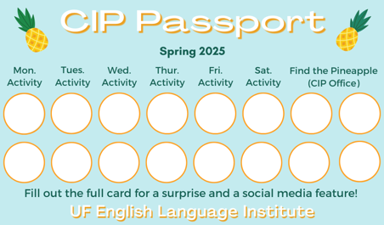

Need a new CIP Passport? Stop by the CIP Office.

Find the Pineapple
Remember the CIP Pineapple is hidden in a new place every Monday in the CIP office. Stop by and find it for hole punches!
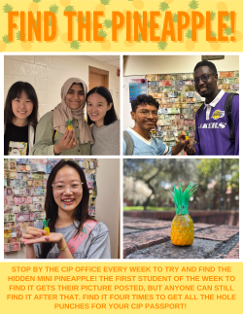

Notes from the Office

We Need Volunteer for ELI Promo Videos: Do you want to be a social media star? The ELI is looking for students to appear in videos on our YouTube channel and Instagram page. You will meet with Christine to film a 15-20 minute interview talking about your experience in Gainesville and at the ELI. If you are interested or have questions, please talk to Christine (christinevoigt@ufl.edu).

People Out: Daryl will be out from March 24th-27th. Christine will be out March 27th.
UF Federal Tax forms for International Students: Were you in the U.S. in 2025 on an F or V visa? If yes, you have a responsibility to file tax forms with the U.S. Internal Revenue Service (IRS). Tax forms are due on April 15th this year. They are filed for the previous calendar year, which in this case is 2025.
You must provide required tax forms even if you did not earn any money in the U.S. in 2025. All F and J visa students (including dependents) who were in the US last year must submit IRS form 8843. You can get the form 8843 from the ELI main office.
You cannot submit this document electronically. You must physically mail it to this address by April 15th:
Department of the Treasury
Internal Revenue Service Center
Austin, TX 73301-0215
Because you are at UF and have an active Gatorlink, you have free access to Sprintax, a web-based tax preparation software designed for non-resident aliens, including international students, scholars, and visa holders in the U.S. Sprintax can help with filling in form 8843, but you will need to print and mail the document yourself. Contact Daryl or Christine to receive:
- the UF student Sprintax link
- help filling out form 8843
- information about how to mail form 8843 to the IRS address in Texas
If you had on-campus employment in 2025 as an international student, you will receive a form from your employer reporting your income and tax withholdings called a W-2. Because you earned reportable income, you must submit a federal tax return to file your W-2. Talk to Daryl if you had on-campus employment last year and have questions about filling your taxes.

Birthdays!
Students |  | Staff
Bruno Barron Vilar, March 24 |  | None this week!
Hugues Louis Jacques, March 30 | 

Grammar:

Q: Which one is correct: I am good or I am well.

A: Great question! Both sentences could technically be correct. Remember, that the verb be is modified by an adjective, rather than an adverb. So, that’s why you can say I am good. You could say I am tired. Or I am happy. All adjectives.

Well can also be an adjective, meaning healthy, not sick. So, if you say I am well, you are saying, I am not sick.

Joke of the Week

Q: Why are fish so smart?
A: Because they swim in schools!
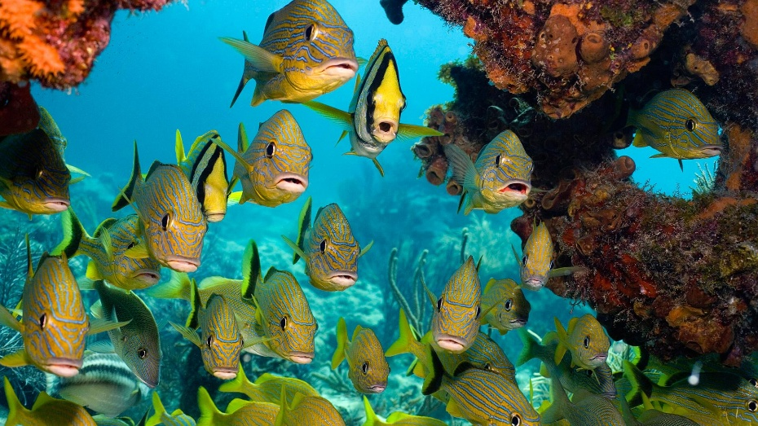

Student Voices
 | Every semester, we have amazing student writers, so we take your writing and publish it in an online collection called Student Voices. In past semesters, students have written paragraphs, essays, creative stories, recipes, letters, obituaries, poetry, and more. You can see past editions of Student Voices (https://eli.ufl.edu/news-publications/, scroll to the bottom of the page) for inspiration.

We encourage you to submit anything of your work that you wish to see published. It can be from any class or something you have written on your own but ask your teachers for help editing! You can email it to Olga Moody (omoody@ufl.edu) or to your teacher. Please include your name and class on your submission. The deadline for submissions is Friday, March 27th.

 | I need students, LAs, instructors, staff, and administrators to help me write the Weekly!  - Write a paragraph about your experiences this semester. You could write about an ELI activity, a Gainesville event, a fabulous local restaurant, or tell us about a place or event in your country that we should visit.  - You could also ask me to write about a topic that you are curious about  - Send me grammar questions for me to put in the Weekly.  - Send me manners and culture questions for me to put in the Weekly.  - Send me jokes to put in the Weekly.

Send your paragraphs and/or questions to Jen Ramos (jenramos@ufl.edu) Use the subject heading: ELI Weekly.

