The ELI Weekly

Falling Caterpillars

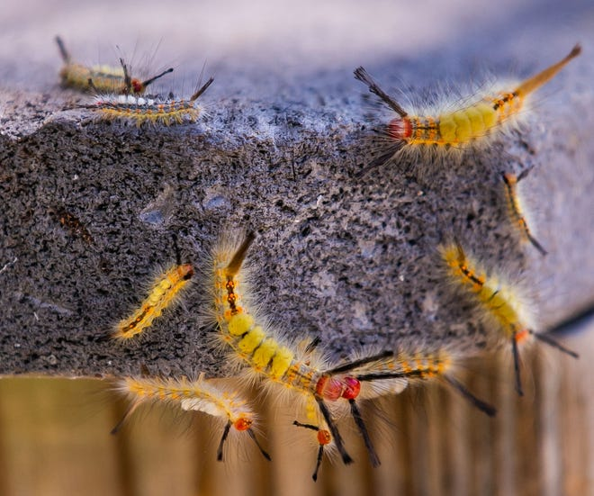
You may have noticed these caterpillars everywhere lately—on the sidewalk, buildings, tree trunks, and even falling from trees! These furry little creatures are tussock moth caterpillars, and though they may look like pests, they are actually an important part of the local ecosystem.

The influx of tussock moth caterpillars you are seeing everywhere on campus these days is a natural seasonal occurrence. The caterpillars feed on the soft spring leaves of oak trees. In April, they will make cocoons and emerge as moths a few weeks later.

Birds, lizards and insects rely on tussock moth caterpillars as a food source and their presence is part of the natural balance of Florida’s environment. These caterpillars are not poisonous, but they can irritate the skin if you come in contact with them. So, for now, watch out for falling caterpillars!

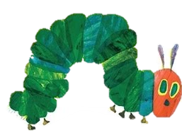

CIP Photo of the Week: Coffee Talk
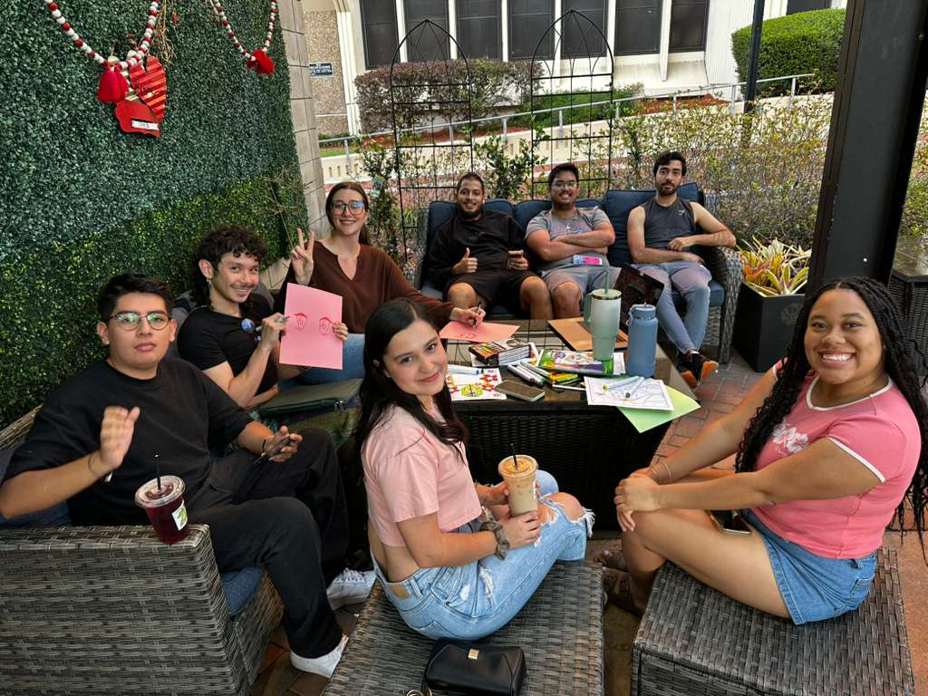

CIP Recommendations:

CIP Team Recommendations

Get different recommendations from your LAs and CIP friends each week! This week is hobbies!

Hobbies

Aurora: Reading and crocheting

Elijah: Karaoke and roller skating

Kemarah: Journaling and nail art

Lexa: Dancing and looking up flights I won’t take

Paola: Duolingo and making pasta from scratch

Sam: Yoga and taking pictures of flowers

Shawn: Cooking and planning events

Tate: Mixing music and bird watching

Talk to LAs and the CIP Office to learn more about their favorite hobbies and tell them about yours!

CIP Weekday Activities
 | Monday, March 30 th – Coffee Talk – 6:00 – 8:30pm
 | Socialize with LAs and ELI friends at Le Macaron in Celebration Pointe! Play games, speak English, and get coffee, or get dinner and explore nearby shops! Take bus 75.  The location will change each week.  Address: 4949 Celebration Pointe Ave Suite 80, Gainesville, FL 32608
 | Tuesday, March 31 st – Volleyball – 6:30 – 9:00pm
 | Play volleyball and hang out at Lexington Crossing Apartments Phase 2 Volleyball Courts with us! No experience necessary! You can also watch, socialize or play other games if you don’t want to play volleyball. Take bus 35.  Address: 3700 SW 27th St, Gainesville, FL 32608
 | Wednesday, April 1st – Satchel’s Pizza – 6:00 – 9:00pm
 | Check out this iconic pizza restaurant filled with amazing recycled art! Shop at their super fun gift shop and try some delicious pizza. Explore the garden in the back and even sit in mini airplane! It is open mic night so you can watch people perform music and other art, and you can also perform if you would like to! Try to come right at six so we can reserve some good tables before it gets crowded. Meet in the BACK entrance of Satchel’s Pizza (called Lightning Salvage). Take bus 15 or a rideshare. Bring money to spend on food or shopping in the store.  Address: 1800 NE 23rd Ave, Gainesville, FL 32609
 | Thursday, April 2nd – Depot Park – 6:30 – 9:00pm
 | Explore Depot Park with ELI friends. See if you can find gators in the lake, throw around the frisbee, start a game of soccer, get burgers at Goldie’s, or walk the trail with friends and sunset! Meet in the grassy area in front of the Boxcar.  Address: 201 SE Depot Ave, Gainesville, FL 32601
 | Friday, April 3rd – Reitz Game Room – 6:30 – 9:00pm  Hang out with friends in the Reitz Game Room! You can go bowling, play pool, and play board games! Bring your Gator1 ID for cheaper rates. Some Fridays, the Reitz plans Gator Nights! Check out the fun themed activities they may have this week.  Address: 655 Reitz Union Drive, Gainesville, FL 32611
 | Call Tate or Paola if you have any issues finding the ELI at an activity. Their numbers can be found on the signups.

WEEKEND EVENT – St. Augustine Trip


Saturday, April 4th – St. Augustine Beach and Town – 8:15am to 9:15pm
This Photo by Unknown Author is licensed under CC BY-NC-ND
Spend a full day with the ELI exploring St. Augustine! We will spend time at the beautiful beach before heading to the historic town of St. Augustine, the oldest city in the United States! Expect a full day of fun and sun! Please read all the information below:
Tickets and Self-Drivers
Tickets are sold out but come talk to Tate if you are still interested in attending. If you find a ride with someone else, please offer to pay them 25 dollars because that is around how much it will cost for mileage and parking per person. If you are a self-driver or plan on riding with someone else, please email or text Tate so she knows to expect you on the trip! Make sure to follow the ELI schedule listed below.

What to Bring
- Bathing suit (It is suggested to wear your suit under your clothes to save time changing when we arrive at the beach. We have a tight schedule and bathroom space is limited. In the past, students have felt that waiting in lines at the bathrooms took too much of their time.)
- Sunscreen
- Towel
- Packed lunch and snacks
- Sports balls/games/beach supplies you might like to have on the beach
- Water
- A change of clothes (for walking around the town)
- An umbrella (just in case if it rains)
- Money for dinner and shopping

April 4th St. Austine Trip Schedule
Make sure to follow this schedule. It is subject to change. If anything changes on the day of the activity, your trip LA or Tate will let you know.
8:15am – Meet at Norman Parking Garage – DO NOT BE LATE
10:30am – Arrive to Anastasia State Park Beach (1340 Jimmy Buffett Mem Hwy, St. Augustine, FL 32080)
For self-drivers: Park in the lot near the Island Beach Shop and Grill and use that beach access. Entry to the state park is 8 dollars per car.
2:00pm - Change, rinse off, and gather things to leave.
2:30pm – Leave beach for St Augustine Old Town (1 Cordova St, St. Augustine, FL 32084).
For self-drivers: This is the Historic Downtown Parking Facility. Parking is 20 dollars.
3:00pm – Arrive to Old Town
GET DINNER DURING THIS TIME
7:30pm – Leave Old Town to return to Norman Hall – Return to Parking Garage at this time. Do not be late.
9:15pm – Arrive to Norman Parking Garage – Please arrange for a ride home at this time.

Phone Numbers
Tate’s phone number if you are lost or need help: 727-249-6021
Make sure to save the phone number of the LA you are riding with into your phone at Norman before we leave. It is easy to get separated when exploring the town.

Conversation Partners (CPs)
Want to meet with a fluent English speaker and make a new friend? Sign up for a CP! If you choose to sign up, you must meet with your partner for one hour a week. It can take up to two weeks to get a partner from when you sign up. Sign up here!

Returning students, you will not automatically be paired again if you had a CP last semester. Please make sure to sign up again here for the Fall semester if you did not request a Fall partner in your end of term evaluation from last semester.
Please email Elijah at conversationpartners@eli.ufl.edu for any issues, questions or concerns or visit her in the CIP Office during office hours.

CIP Passports
Don’t forget to get your CIP Passport hole punched from the activity leaders at the event (not after). We don’t hole punch passports after the event. Redeem your completed passport for a small gift, a photo for the ELI Instagram, and your name published in the ELI weekly! | 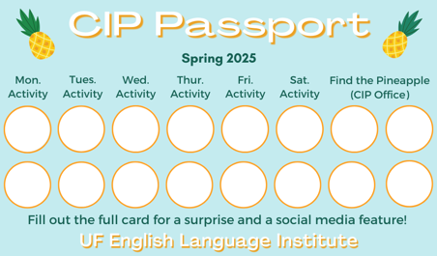

Need a new CIP Passport? Stop by the CIP Office.

Find the Pineapple
Remember the CIP Pineapple is hidden in a new place every Monday in the CIP office. Stop by and find it for hole punches!
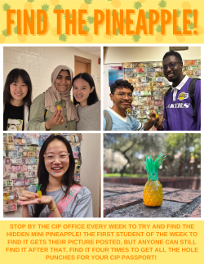

Notes from the Office
College Workshop: Representatives from the Santa Fe College and the College of Central Florida will speak to ELI students on Thursday, April 2nd, at 3:00pm in Matherly Hall, room 214. This is great opportunity to learn about each school's admission policies and deadlines, student services, and degree programs. If you are thinking about attending Santa Fe College or the College of Central Florida, this is a great opportunity to get information and meet their International Student Services team.
Teacher Workday: Friday, April 3rd is an ELI Instructor Workday. There are no ELI classes and the ELI main office will be closed.
ELI Commencement Ceremony: The ELI Commencement Ceremony will be held on Friday, April 24th at 10am. During the Ceremony, we will announce student awards, recognize the ELI scholarship recipients, and watch a slide show of this semester’s CIP activities. It is a great opportunity to celebrate the end of the semester with your friends, LAs, and teachers. Please plan on attending!

We Need Volunteer for ELI Promo Videos: Do you want to be a social media star? The ELI is looking for students to appear in videos on our YouTube channel and Instagram page. You will meet with Christine to film a 15-20 minute interview talking about your experience in Gainesville and at the ELI. If you are interested or have questions, please talk to Christine (christinevoigt@ufl.edu).
Summer Semester Dates: Summer C classes begin May 18th and end on August 7th. Summer break is June 22nd to June 26th. Returning students must check-in online between May 4th and May 8th. Schedules for returning students will be available on Friday, May 15th and the Welcome Picnic is Saturday, May 16th. Students with government or university scholarships will need to provide a new financial guarantee by Wednesday, May 20th.

Birthdays!
Students |  | Staff
None this week! |  | Shawn Kapersaud | April 3
 | 

Grammar:

Q: When I said, “I slept early last night,” people didn’t understand me. Why not?

We would normally use verb phrases like go to sleep, go to bed or fall asleep for this situation. You can say, for example, I went to sleep early last night. People will definitely understand this!

Joke of the Week

Q: What did the new spring rose say to the other spring rose?
A: Hey, Bud!


Student Voices
 | Good news! The deadline to submit your writing to Student Voices has been extended to Tuesday, April 7th. You can email it to Olga Moody (omoody@ufl.edu) or to your teacher. Please include your name and class on your submission.

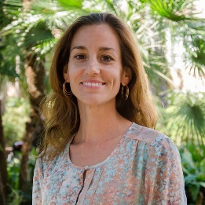 | I need students, LAs, instructors, staff, and administrators to help me write the Weekly!  - Write a paragraph about your experiences this semester. You could write about an ELI activity, a Gainesville event, a fabulous local restaurant, or tell us about a place or event in your country that we should visit.  - You could also ask me to write about a topic that you are curious about  - Send me grammar questions for me to put in the Weekly.  - Send me manners and culture questions for me to put in the Weekly.  - Send me jokes to put in the Weekly.

Send your paragraphs and/or questions to Jen Ramos (jenramos@ufl.edu) Use the subject heading: ELI Weekly.

