The ELI Weekly

ELI at the Florida International Leadership Conference (FILC)

By Christine Voigt

ELI at the Florida International Leadership Conference (FILC)
On March 27-29, Tate and I had the amazing opportunity to take three ELI students to attend the 2026 Florida International Leadership Conference (FILC) in Fruitland Park, FL. FILC is a chance for students from all universities in Florida to participate in conference sessions and trainings about international leadership, as well as have fun experiences like bonfires, karaoke, a “Glow in the Dark” dance, and other camp-style activities. It was a great time!

Zennure Arga wrote the following about her experience:

Attending FILC was an incredible experience. The campsite setting made the learning process both fun and relaxing, far from a traditional classroom feel. Every activity was thoughtfully designed to improve our leadership skills, teaching me the importance of teamwork and cultural adaptability. It was a perfect balance of education and enjoyment.

In addition to the fun and learning, all of the students from the ELI participated in the Elevator Pitch contest, where they had to present a 1-minute speech in front of all 140 people who attended the conference. This is something that is difficult to do in your primary language, but they did in English and all did an absolutely amazing job!

I couldn’t be more proud of Zennure, Ildemar, and Silvano for being open to the experience and showing other Forida universities how amazing ELI students are.

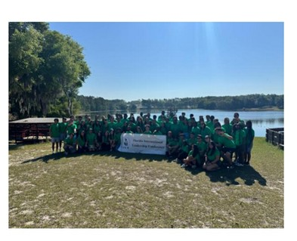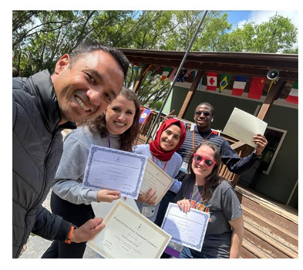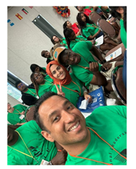

CIP Photo of the Week: Coffee Talk
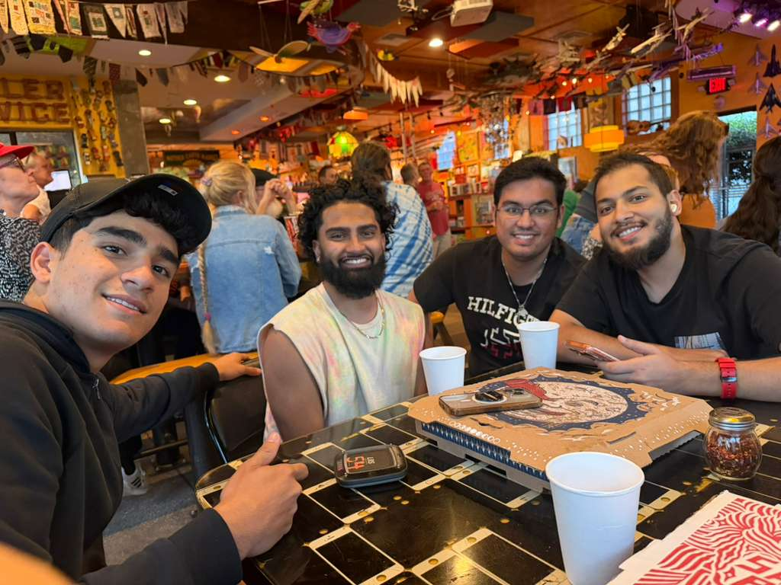
CIP Recommendations:

Get different recommendations from your LAs and CIP friends each week! This week is favorite slang words!

Slang WordsAurora: Ate - Meaning you did something really great or cool or did something really well.

Elijah: Gag - It is like surprise / joy of some sorts — like "omg gag i didn’t know u were an olympic medalist."

Kemarah: Shawty: An affectionate term for close friends or partner.

Lexa: Glorble - When something is so global and cool, like the word exotic but more positive.

Paola: Bruh - It has the same function as using “bro,” “dude,” and even “seriously?” depending on your tone!

Sam: Slay - It basically has the same meaning as "awesome" or "doing really well at something."

Shawn: Fwe - It has the same meaning as saying “that’s fire," which means really awesome/cool/amazing.

Tate: Unc - It means someone is old or acting old. It comes from the word "uncle."

Talk to LAs and the CIP Office to learn more about their favorite slang words and tell them about yours or teach them one from your own language!

CIP Weekday Activities
Monday, April 6th – Coffee Talk – 5:30 – 8:00pm
*New Time this week only
 | Socialize with LAs and ELI friends at Sweetberries! Play games, speak English, and get coffee, or get dinner in downtown! Take bus 10 or 5.  The location will change each week.  Address: 619 NW 5th Ave, Gainesville, FL 32601
 | Tuesday, April 7th – Volleyball – 6:30 – 9:00pm
 | Play volleyball and hang out at Lexington Crossing Apartments Phase 2 Volleyball Courts with us! No experience necessary! You can also watch, socialize or play other games if you don’t want to play volleyball. Take bus 35.  Address: 3700 SW 27th St, Gainesville, FL 32608
 | Wednesday, April 8th – Depot Park – 7:00 – 9:30pm *New time
 | Explore Depot Park with ELI friends. See if you can find gators in the lake, throw around the frisbee, start a game of soccer, get burgers at Goldie’s, or walk the trail with friends and sunset! Meet in the grassy area in front of the Boxcar.  Address: 201 SE Depot Ave, Gainesville, FL 32601
 | Thursday, April 9th – No Activity
 | We have removed Game Room as an activity due to lack of student interest
 | Friday, April 10th – Rotating Activity: One Love Café Live Music – 5:30 – 8:00pm  Come socialize with friends at One Love Cafe where you can enjoy their outdoor patio, order food, and listen to live music! You can also walk around the areas shops and restaurants or play games outdoor games. Take bus 43.  Address: 4989 Northwest 40th Place, Gainesville, FL 32606
 | Call Tate or Paola if you have any issues finding the ELI at an activity. Their numbers can be found on the signups.

WEEKEND EVENT – No Weekend Trip

Study for finals!


Conversation Partners (CPs)
Want to meet with a fluent English speaker and make a new friend? Sign up for a CP! If you choose to sign up, you must meet with your partner for one hour a week. It can take up to two weeks to get a partner from when you sign up. Sign up here!

Returning students, you will not automatically be paired again if you had a CP last semester. Please make sure to sign up again here for the Fall semester if you did not request a Fall partner in your end of term evaluation from last semester.
Please email Elijah at conversationpartners@eli.ufl.edu for any issues, questions or concerns or visit her in the CIP Office during office hours.

CIP Passports
Don’t forget to get your CIP Passport hole punched from the activity leaders at the event (not after). We don’t hole punch passports after the event. Redeem your completed passport for a small gift, a photo for the ELI Instagram, and your name published in the ELI weekly! | 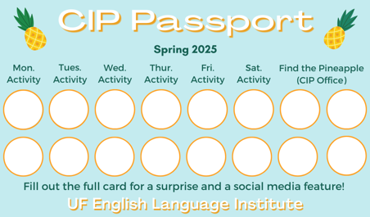

Need a new CIP Passport? Stop by the CIP Office.

CIP Passport Completers

Congratulations on completing your passport and being so involved in the CIP!


Silvano Tandela

Fahad Sumait

AD Murshid

Find the Pineapple
Remember the CIP Pineapple is hidden in a new place every Monday in the CIP office. Stop by and find it for hole punches!
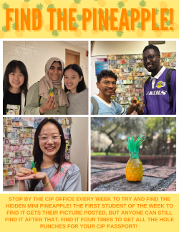

Notes from the Office
EOT Evaluations: Soon we will be doing our final course evaluations. This is your opportunity to provide feedback for how the class went this semester. Please go to this link https://bit.ly/4048gmH to review the evaluations so that you know how to fill them out when they are distributed in class. ELI administrators will review them and share the results with your teachers and Language Assistants to help them plan the class for next semester.
Apartment Leases: As the semester draws to a close, keep in mind that your lease might be ending soon. It is important to know the exact date that your apartment lease ends so you can make plans. If you’re not sure when it ends, ask your apartment office. If you need help finding a hotel to stay in short-term (you should ask your friends first!), someone to take over your lease, or a new apartment, talk to Christine in Matherly 223.

Check your I20s: If your I-20 is expiring soon, make an appointment with Daryl in MAT 223 to renew your I-20 before it expires.

We Need Volunteer for ELI Promo Videos: Do you want to be a social media star? The ELI is looking for students to appear in videos on our YouTube channel and Instagram page. You will meet with Christine to film a 15-20 minute interview talking about your experience in Gainesville and at the ELI. If you are interested or have questions, please talk to Christine (christinevoigt@ufl.edu).
ELI Class Photo: On Tuesday, April 7, we will be taking a group photo of everyone at the ELI at the bronze Gator sculpture outside the Southwest entrance of Matherly Hall. The sculpture is known as Gator Ubiquity (see photo). Your Listening/Speaking teachers or LAs will walk you over there between the two L/S periods on Thursday. If it rains, we will take the photo on Thursday, April 9.

Birthdays!
Students |  | Staff
Jaehyung Lee | April 11 | Emily Szydlowski | April 8
 |  | Thomas Dolce | April 12
 | 

Culture:

Q: Does English have any wise sayings like we do in my language?

Yes, wise sayings in English might be called a proverb, an aphorism, or adage.

Here’s one: A bird in the hand is worth two in the bush.

What do you think that means?

Joke of the Week

Q: What does a house wear?
A: Adress!


Student Voices
 | Good news! The deadline to submit your writing to Student Voices has been extended to Tuesday, April 7th. You can email it to Olga Moody (omoody@ufl.edu) or to your teacher. Please include your name and class on your submission.

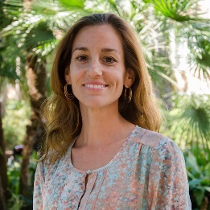 | Time is running out to get your writing published in the ELI Weekly! You can contribute to one of the last ELI Weekly editions by sending any of the following:  - Write a paragraph about your experiences this semester. You could write about an ELI activity, a Gainesville event, a fabulous local restaurant, or tell us about a place or event in your country that we should visit.  - You could also ask me to write about a topic that you are curious about  - Send me grammar questions for me to put in the Weekly.  - Send me manners and culture questions for me to put in the Weekly.  - Send me jokes to put in the Weekly.

Send your paragraphs and/or questions to Jen Ramos (jenramos@ufl.edu) Use the subject heading: ELI Weekly.

