The ELI Weekly

Happy Retirement to Todd!

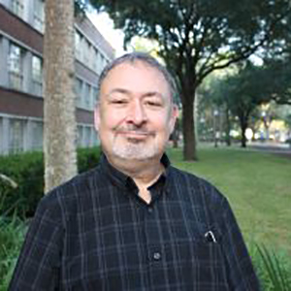
Please help us say goodbye to and congratulate ELI teacher and Associate Instructional Professor Todd Allen! Todd is retiring at the end of this semester after teaching at the UF ELI for over 30 years!!!!

Todd has been faculty at the ELI longer than anyone else at the ELI right now, including longer than Director Megan Forbes and Associate Director Patricia Moon! In addition to teaching every course at the ELI, Todd has served as ELI Grammar Coordinator, Listening/Speaking Coordinator, Reading/Writing Coordinator, TOEFL Coordinator, Accreditation Self-Study Co-Coordinator, and has chaired multiple ELI search committees. He was also the Editor of the ELI Weekly for over 15 years.

In the field of teaching English language, Todd has served as a CEA Accreditation Site Reviewer, visiting 20 different English language programs in the United States, served on the US Fulbright National Screening Committee, and has presented at over a dozen state, regional, national, and international conferences.

Please help us thank Todd for his decades of service and congratulate him on his well-deserved retirement!!!

Quick Quiz:

Which of the following were invented *after* Todd Allen started teaching at the ELI?

- MP3 players
- Google
- PlayStation
- The Internet
- iPod
- Phone Cameras
- Fire

ELI Scholarship Winners



The winners of the ELI Scholarships this semester are the following:

- Vasile Scutaru - JAYNE C. HARDER MEMORIAL SCHOLARSHIP
- Tiffany Salazar- J.C. CASAGRANDE PEACE SCHOLARSHIP
- Veronica Marinelli - 1st RUNNER UP

Thank you to the nominating teachers and LAs, and the members of the scholarship committee this semester (Daryl Bish, Megan Forbes, Patrick Klager, Patricia Moon Tapper, and Tate Quinones).

Please congratulate the winners and nominees if you see them!

CIP Photo of the Week: Coffee Talk
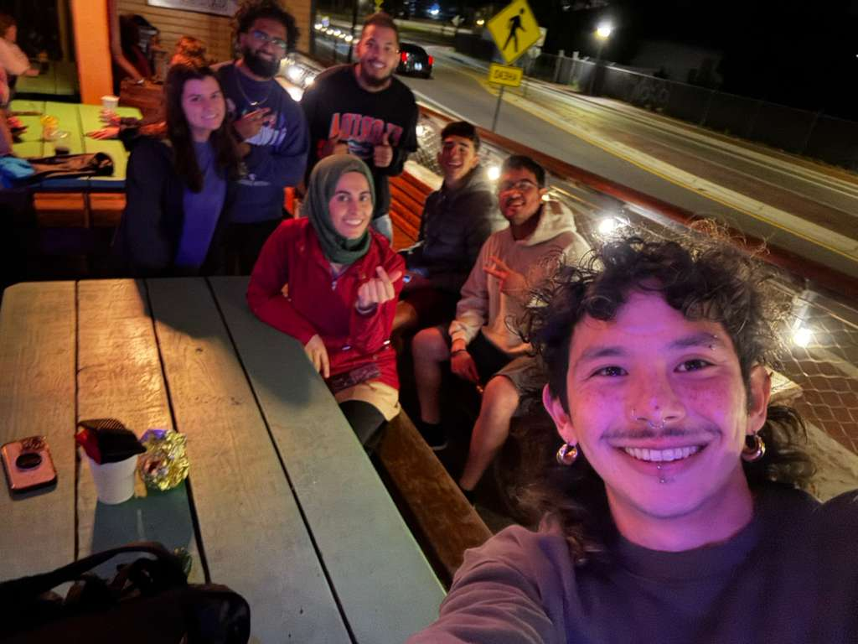

CIP Weekday Activities
 | Monday, April 13th – Coffee Talk – 6:00 – 8:00pm
 | Socialize with LAs and ELI friends at Mochiry! Play games, speak English, and get coffee/tea/donuts, or get dinner! Take bus 10 or 5.  The location will change each week.  Address: 3822 Newberry Rd Suite D, Gainesville, FL 32607
 | Tuesday, April 14th – Volleyball – 6:30 – 9:00pm
 | Play volleyball and hang out at Lexington Crossing Apartments Phase 2 Volleyball Courts with us! No experience necessary! You can also watch, socialize or play other games if you don’t want to play volleyball. Take bus 35.  Address: 3700 SW 27th St, Gainesville, FL 32608
 | Wednesday, April 15th – Depot Park – 7:00 – 9:30pm
 | Explore Depot Park with ELI friends. See if you can find gators in the lake, throw around the frisbee, start a game of soccer, get burgers at Goldie’s, or walk the trail with friends and sunset! Meet in the grassy area in front of the Boxcar.  Address: 201 SE Depot Ave, Gainesville, FL 32601
 | Thursday, April 16th - Rotating Activity: Cabana Beach Pool Party – 5:30 – 8:00pm
Hang out with ELI friends at the pool for our last weekday activity! Swim, play water sports, and enjoy Cabana Beach Apartment's outdoor space and super fun pool!
Address: 1601 SW 51st Terrace, Gainesville, FL 32607

 | Friday, April 17th – No Activity
 | Call Tate or Paola if you have any issues finding the ELI at an activity. Their numbers can be found on the signups.

WEEKEND EVENT – End of Semester BBQ!

Saturday, April 18th- End of Semester BBQ - 11:45am - 4:00pm

All are welcome to celebrate the end of the semester at our BBQ. Come get free food and kayak or canoe on beautiful Lake Wauburg, North Shore. Play sports, swim and jump off the dock, socialize, and enjoy Florida nature with friends for our very last event of the semester. Meet at Norman Parking Garage.
Please note, no smoking or vaping is allowed anywhere at this location, even if you are outside.
Entrance to the park is free with your Gator1 ID and mentioning the event with the ELI at the entrance gate. Boating has a small fee.

You must sign up to attend this activity, even if you plan on driving yourself. We need to make sure we know how much food to provide. Sign up here!

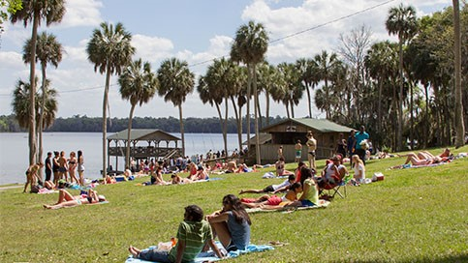

Conversation Partners (CPs)
Want to meet with a fluent English speaker and make a new friend? Sign up for a CP! If you choose to sign up, you must meet with your partner for one hour a week. It can take up to two weeks to get a partner from when you sign up. Sign up here!
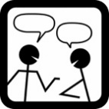
Returning students, you will not automatically be paired again if you had a CP last semester. Please make sure to sign up again here for the Fall semester if you did not request a Fall partner in your end of term evaluation from last semester.
Please email Elijah at conversationpartners@eli.ufl.edu for any issues, questions or concerns or visit her in the CIP Office during office hours.

CIP Passports
Don’t forget to get your CIP Passport hole punched from the activity leaders at the event (not after). We don’t hole punch passports after the event. Redeem your completed passport for a small gift, a photo for the ELI Instagram, and your name published in the ELI weekly! | 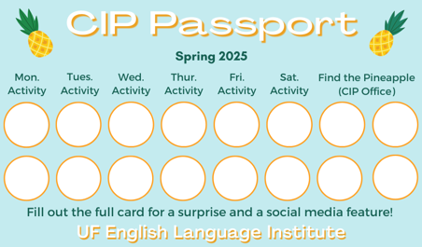

Need a new CIP Passport? Stop by the CIP Office.

Find the Pineapple
Remember the CIP Pineapple is hidden in a new place every Monday in the CIP office. Stop by and find it for hole punches!
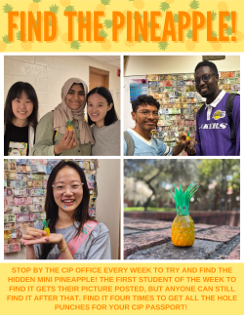

Notes from the Office
Apartment Leases: As the semester draws to a close, keep in mind that your lease might be ending soon. It is important to know the exact date that your apartment lease ends so you can make plans. If you’re not sure when it ends, ask your apartment office. If you need help finding a hotel to stay in short-term (you should ask your friends first!), someone to take over your lease, or a new apartment, talk to Christine in Matherly 223.

Check your I20s: If your I-20 is expiring soon, make an appointment with Daryl in MAT 223 to renew your I-20 before it expires.

We Need Volunteer for ELI Promo Videos: Do you want to be a social media star? The ELI is looking for students to appear in videos on our YouTube channel and Instagram page. You will meet with Christine to film a 15-20 minute interview talking about your experience in Gainesville and at the ELI. If you are interested or have questions, please talk to Christine (christinevoigt@ufl.edu).

Birthdays!
Students |  | Staff
Zennure Arga | April 18 | None this week!
 | 

Grammar:

Q: Do words that start with w and wh have the same sound?

A: Great question! The wh- sound used to sound like hw-, as is still true in the word who. This was the original sound of the wh-, but its pronunciation changed over time to the same sound as the w-. So, for most people, the words which and witch have the same pronunciation. They are homophones.

Like most things in English, however, there are exceptions. For some people in Scotland, Ireland, and some parts of the Southern U.S., the wh- retains its original hw- sound.

Joke of the Week

Q: Does February like March?
A: No, but April May!
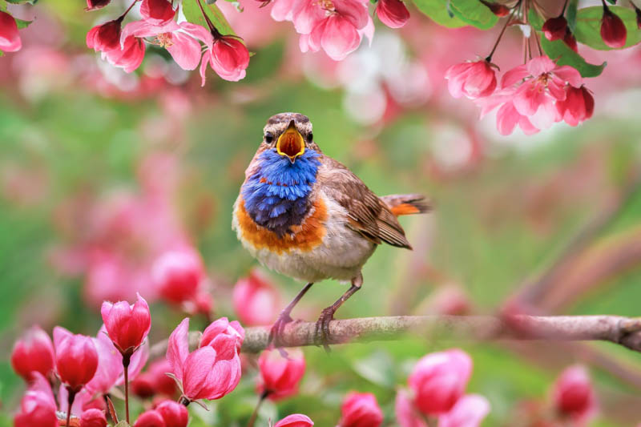

 | I hope you enjoyed reading the ELI Weekly this semester!

Answers to Todd’s Retirement Quiz:

(A, B, C, E, F, G: The Internet (World Wide Web) launched in 1990, Fire was invented between .5 and 1.5 million years ago).

