The ELI Weekly

My Hometown: Iquitos, Peru

by Dasha Vasquez

If you ever have the chance to visit Peru, I highly recommend visiting my hometown, Iquitos, the largest city in the world that cannot be reached by road. The best way to explore it is by taking a boat tour on the Amazon River, where you can enjoy the beautiful rainforest and, if you are lucky, see pink dolphins swimming in the wild. You should also visit Monkey Island, a rescue center that protects monkeys and helps them return to their natural habitat. Another unforgettable experience is seeing the meeting point of the Nanay River and the Amazon River, where you can clearly notice the different colors of the water before they gradually mix together. After exploring nature, don’t miss the opportunity to try delicious Amazonian food. My favourite
dishes are juane, a traditional rice dish wrapped in bijao leaves, paiche, one of the largest freshwater fish in the world, and suri, a famous Amazonian delicacy that many adventurous visitors like to try. Iquitos is a unique destination full of nature, culture, and unforgettable experiences that I believe everyone should visit at least once.

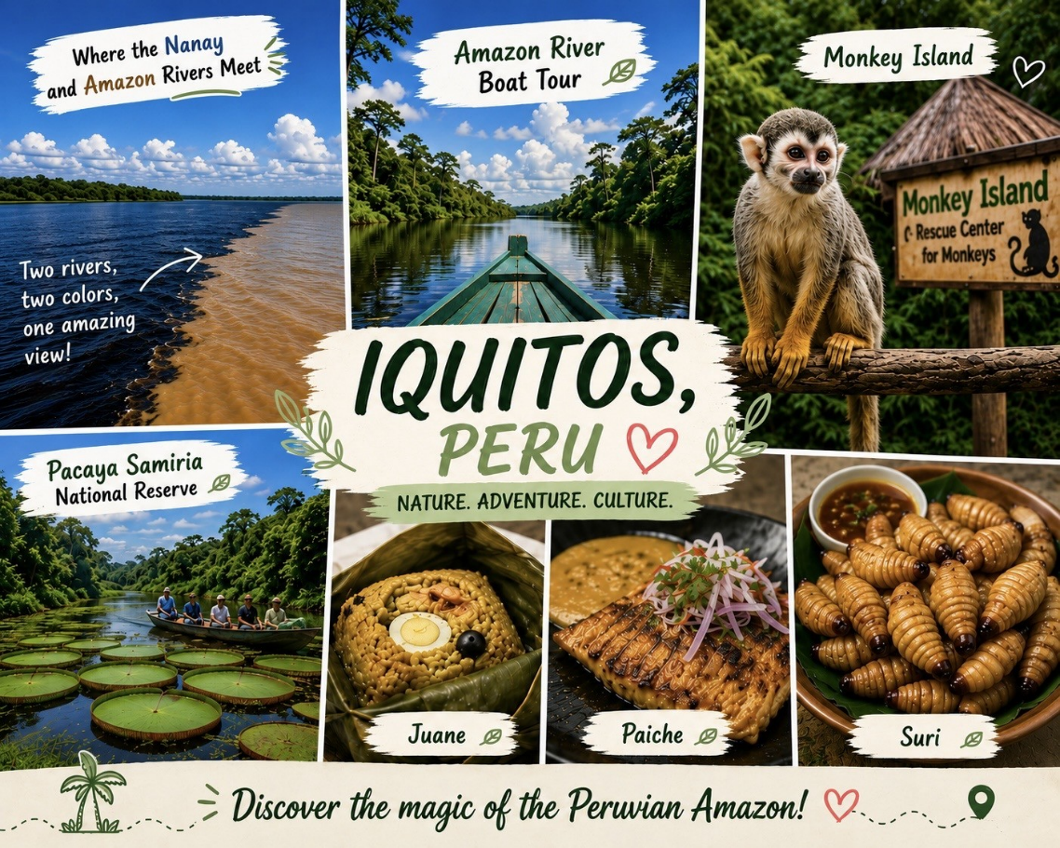

CIP Photo of the Week: Green Bridges

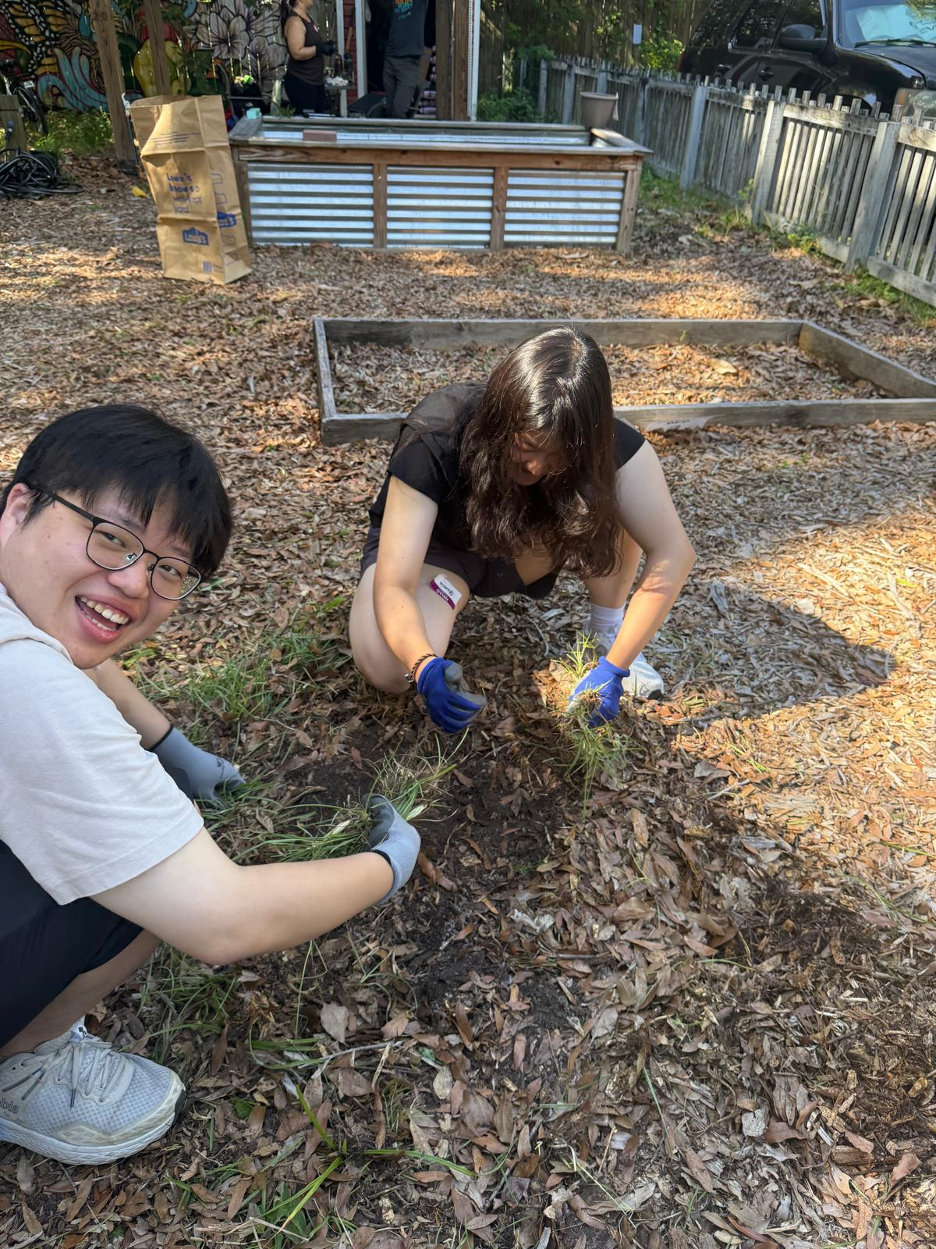

CIP Weekday Activities
 | Monday, July 20th – Coffee Talk – 6:30-9:00pm
 | Socialize with LAs and ELI friends at Curia on the Drag! Play games, speak English, and try the coffee and food truck menu and explore the fun outdoor space! Take bus 6 or 15.  The location will change each week.  Address: 2029 NW 6th St, Gainesville, FL 32609
 | Tuesday, July 21st – Volleyball – 6:30-9:00pm
 | Play volleyball and hang out at Lexington Crossing Apartments Phase 2 Volleyball Courts with us! No experience necessary! You can also watch, socialize or play other games if you don’t want to play volleyball. Take bus 35.  Address: 3700 SW 27th St, Gainesville, FL 32608
 | Wednesday, July 22nd – Final Green Bridges Event: Youth Leadership for Community Empowerment Workshop – 3:00 -4:30pm
 | Please join us for our final Green Bridges event right after class in Matherly 210! Listen to our guest speaker, Juan Carlos Rodriguez – Education and Outreach Specialist as he inspires and educates about how to be a leader in your community! Meet other Green Bridges friends and help us close our successful semester of working on sustainability and community development together!
 | Thursday, July 23rd – Thrifting and Germain’s – 5:00 - 7:30pm
 | Thrift for fun used clothes and other vintage items at Flashback’s for the first hour of this activity (Flashback’s closes at 6pm)! Then go right next door to get Germain’s famously delicious chicken sandwiches! Explore other fun spots in this charming area like the record store. Take bus 15.
NO WEEKEND EVENT! STUDY FOR FINALS!



Conversation Partners (CPs)
Want to meet with a fluent English speaker and make a new friend? Sign up for a CP! If you choose to sign up, you must meet with your partner for one hour a week. It can take up to two weeks to get a partner from when you sign up. Sign up here!

Returning students, you will not automatically be paired again if you had a CP last semester. Please make sure to sign up again here for the Spring semester if you did not request a /spring partner in your end of term evaluation from last semester.
Please email Elijah at conversationpartners@eli.ufl.edu for any issues, questions or concerns or visit him in the CIP Office during office hours.

CIP Passports
Don’t forget to get your CIP Passport hole punched from the activity leaders at the event (not after). We don’t hole punch passports after the event. Redeem your completed passport for a small gift, a photo for the ELI Instagram, and your name published in the ELI weekly! | 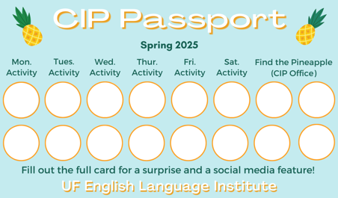

Need a new CIP Passport? Stop by the CIP Office.

Find the Pineapple
Remember the CIP Pineapple is hidden in a new place every Monday in the CIP office. Stop by and find it for hole punches!
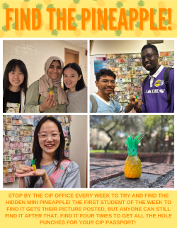

Notes from the Office
Returning Student Survey: We are asking you to tell us your plan for next semester. All students must complete the Returning Student Survey in myELI by Friday, July 24. Please do the survey even if you are not yet 100% sure of your plans. Please tell is what you think you will do. You can change your answer later if needed.
In Reading/Writing classes this week, we help you submit the Returning Student Survey in myELI and answer questions about next semester. If you have an F-1 visa, the ELI needs to know your plans for the Fall semester so I can take appropriate action with your I-20 in SEVIS.
Instructions for how to get to and submit the survey are attached. You can complete the survey in myELI right now! If you need help, you can email me at studyenglish@eli.ufl.edu or call 352-273-4392 to ask questions or schedule a time to meet.
Important Fall Semester Dates
If you will be returning for the fall semester, you should check these important dates:
All students returning for the Fall 2026 semester MUST check in online between August 17th and August 21st.
Returning student schedules will be available on Friday, August 28th.
The Welcome Picnic will be on Saturday, August 29th.
Classes will begin on Monday, August 31st.

Other important dates:
September 3rd: Tuition and new Financial Guarantees are due
September 7th: Labor Day. No classes and the ELI office is closed
September 28th: Instructor Workday. No ELI classes
October 9th: Homecoming Holiday. No classes and the ELI office is closed
October 26th: Instructor Workday. No ELI classes
November 11th: Veteran’s Day Holiday. No classes and the ELI office is closed
November 21st – November 29th: Thanksgiving Break. No classes and the ELI office is closed
December 3rd: Last day of Fall ELI classes.

Class Photo: We are taking an ELI class photo on Tuesday, July 21st at 12:05pm in front of GUS, the Gator Ubiquity Statue, in the Matherly Courtyard. If it is raining, we will take the picture on Thursday, July 23rd at the same time and place.

Birthdays!
Students |  | Staff

None this week!

Manners & Culture:

Q: Does Florida have any hot springs?

A: Florida has a lot of natural springs (somewhere between 700 and 1,000), and most are the same temperature all year round (about 72º F/22º C), which feels great on a hot summer day!

However, if you’re looking for something a bit warmer, you’re in luck! Warm Mineral Springs in North Port, FL boasts a year-round temperature of 85 º F/29 º C. According to its website, Warm Mineral Springs has the highest mineral contents of any natural springs in the U.S. and is known for its therapeutic properties!

Joke of the Week

Q: Why don’t oysters share their pearls??
A: They’re shellfish!
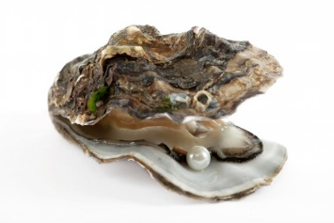

Student Voices
 | Every semester, we have amazing student writers, so we take your writing and publish it in an online collection called Student Voices. In past semesters, students have written paragraphs, essays, creative stories, recipes, letters, obituaries, poetry, and more. You can see past editions of Student Voices (https://eli.ufl.edu/news-publications/, scroll to the bottom of the page) for inspiration.

We encourage you to submit anything of your work that you wish to see published. It can be from any class or something you have written on your own but ask your teachers for help editing! You can email it to Megan Forbes (mforbes@eli.ufl.edu) or to your teacher. Please include your name and class on your submission. The deadline for submissions has been extended to Friday, July 24th

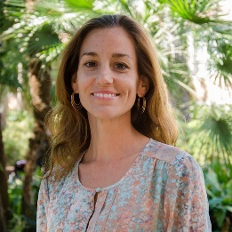 | I need students, LAs, instructors, staff, and administrators to help me write the Weekly!  - Write a paragraph about your experiences this semester. You could write about an ELI activity, a Gainesville event, a fabulous local restaurant, or tell us about a place or event in your country that we should visit.  - You could also ask me to write about a topic that you are curious about  - Send me grammar questions for me to put in the Weekly.  - Send me manners and culture questions for me to put in the Weekly.  - Send me jokes to put in the Weekly.

Send your paragraphs and/or questions to Jen Ramos (jenramos@ufl.edu) Use the subject heading: ELI Weekly.

