The ELI Weekly

Thank You and Farewell to Jen Ramos!!!

Jen’s last day at the ELI will be THIS Thursday, July 30th. Jen is leaving the ELI to teach in the Alachua County Public Schools. The students at Westwood Middle School are very, very lucky!!!

Everyone at the ELI owes Jen an uncountable number of thank-yous. Did you know that Jen has been teaching at the ELI since 2005 and that UF promoted Jen to the rank of Associate Instructional Professor in 2014?

Jen has taught thousands of ELI students over the past 21 years. She has also served as the ELI Skills Coordinator and ELI Reading/Writing Coordinator.
Jen has chaired many, many committees at the ELI and even represented the ELI as a Fulbright Scholar in the Dominican Republic.

Did you know that Jen is a professional editor? She helps faculty, scholars, and students prepare scholarly writing for publishing. She is even the co-editor of an international newsletter… the TESOL Intercultural Communication Interest Section Newsletter. Jen has taught the UF Scholarly Writing course for UF faculty, students, and scholars for many years and most recently has been teaching the ELI evening English for Academic Purposes class. Of course, everyone knows that Jen is also the editor of our own ELI Weekly publication!

Please join us this week in thanking Jen for her incredible contributions to the ELI. We will miss you, Jen!!!

CIP Weekday Activities
 | Monday, July 27th – Coffee Talk at Mochiry – 6:30 to 9:00pm  Socialize with LAs and ELI friends at Curia on the ! Play games, speak English, and try the coffee and food truck menu and explore the fun outdoor space! Take bus 6 or 15.  The location will change each week.  Address: 2029 NW 6th St, Gainesville, FL 32609
 | Tuesday, July 28th – Volleyball – 6:30-9:00pm  Play volleyball and hang out at Lexington Crossing Apartments Phase 2 Volleyball Courts with us! No experience necessary! You can also watch, socialize, or play other games if you don’t want to play volleyball. The ELI is usually in the volleyball court in the back of the complex next to the basketball court. Make sure to go to phase 2 of the complex! Take bus 35.  Address: 3700 SW 27th St, Gainesville, FL 32608
 | Thursday, July 30th – Thrifting and Germain’s – 6:30 -9:00pm  Hang out with friends in the Reitz Game Room! You can go bowling, play pool, and play board games! Bring your Gator1 ID for cheaper rates. There is even Karaoke on Thursdays!  Address: 655 Reitz Union Drive, Gainesville, FL 32611
WEEKEND EVENT

Saturday, August 1st- End of Semester BBQ - 11:30am - 3:30pm
All are welcome to celebrate the end of the semester at our BBQ. Come get free food and kayak or canoe on beautiful Lake Wauburg, North Shore. Play sports, swim and jump off the dock, socialize, and enjoy Florida nature with friends for our very last event of the semester. Meet at Norman Parking Garage.
Please note, no smoking or vaping is allowed anywhere at this location, even if you are outside.
Entrance to the park is free with your Gator1 ID and mentioning the event with the ELI at the entrance gate. Boating has a small fee.

You must sign up to attend this activity, even if you plan on driving yourself. We need to make sure we know how much food to provide. Sign up here!

Conversation Partners (CPs)
Want to meet with a fluent English speaker and make a new friend? Sign up for a CP! If you choose to sign up, you must meet with your partner for one hour a week. It can take up to two weeks to get a partner from when you sign up. Sign up here!

Returning students, you will not automatically be paired again if you had a CP last semester. Please make sure to sign up again here for the Spring semester if you did not request a /spring partner in your end of term evaluation from last semester.
Please email Elijah at conversationpartners@eli.ufl.edu for any issues, questions or concerns or visit him in the CIP Office during office hours.

CIP Passports
Don’t forget to get your CIP Passport hole punched from the activity leaders at the event (not after). We don’t hole punch passports after the event. Redeem your completed passport for a small gift, a photo for the ELI Instagram, and your name published in the ELI weekly! | 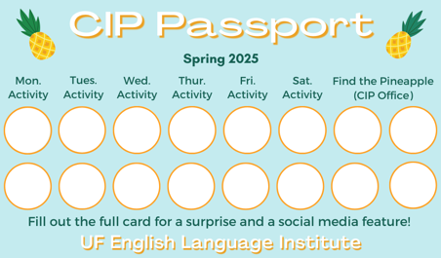

Need a new CIP Passport? Stop by the CIP Office.

Find the Pineapple
Remember the CIP Pineapple is hidden in a new place every Monday in the CIP office. Stop by and find it for hole punches!
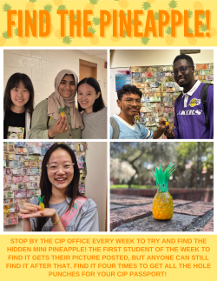

Notes from the Office
Information Session on Changes in F and J Visa Rules: On July 16th, the U.S. Department of Homeland Security (DHS) published a new rule that changes how F-1 student status will work in the United States. The new rule will start on September 15, 2026. The rule could change or be canceled in the future because of court cases or Congress. However, at this moment we must assume the new rules will apply after September 15. Until September 15, 2026, the current F-1 rules will stay the same.
We know there are many questions about the new rule. If you are an ELI student on an F or J visas you can attend an information session at 3pm on Wednesday, July 29th, in Matherly Hall room 208. Daryl and Megan will be there to explain the changes and the UF Director of International Student Services, Martine Angrand, will also be there to answer questions.
If you want to read the rule yourself, you can find it here: Federal Register Notice: Establishing a Fixed Time Period of Admission and an Extension of Stay Procedure for Nonimmigrant Academic Students, Exchange Visitors, and Representatives of Foreign Information Media
The US Government has published a FAQ page here.
You should also plan on speaking individually to Daryl and possibly an immigration attorney about your specific situation.
Class Photo: We are taking an ELI class photo on Tuesday, July 28th at 12:05pm in front of GUS, the Gator Ubiquity Statue, in the Matherly Courtyard. If it is raining on Tuesday, we will take the photo on Thursday, July 30th.
ELI Commencement Ceremony: The ELI Commencement Ceremony will be held on Thursday, August 6th at 6pm in Matherly Hall room 18. During the Ceremony, we will announce student awards, recognize the ELI scholarship recipients, and watch a slide show of this semester’s CIP activities. It is a great opportunity to celebrate the end of the semester with your friends, LAs, and teachers. Please plan on attending!

Birthdays!
Students | Staff
Jose Toro Trochez July 27 | Patricia Moon July 31
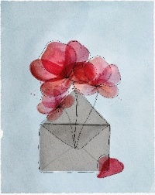

Grammar:

Q: Sometimes when I say thank you, people don’t say you’re welcome. They just say uh huh or something weird like that. Why?

A: We don’t always say you’re welcome when someone says thank you. Especially if we think whatever we did for the other person is pretty small, we might say sure, no problem, or no worries.

If we do something really tiny for someone, like passing back a paper in class, we might say simply uh huh when they say thank you. In other words, it’s like saying: you are very kind, but I don’t deserve to be thanked.

Joke of the Week

Q: Why shouldn’t you ever give Elsa a balloon?
A: She’ll just let it go!


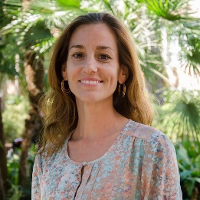 | - Thank you to the students who submitted their writing to the ELI Weekly this semester! And to Megan for editing each issue!

