The ELI Weekly

Our Florida Springs
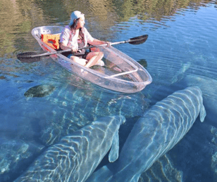
Have you ever heard the term first magnitude springs? Some of you visited one last Saturday when you braved the cold at Silver Springs!

First magnitude is a special designation for springs that discharge more than 65 million gallons of water per day! Florida has 27 first magnitude springs, two of which are in our area: Ichetucknee Springs in Ft. White and Silver Springs near Ocala. The Gainesville brewery First Magnitude Brewing Co. is named for these big, powerful springs.

You may have noticed manatees seeking refuge from the extreme cold in the warmer waters of Silver Springs.

Manatees go to the springs in winter because they provide a constant temperature of 70º to 72º Fahrenheit (21 º to 22 º Celsius).This temperature allows them to stay warm and avoid cold shock, which can be fatal for them. The springs are also a refuge where they can find food and rest during the winter months.

Which of Florida’s 1,000+ springs have you visited? Would you like to visit some more?
Check out 15 Magical Secret Spots And Hidden Gems In Florida - Florida Trippers to get some inspiration!

Recognition of Scholarship Winners

Looking for a great role model? Look no further than these 3 outstanding ELI students! They were so successful last semester that they were awarded an ELI scholarship for Spring semester:
- Ildemar Salazar - JAYNE C. HARDER MEMORIAL SCHOLARSHIP
- Zennure Arga - J.C. CASAGRANDE PEACE SCHOLARSHIP
- Silvano Tandela – GATOR GIVING DAY SCHOLARSHIP

Photo of the Week: Coffee Talk

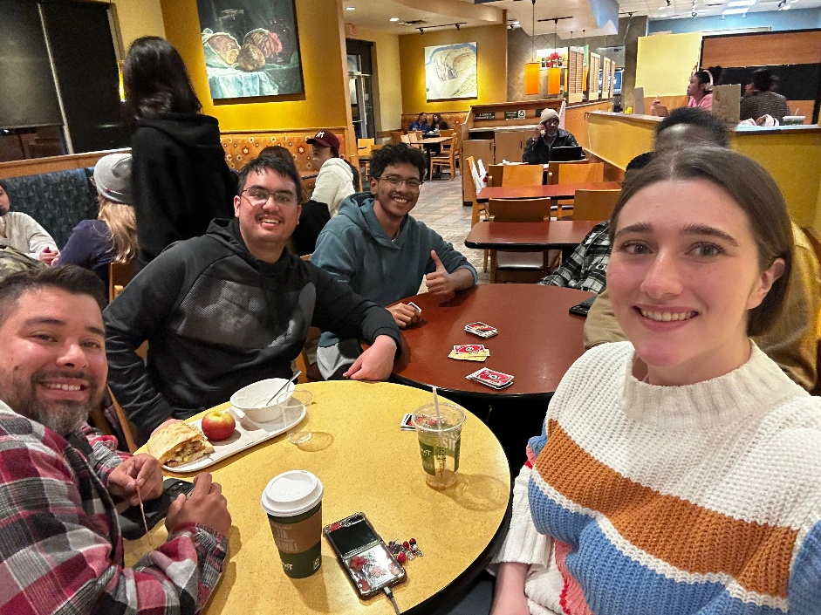

CIP Recommendations:

Gainesville Things to Do Recommendations:
Aurora: Lay in a hammock at Lake Alice
Elijah: Rock climbing at The Knot
Kemarah: Explore Depot Park
Lexa: Palamino’s on Friday nights
Paola: Clubbing at Cantina Añejo
Sam: Visit Kanapaha Botanical Gardens
Shawn: Shop at the monthly Vintage Market
Tate: Hang out at The Lynx bookstore

Talk to LAs and the CIP Office to learn more about their favorite things to do in town and share yours with them!

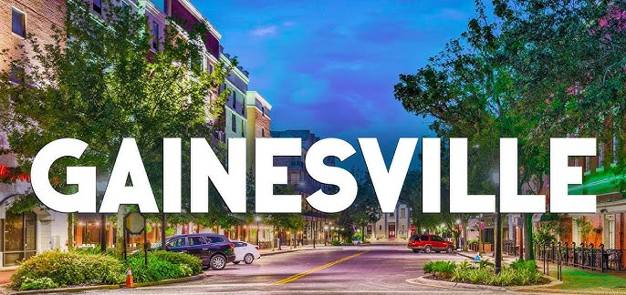

CIP Weekday Activities:
 | Monday, February 2nd – Coffee Talk – 6:30-9:00pm
 | Socialize with LAs and ELI friends at Mochiry! Play games, speak English, and try this Gainesville famous ice cream or get dinner nearby! Take bus 6.  The location will change each week.  Address: 3822 Newberry Rd Suite D, Gainesville, FL 32607
 | Tuesday, February 3rd – Volleyball – 6:30-9:00pm
 | Play volleyball and hang out at Lexington Crossing Apartments Phase 2 Volleyball Courts with us! No experience necessary! You can also watch, socialize or play other games if you don’t want to play volleyball. Take bus 35. Make sure to check both volleyball courts in the complex. We are often at the one in the very back.  Address: 3700 SW 27th St, Gainesville, FL 32608
 | Wednesday, February 4th – Skate Station Funworks – 6:30-9:30pm
 | Roller skate with your ELI friends! Skating is only 6 dollars on Wednesday. Bring extra money if you want to buy food, do go karting, or other activities. Meet inside Skate Station. Take bus 23 or 75. Anyone under 18 needs to leave by 8pm for Skate Station’s adult night.  Address: 1311 NW 76th Blvd, Gainesville, FL 32606
 | Thursday, February 5th – Soccer– 6:30pm – 9:00pm NEW LOCATION  Come play Soccer on campus at Maguire Field on campus! No experience necessary! You can also watch, socialize or play other games if you don’t want to play soccer.  Address: Bledsoe Dr, Gainesville, FL 32611
 | Friday, February 6th– Reitz Game Room – 6:30pm – 9:00pm
 | Hang out with friends in the Reitz Game Room! You can go bowling, play pool, and play board games! Bring your Gator1 ID for cheaper rates. Some Fridays, the Reitz plans Gator Nights! Check out the fun themed activities they may have this week.  Address: 655 Reitz Union Drive, Gainesville, FL 32611

Weekend Activity: Volunteer Weekend



Help out your local community! Choose one of the following options:

Saturday, February 7th - Green Bridges: Gardening and Sustainability – 9:45am to 12:00pm

An ELI alumnus you may know, Jeftey, has a special project through for ELI students to volunteer and learn! Do a sustainability and farming workshop, gardening practice, and farming! Jeftey will lead the way and you will get to explore and contribute to an amazing, sustainable garden right on campus! Meet in front of the bat houses near Lake Alice, take bus 20. You must wear closed-toed shoes.

Address: Lake Alice - Museum Rd, Gainesville, FL 32611

You must sign up to attend this event: https://www.signupgenius.com/go/20F0C4BA9A823A02-61934556-volunteer

Sunday, February 8th – Millcreek Retirement Home for Horses – 9:15am to 1:30pm

Help maintain a horse farm that makes a sanctuary and home for older horses! Clean up the farm and help with other maintenance tasks so the horses have a great place to live! At the end of your volunteering, you will get to feed the horses! Meet at Norman Parking Garage. You must wear closed-toed shoes. Bring water and sunscreen!

You must sign up to attend this event: https://www.signupgenius.com/go/20F0C4BA9A823A02-61934556-volunteer

Other CIP Reminders

Passport Completers

CIP Passports
Don’t forget to get your CIP Passport hole punched from the activity leaders at the event (not after). We don’t hole punch passports after the event. Redeem your completed passport for a small gift, a photo for the ELI Instagram, and your name published in the ELI weekly!  Need a new CIP Passport? Stop by the CIP Office | 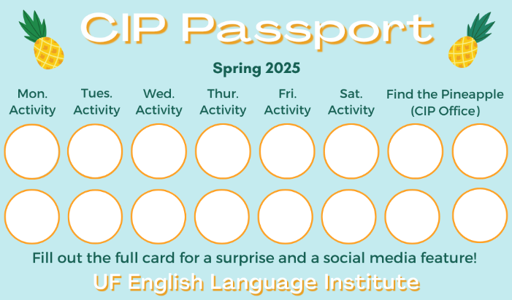

Find the Pineapple
Remember the CIP Pineapple is hidden in a new place every Monday in the CIP office. Stop by and find it for hole punches!

Notes from the Office
People out: Tate will be out of the office on February 2nd. Tate and Christine will be out of the office from February 3rd to February 5th. Please plan around these dates if you need to talk to them.
Important Documents: If you are traveling during the break (for example, leaving the US and coming back), make sure your I-20 is signed. Also check the expiration date. You can make an appointment with Daryl to sign your I-20 or to renew your I-20 before it expires.
As a reminder, all people in the US on a visa should always have their I-94 with them. The I-94 is proof that you are a registered alien in the US and shows that you are here on a non-immigrant visa. You can access your I-94 at https://i94.cbp.dhs.gov/home. Contact Daryl if you cannot access your I-94.
Also, have access to copies of other important documents, like your I-20, visa, passport, letter from USCIS, or other government issued documents related to your status in the U.S.

Birthdays!
Students |  |  |  | Staff
Maria Luiza Proetti |  |  | February 4 | None this week
Abdulrahman Murshid |  |  | February 6
 |  |  | 
 |  |  | Happy Birthday!

Manners & Culture

Q: It seems strange to call my ELI teachers by their first name. I would never do that in my country!
A: American communication style is often very informal. We often use people’s first names instead of more formal forms of address, such as Mr. or Mrs. or Dr.
At the ELI, we use this informality to create a closer connection between teachers and students. Your ELI teachers are very accustomed to being called by their first names and do not consider it disrespectful in any way!
That doesn’t mean we call everyone by their first name in the U.S. Children in school call their teachers Miss/Mrs./Ms. or Mr. + Last name. For example, I would be called Mrs. Ramos if I were a teacher in a different setting.
Grammar

Q: When do I use ‘the people’ vs. ‘people’
A: Great question. It depends if you are talking about all people or specific people.
For example:
The people in my grammar class are so friendly. (specific people)
People spend hours scrolling through social media. (all people, people in general)
Can you see the same rule in these examples?
- People think their mom’s cooking is the best in the world.
- The people who I met at the ELI have become my best friends.

Joke of the Week

Q: What did the hat say to the scarf?
A: You hang around while I go on ahead!


Notes from the Editor
 | Thank you to everyone who sent stories, grammar questions, culture questions, photos, and jokes to the Weekly this semester!  

