The ELI Weekly

Grab a Good Book
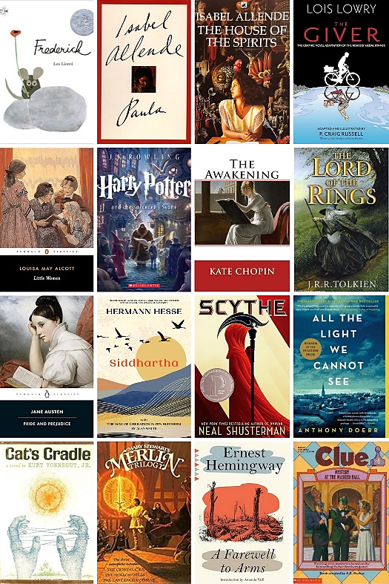
When is the last time you sat down with a good book just to read for pleasure? No comprehension questions to answer, no vocabulary to define, no summaries to write—just you and the words on the page to keep you company.

Reading for pleasure has benefits beyond enjoyment and relaxation. Reading for pleasure in English is a great way to improve your language skills! And with Summer Break coming up, you might want to have a great book on hand.
Recently, I asked some ELI teachers, staff, and administrators about their favorite books. The books that they mentioned are in the image on the left. Here are some of their individual responses:
Patrick: As a kid I used to love Clue Mystery books. My mom would buy them at the book fair at school.
Lia: The House of the Spirits by Isabel Allende captured my imagination and made me want to travel.
Heidy: My favorite book is All the Light We Cannot See. It was made into a Netflix series, but it’s not as good as the book!
Christine: It’s hard to choose just one. I loved the Lord of the Rings trilogy and also Cat’s Cradle by Kurt Vonnegut.
Tara: I love classic books like Pride and Prejudice, Little Women, and the Scarlet Letter.
Megan: The children’s book Frederick is one of my favorites.
Maya: My last three good reads: If I Ever Return Pretty Peggy-o; The Dictionary of Lost Words; A Pig in Provence.
Melina: My current favorite is Thirty Below, about the first group of female mountaineers to summit Denali.
Your editor loves the book Paula by Isabel Allende. (Warning: You will cry. A LOT.)
The ELI has a large collection of both fiction and nonfiction books that have been adapted for English language learners. Ask your RW teacher if you’d like to look at the collection and borrow one!
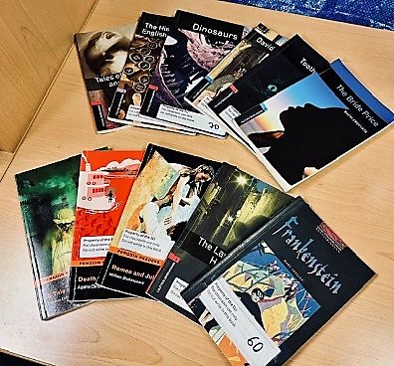
What about you—what is your favorite book?

Weekend Event

Saturday, June 14th – Horse Competition at the World Equestrian Center – 9:30am to 1:30pm

Ocala is the horse capital of the world! Get ready to see some horse jumping competitions and explore the amazing World Equestrian Center! There are incredible restaurants, bakeries, and shops in addition to the grand arenas. This event is free. Bring some spending money for lunch or pack your own.

Meet at Norman parking garage.

You must sign up for this event. Please only sign up for “I need a ride” if you need a space in an LA’s car.

Sign up here!

CIP Weekday Activities
Monday, June 9th – Coffee Talk – 6:30-9:00pm
(No ELI Classes, Instructor Workday)
 | Socialize with LAs and ELI friends at the Panera Bread on Archer Road! Play games, speak English, and drink a coffee or get dinner at the food truck in the area! Take bus 6.  This semester, the location will change each week.  Address: 3443 SW Archer Rd Suite 1A, Gainesville, FL 32608
 | Tuesday, June 10th – Volleyball – 6:30-9:00pm
 | Play volleyball and hang out at Lexington Crossing Apartments Phase 2 Volleyball Courts with us! No experience necessary! You can also watch, socialize or play other games if you don’t want to play volleyball. Take bus 35.  Address: 3700 SW 27th St, Gainesville, FL 32608
 | Wednesday, June 11th – Soccer – 6:30-9:00pm
 | Come play Soccer on campus at Flavet Field on campus! No experience necessary! You can also watch, socialize or play other games if you don’t want to play soccer.  Address: Woodlawn Dr, Gainesville, FL 32603
 | Thursday, June 12th – Gator Salsa – 5:00 – 7:30pm
 | Take salsa lessons in downtown Gainesville! Learn how to dance salsa and bachata in a free beginner, intermediate, or advanced class. Then, at the end, enjoy open dancing! Meet outside the Bull downtown. Bring comfortable shoes. No experience necessary. Take bus 1 or 5.  Address: 220 NW 8th Ave #20, Gainesville, FL 32601
 | Friday, June 13th – Reitz Game Room – 6:30 – 9:00pm
 | Hang out with friends in the Reitz Game Room! You can go bowling, play pool, and play board games! Bring your Gator1 ID for cheaper rates. Many Fridays are Gator Nights so bring your ID to check in and see all the fun themed activities the Reitz may have planned for you this week in addition to the game room!  Address: 655 Reitz Union Drive, Gainesville, FL 32611

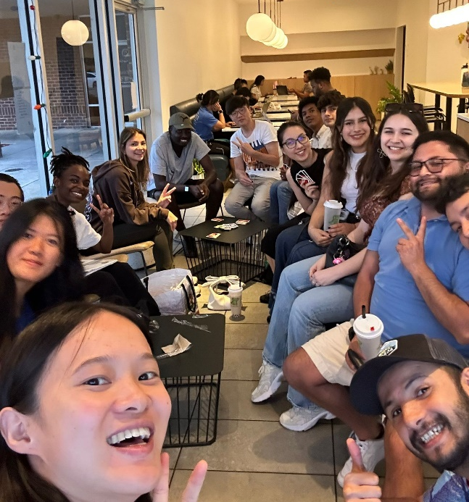
CIP Photo of the Week: Coffee Talk

Other CIP Reminders

Conversation Partners (CPs)
 | Want to meet with a fluent English speaker and make a new friend? Sign up for a CP! If you choose to sign up, you must meet with your partner for one hour a week. It can take up to two weeks to get a partner from when you sign up. Please sign up here!
Please email Joey at conversationpartners@eli.ufl.edu for any issues, questions or concerns or visit her in the CIP Office during office hours.

CIP Passports
Don’t forget to get your CIP Passport hole punched from the activity leaders at the event (not after). We don’t hole punch passports after the event. Redeem your completed passport for a small gift, a photo for the ELI Instagram, and your name published in the ELI weekly! | 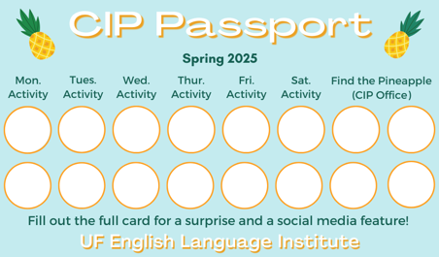

Need a new CIP Passport? Stop by the CIP Office.

Find the Pineapple
Remember the CIP Pineapple is hidden in a new place every Monday in the CIP office. Stop by and find it for hole punches!

Notes from the Office
Keep your I-94 with you: As a reminder, all people in the US on a visa should always have their I-94 with them. The I-94 is proof that you are a registered alien in the US and shows that you are here on a non-immigrant visa. You can access your I-94 at https://i94.cbp.dhs.gov/home. Contact Daryl if you cannot access your I-94. Also, have access to copies of other important documents, like your I-20, visa, passport, letter from USCIS, or other government issued documents related to your status in the U.S.

Daryl Out: Daryl will be out of the office on June 13th and June 16th. Please plan around those dates if you need to talk to him.

Juneteenth and Summer Break: Just a reminder that UF will be closed on Thursday, June 19th in observance the Juneteenth, a federal holiday. UF will also be closed the week of June 23rd – 27th for Summer Break. Some RW classes will not meet on June 20th, but will make up the class time during the semester.

New Presidential Proclamation: This is information about a new presidential proclamation that may affect international students from certain countries. These orders were signed by President Trump and will go into effect at 12:01 a.m. ET on June 9, 2025.

What You Need to Know
The rule will limit visa issuance and travel to the United States for people from these 19 countries:

- Full visa ban (both immigrant and nonimmigrant visas – all categories):
Afghanistan, Burma, Chad, Republic of Congo, Equatorial Guinea, Eritrea, Haiti, Iran, Libya, Somalia, Sudan, Yemen
If you are from one of these countries, your ability to obtain a new F-1 visa will be restricted starting June 9.

- Partial visa ban (immigrant visas and B-1/B-2, F, M, and J visas):
Burundi, Cuba, Laos, Sierra Leone, Togo, Turkmenistan, Venezuela
If you are from one of these countries, your ability to get a new F-1 visa may be restricted starting June 9.

What This Means for You
- Visas issued before June 9 will remain valid and will not be revoked.
- If you are from an affected country and are in the U.S., the ban does not affect you as long as you remain in the country.
- There are exceptions to the ban, such as for dual nationals, U.S. green card holders, and certain travelers with special visa classifications. These exceptions are specific and may require legal guidance.

Recommended Actions
- Review your travel plans carefully. You can find some information from the UF International Center about F-1 travel here:
https://internationalcenter.ufl.edu/f-1-student/f-1-status-requirements/travel
- Consult with an immigration attorney if you are unsure how this may affect you.
- Watch for updates from the U.S. Department of State. We will share any relevant information as soon as it becomes available.
- If you have questions about travel on the F-1 visa with an ELI I-20 talk to Daryl.

Support

We understand this may be a time of heightened stress, anxiety, and concern for you and your loved ones. We recognize how stressful this situation may be for you. Please remember that you can always talk to Christine or Daryl if you need help or have questions or worries.

Birthdays
Students |  | Staff
Beatriz Rueda Espinel | June 10 | None
Mikail Abdul Hamid | June 13
Lina Perdomo Cano | June 14
 |  | 

Happy Birthday!

Grammar

Q: How can I understand the difference between Miss, Mrs. and Ms.?
A: One thing that they all have in common is that they are all used to address women and are usually followed by the family name or last name.

The differences between the three are as follows:

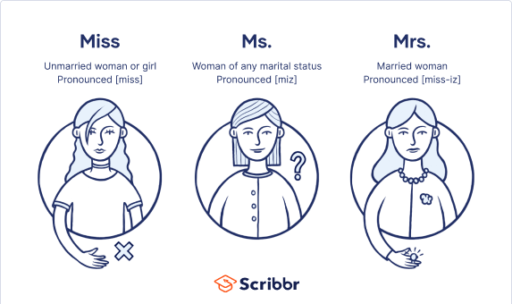
In professional or academic settings, it is common to address a woman as Ms. or, if applicable, by a professional title, such as Dr. or Professor.


Joke of the Week

Q: Why can’t a leopard hide?
A: He’s always spotted!

Special Note from Student Voices editor, Thomas Dolce

Every semester, the ELI publishes a collection of student writing. You can send a piece of your writing to be published for everyone to read. You can send paragraphs, essays, stories, recipes, poetry, and even photos. Also, the best two pieces of writing will be recognized at the ELI Commencement ceremony at the end of the semester. For inspiration, you can find previous editions of The ELI Student Voices on the ELI website.

To submit your writing, please email Thomas Dolce at tomdolce@ufl.edu. Please include your name and class. The last day to submit a piece of writing is July 18th. We can’t wait to read your writing!

Urgent Request!
I need students, LAs, instructors, staff, and administrators to help me write the Weekly!
- Write a paragraph about your experiences this semester. You could write about an ELI activity, a Gainesville event, a fabulous local restaurant, or tell us about a place or event in your country that we should visit.
- Send me grammar questions for me to put in the Weekly.
- Send me manners and culture questions for me to put in the Weekly.
- Send me jokes to put in the Weekly.

Send your paragraphs and/or questions to Jen Ramos (jenramos@ufl.edu) Use the subject heading: ELI Weekly.




