The ELI Weekly

Giving Back: Why I Volunteer
By Mikail Abdul Hamid, RW60

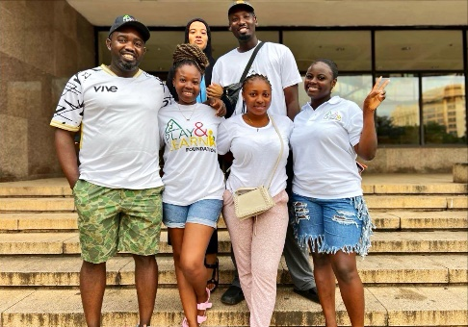
Volunteerism means helping others with your time, energy, or skills without asking for money. You can do it in your school, in your community, or even online. It can be something small or big, but it always matters.

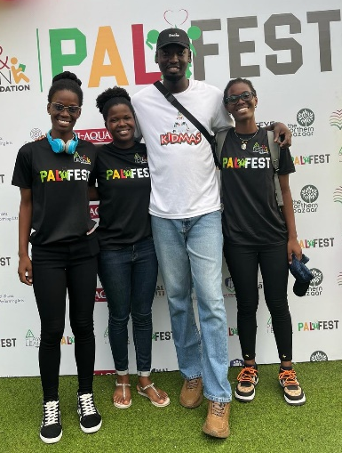
People volunteer for many reasons. Some do it because they want to give back to their communities. Some want to learn new things or gain experience. Some do it because of their faith or just because they care. But for me, it was because I know what it feels like to benefit from societal effort to help people in need. I wanted to feel useful and also pay back. Through the journey of volunteering, I learned a lot and met many different characters.

Some people think you must have a lot of time or money to help others. But that is not true. We all have something we can offer. Even a little help makes a big difference. You can join school groups, local NGOs, or just ask someone, “How can I help?”

One quote I like says: “You make a living by what you get. You make a life by what you give.” Volunteering is not wasting time—it is giving back for what you received in life.

Photo of the Week: Volunteer Weekend
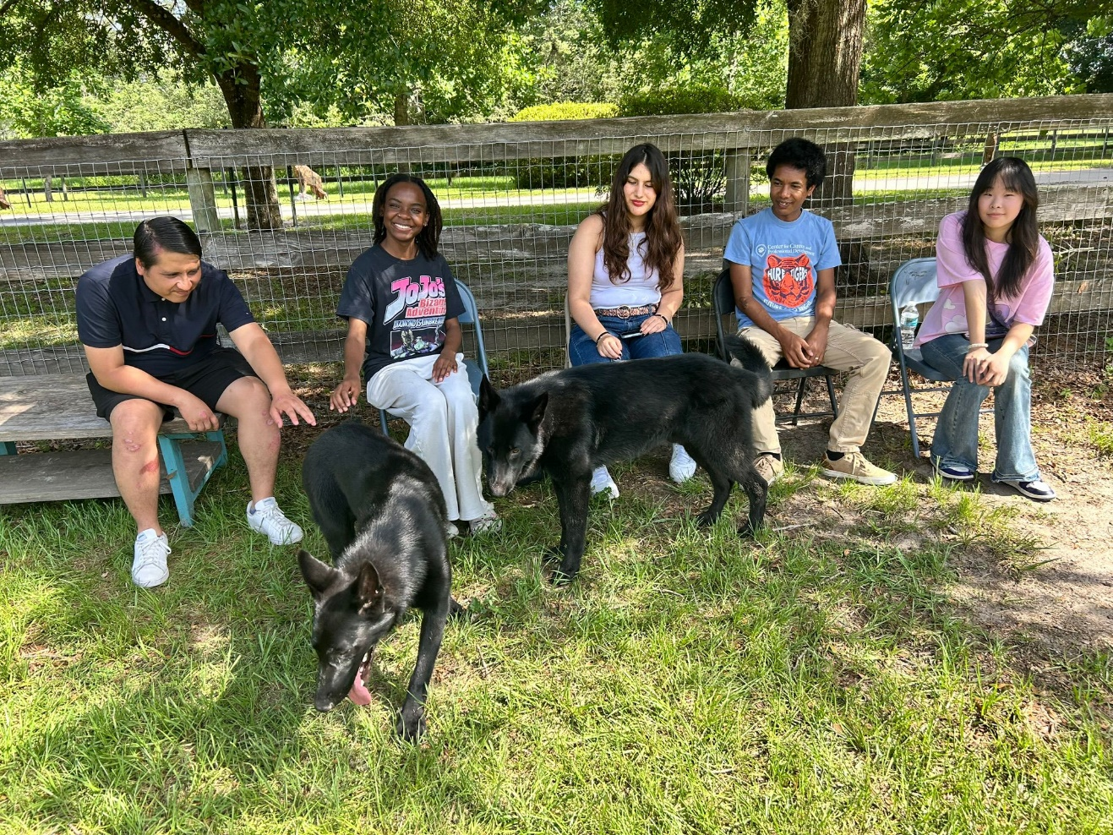

CIP Weekend Activity
 | Monday, June 16th – Coffee Talk – 6:30-9:00pm
 | Socialize with LAs and ELI friends at the Kava Gator Coffee Shop in downtown Gainesville! Play games, speak English, and drink a coffee or get dinner at the food truck in the area! Take bus 1 or 5.  This semester, the location will change each week.  Address: 185 E University Ave, Gainesville, FL 32601
 | Tuesday, June 17th – Volleyball – 6:30-9:00pm
 | Play volleyball and hang out at Lexington Crossing Apartments Phase 2 Volleyball Courts with us! No experience necessary! You can also watch, socialize or play other games if you don’t want to play volleyball. Take bus 35.  Address: 3700 SW 27th St, Gainesville, FL 32608
 | Wednesday, June 18th – Soccer – 6:30-9:00pm
 | Come play Soccer on campus at Flavet Field on campus! No experience necessary! You can also watch, socialize or play other games if you don’t want to play soccer.  Address: Woodlawn Dr, Gainesville, FL 32603
Thursday, June 19th – Juneteenth

No Activity

 | Friday, June 20th – Reitz Game Room – 6:30 – 9:00pm
 | Hang out with friends in the Reitz Game Room! You can go bowling, play pool, and play board games! Bring your Gator1 ID for cheaper rates. Many Fridays are Gator Nights so bring your ID to check in and see all the fun themed activities the Reitz may have planned for you this week in addition to the game room!  Address: 655 Reitz Union Drive, Gainesville, FL 32611

Weekend Event

NO WEEKEND EVENT – Summer Break

Next Saturday, June 28th, please join us for the B-term Welcome Picnic at noon in front of Norman Hall.

Other CIP Reminders

Conversation Partners (CPs)
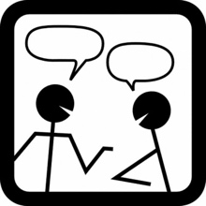 | Want to meet with a fluent English speaker and make a new friend? Sign up for a CP! If you choose to sign up, you must meet with your partner for one hour a week. It can take up to two weeks to get a partner from when you sign up. Please sign up here!
Please email Joey at conversationpartners@eli.ufl.edu for any issues, questions or concerns or visit her in the CIP Office during office hours.

CIP Passports
Don’t forget to get your CIP Passport hole punched from the activity leaders at the event (not after). We don’t hole punch passports after the event. Redeem your completed passport for a small gift, a photo for the ELI Instagram, and your name published in the ELI weekly!  Need a new CIP Passport? Stop by the CIP Office | 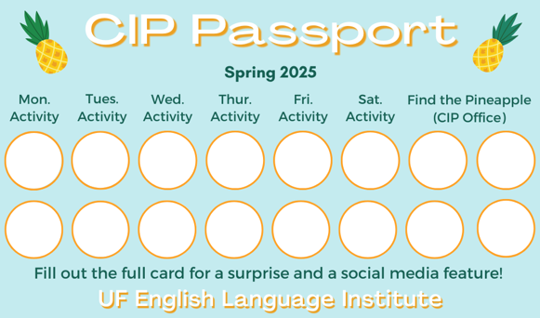

Find the Pineapple
Remember the CIP Pineapple is hidden in a new place every Monday in the CIP office. Stop by and find it for hole punches!

Ideas for Summer Break

There are many great things to do in and around Gainesville for Summer Break for those of you who don’t want to travel too far. You could catch a movie and dinner in Celebration Point. You could stroll through UF’s Harn Museum. You could have a picnic in Depot Park. You could enjoy a free-Friday concert in Bo Diddley Plaza in downtown Gainesville. You could enjoy the cool water of nearby springs, including Poe Springs, Ginny Springs, or Gilchrist Blue Springs. Or head out to the town of High Springs for ice cream and antiquing.
For those of you looking to travel a little further, there are many interesting places to explore! In Florida: the beaches of the FL Panhandle, St. Augustine, Tampa, Sarasota, Orlando, Miami, the Florida Keys. In Georgia: Atlanta, Jekyll Island, and Savannah.

If you're planning on renting a car, be sure to call all of the companies in town to check on the available rates—also note that most require drivers to be 25 or older.
Important: As a reminder, all people in the US on a visa should always have their I-94 with them. The I-94 is proof that you are a registered alien in the US and shows that you are here on a non-immigrant visa. You can access your I-94 at https://i94.cbp.dhs.gov/home. Contact Daryl if you cannot access your I-94.
Also, you should also always have access to copies of other important documents, like your I-20, visa, passport, letter from USCIS, or other government issued documents related to your status in the U.S.
Before you travel, you should check your I-20! You should make sure your I-20 is signed and check the expiration date. You can make an appointment with Daryl to sign your I-20 or to renew your I-20 before it expires.

Notes from the Office
Apartment Leases: In the Summer, many student leases end on July 31st. The ELI semester ends on August 9th, so you may need to find another place to stay for a little while! It is important to know the exact date that your apartment lease ends so you can make plans. If you’re not sure when it ends, ask your apartment office.
If you need help finding a place to stay in the short term (like a hotel or Airbnb), someone to take over your lease, or a new apartment, talk to Christine in Matherly 223. If you will leave the ELI after this semester and need another person to take over your lease, Christine can help with that also.
New Students: The Summer B term will begin soon, and new students are arriving in Gainesville during Summer Break. Come meet the new ELI students at the midterm welcome picnic on June 28th and be sure to make them feel welcome when you see them in your classes, at activities, and in the hallways

Course Evaluations: Soon we will be doing midterm course evaluations. This is your opportunity to provide feedback for your classes. Please go to this link https://bit.ly/4048gmH to review the evaluations so that you know how to fill them out when they are distributed in class. Your teachers and Language Assistants will use this information to plan the class for the rest of the semester.
Juneteenth: Remember, there will be no class ELI or UF classes on Thursday, June 19th in observance of Juneteenth, a federal holiday. There will be no RTS bus service on this day.
Summer Break: There will be no ELI or UF classes the week of June 23 to June 27th. RTS bus service will be limited from June 21st – June 29th.
People out: Daryl will be out of the office on June 20th. Christine will be out from June 20th to 23rd. Please plan around these dates if you need to meet with either of them.

Birthdays!
 | 
  Students
  David Medina Rueda June 29
  Staff
  Lexa Thompson | June 28
 | Happy Birthday!

Manners & Culture

Q: Why are the classrooms in Matherly Hall so cold?

A: Here are a few reasons why the classrooms can feel like an ice box:
- Americans generally find colder temperatures more comfortable. Many Americans like icy drinks and cold rooms during the hot and humid summer months.
- In terms of design, the formulas used to design AC systems are based on the metabolic activity of a 40-year-old, 155-pound male, which doesn't accurately represent everyone's needs. Women have lower metabolic rates and produce less heat, meaning they may feel colder in a room designed for the standard male. This outdated standard can lead to over-cooling in some buildings, resulting in uncomfortable temperatures for some individual
- In some cases, AC units might be placed in areas of the building where they can't effectively cool other areas, leading to localized cold spots.

Q: Why do Americans say “Yeah” or “Okay” every few seconds when they’re listening to someone else talk?

A : It's to show that the other person is listening and acknowledging what the other person is saying. If the listener is silent, it might seem like they are not paying attention.

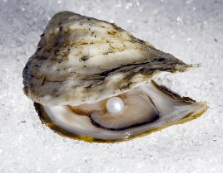
Joke of the Week

Q: Why don’t oysters like to share their pearls?
A: Because they’re shellfish!

Student Voices
 | Every semester, we have amazing student writers, so we take your writing and publish it in an online collection called Student Voices. In past semesters, students have written paragraphs, essays, creative stories, recipes, letters, obituaries, poetry, and more. You can see past editions of Student Voices (https://eli.ufl.edu/news-publications/, scroll to the bottom of the page) for inspiration.

Every semester, the ELI publishes a collection of student writing. You can send a piece of your writing to be published for everyone to read. You can send paragraphs, essays, stories, recipes, poetry, and even photos. Also, the best two pieces of writing will be recognized at the ELI Commencement ceremony at the end of the semester. For inspiration, you can find previous editions of The ELI Student Voices on the ELI website.

To submit your writing, please email Thomas Dolce at tomdolce@ufl.edu. Please include your name and class. The last day to submit a piece of writing is July 18th. We can’t wait to read your writing!

Request for Submissions
I need students, LAs, instructors, staff, and administrators to help me write the Weekly!
- Write a paragraph about your experiences this semester. You could write about an ELI activity, a Gainesville event, a fabulous local restaurant, or tell us about a place or event in your country that we should visit.
- Send me grammar questions for me to put in the Weekly.
- Send me manners and culture questions for me to put in the Weekly.
- Send me jokes to put in the Weekly.

Send your paragraphs and/or questions to Jen Ramos (jenramos@ufl.edu) Use the subject heading: ELI Weekly.
