The ELI Weekly

A Warm Welcome to Our B-Term Students
We hope you had a wonderful Summer Break! While you were off relaxing, we had a group of students arrive to begin the B-term. You may notice some new faces in the hallway and in your classes. Please take a moment to introduce yourselves and make them feel at home. They might have questions about the ELI, UF, or Gainesville that you can answer!

This semester, our B-term students come from a variety of places:
Brazil  China  Colombia  Costa Rica Haiti | Korea  Kuwait  Saudi Arabia  Venezuela
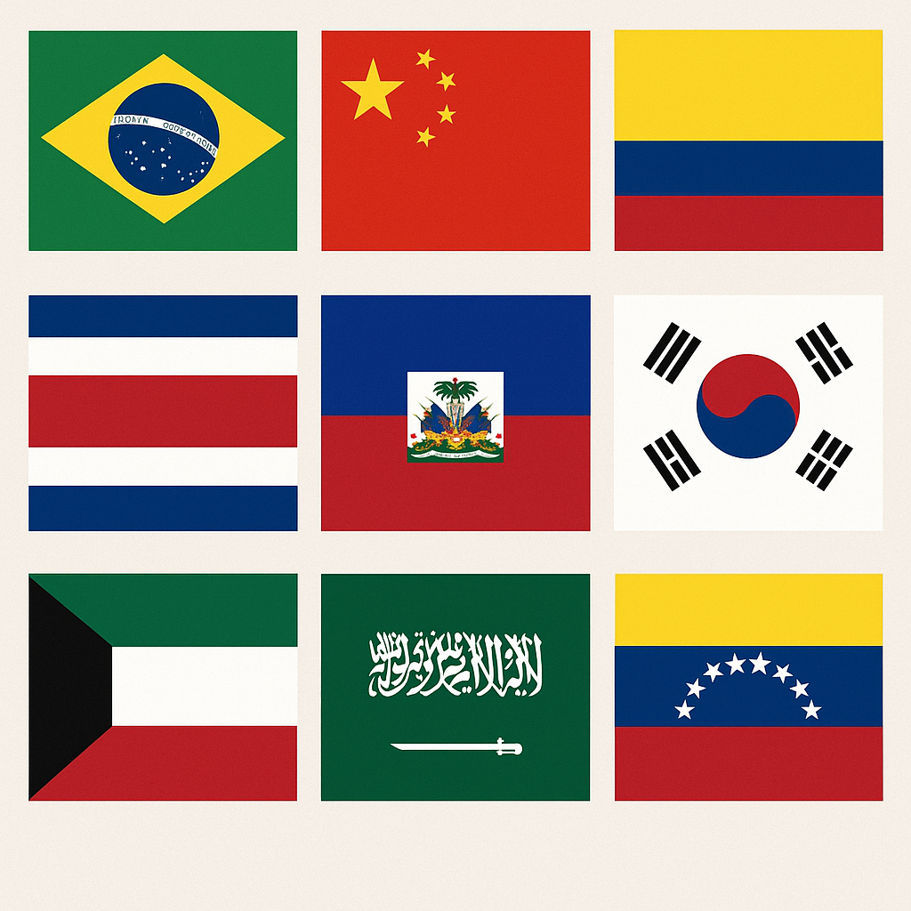

Photo of the Week: World Equestrian Center
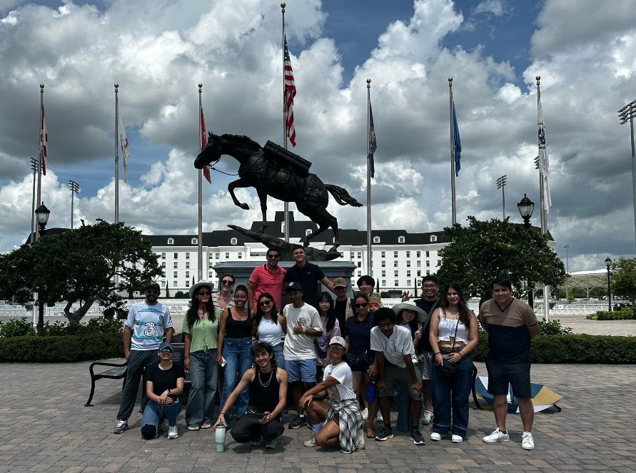

CIP Weekend Activity
 | Monday, June 30^{h} – Coffee Talk – 6:30-9:00pm
 | Socialize with LAs and ELI friends at the Mochiry!  Play games, speak English, and drink a coffee, tea, or dessert! Take bus 5 or 43.  This semester, the location will change each week.  Address: 3822 Newberry Rd Suite D, Gainesville, FL 32607
 | Tuesday, July 1st – Volleyball – 6:30-9:00pm
 | Play volleyball and hang out at Lexington Crossing Apartments Phase 2 Volleyball Courts with us! No experience necessary! You can also watch, socialize or play other games if you don’t want to play volleyball. Take bus 35.  Address: 3700 SW 27th St, Gainesville, FL 32608
 | Wednesday, July 2nd – Soccer – 6:30-9:00pm
 | Come play Soccer on campus at Flavet Field on campus! No experience necessary! You can also watch, socialize or play other games if you don’t want to play soccer.  Address: Woodlawn Dr, Gainesville, FL 32603
 | Thursday, July 3rd – Fanfares and Fireworks – 7:00-10:00pm  Celebrate Independence Day with your ELI friends at this Gainesville tradition on campus! Listen to live music, get food from the food trucks, and hang out with the ELI on Flavet Field until the fireworks show starts after dark!  Address: Woodlawn Dr, Gainesville, FL 32603
 | Friday, July 4th– No Activity
 | 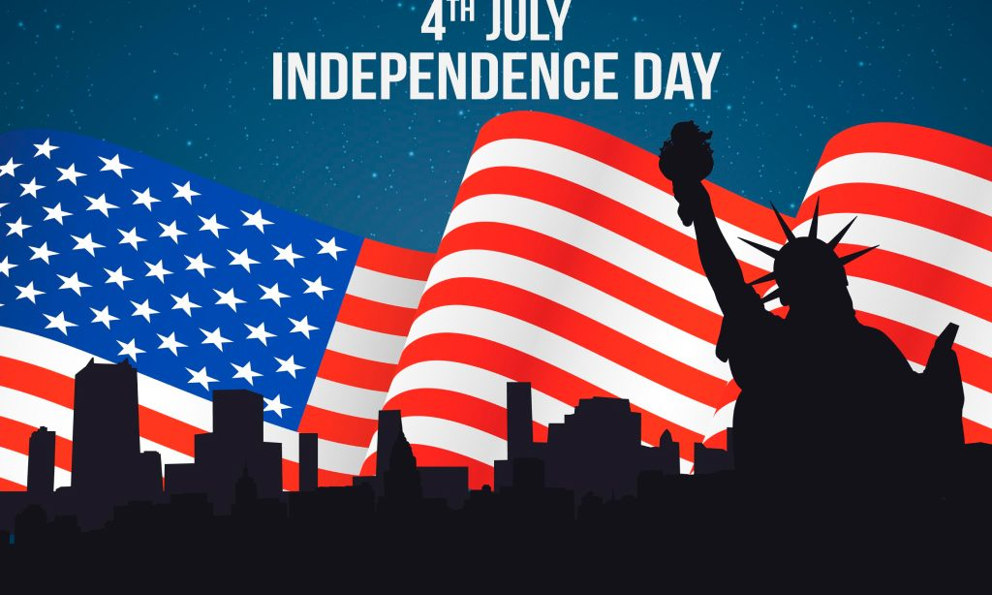

Weekend Event

NO WEEKEND EVENT – Holiday Weekend

Other CIP Reminders

Conversation Partners (CPs)
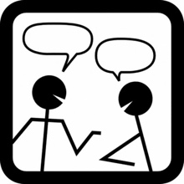 | Want to meet with a fluent English speaker and make a new friend? Sign up for a CP! If you choose to sign up, you must meet with your partner for one hour a week. It can take up to two weeks to get a partner from when you sign up. Please sign up here!
Please email Joey at conversationpartners@eli.ufl.edu for any issues, questions or concerns or visit her in the CIP Office during office hours.

CIP Passports
Don’t forget to get your CIP Passport hole punched from the activity leaders at the event (not after). We don’t hole punch passports after the event. Redeem your completed passport for a small gift, a photo for the ELI Instagram, and your name published in the ELI weekly!  Need a new CIP Passport? Stop by the CIP Office | 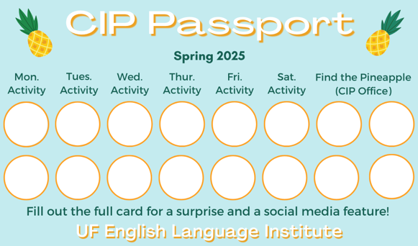

Find the Pineapple
Remember the CIP Pineapple is hidden in a new place every Monday in the CIP office. Stop by and find it for hole punches!

Notes from the Office
Apartment Leases: In the Summer, many student leases end on July 31st. The ELI semester ends on August 9th, so you may need to find another place to stay for a little while! It is important to know the exact date that your apartment lease ends so you can make plans. If you’re not sure when it ends, ask your apartment office.
If you need help finding a place to stay in the short term (like a hotel or Airbnb), someone to take over your lease, or a new apartment, talk to Christine in Matherly 223. If you will leave the ELI after this semester and need another person to take over your lease, Christine can help with that also.
Midterm Grades: Your midterm course grades and grade reports will be available in the myELI portal starting Thursday, July 3rd.
Independence Day Holiday: Remember, there will be no ELI or UF classes on Friday, July 4th in observance of Independence Day, a federal holiday.
People out: Christine will be out on July 7th.

Birthdays!
Students |  | Staff
Norah Alghamdi | June 30 | Kemarah Thermidor | July 1
Jinhyung Lee | July 1

Happy Birthday!



Manners & Culture

Q: What do Americans celebrate on July 4th?

A: Independence Day, which we also call the Fourth of July, is a federal holiday in the United States. This holiday commemorates the adoption of the Declaration of Independence on July 4, 1776. This declaration proclaimed the thirteen American colonies independent from British rule. For this reason, the Fourth of July is considered the birthday of the United States. Americans often go to the beach, have cook-outs, picnics, and pool parties on this day. Some towns have Fourth of July parades. Many people set off fireworks once the sun goes down, so you’re sure to hear and see them streaming across the night sky!

Grammar

Q: Which is correct: “She’s smarter than me” or “She’s smarter than I”?

A : Technically, the second sentence is correct because you are comparing two subjects, not two objects. For everyday conversation, however, the first sentence is perfectly acceptable.

Here is a similar example comparing two objects.

“She gave him more candy than me.”

Or, a little more formal: “She gave him more candy than she gave me.”

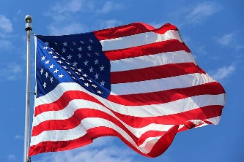
Joke of the Week

Q: What did one flag say to the other?
A: Nothing, it just waved!

Student Voices
 | Every semester, we have amazing student writers, so we take your writing and publish it in an online collection called Student Voices. In past semesters, students have written paragraphs, essays, creative stories, recipes, letters, obituaries, poetry, and more. You can see past editions of Student Voices (https://eli.ufl.edu/news-publications/, scroll to the bottom of the page) for inspiration.

To submit your writing, please email Thomas Dolce at tomdolce@ufl.edu. Please include your name and class. The last day to submit a piece of writing is July 18th. We can’t wait to read your writing!

Request for Submissions
I need students, LAs, instructors, staff, and administrators to help me write the Weekly!
- Write a paragraph about your experiences this semester. You could write about an ELI activity, a Gainesville event, a fabulous local restaurant, or tell us about a place or event in your country that we should visit.
- Send me grammar questions for me to put in the Weekly.
- Send me manners and culture questions for me to put in the Weekly.
- Send me jokes to put in the Weekly.

Send your paragraphs and/or questions to Jen Ramos (jenramos@ufl.edu) Use the subject heading: ELI Weekly.


