The ELI Weekly

Farmers Markets

On Saturday morning, you’ll have the opportunity to visit one of Gainesville’s farmers markets. The Haile Village Farmers Market is open every Saturday from 8:30am till noon. Farmers markets have become very popular in the United States in the last two decades. Unlike shopping in a grocery store or supermarket, farmers markets allow you to buy food directly from the people who grow it. Typically, you can buy locally sourced meat, dairy, and produce at a farmers market. But that’s not all! You can find beautiful flowers, native plants, crafts and delicious baked goods, as well.

So, what’s the benefit of buying at a local farmers market? For one thing, it allows you to ‘eat with the seasons’ as farmers sell the food that has been recently harvested locally, not products that have been grown and shipped from faraway places. Seasonal food is fresher and tends to be tastier. Do you want to know what’s in season right now? Here is a guide: https://www.seasonalfoodguide.org/why-eat-seasonally.

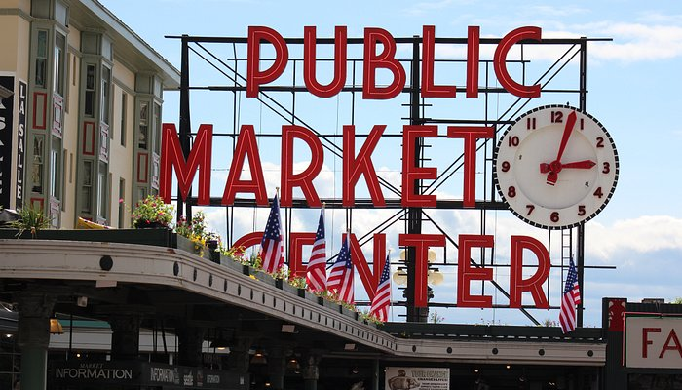
Another benefit of farmers markets is the boost that they give to the local economy. The money you spend on products from local farmers and growers stays in the community and is reinvested with other local businesses.
One of the oldest and most famous farmers markets in the US is in Seattle Washington. Pike Place Market is in downtown Seattle and is known for its iconic clock and sign. You may have seen it featured in movies or maybe you’ve even visited it in person! What about your hometown? Does it have a farmers market?

Photo of the Week: Coffee Talk
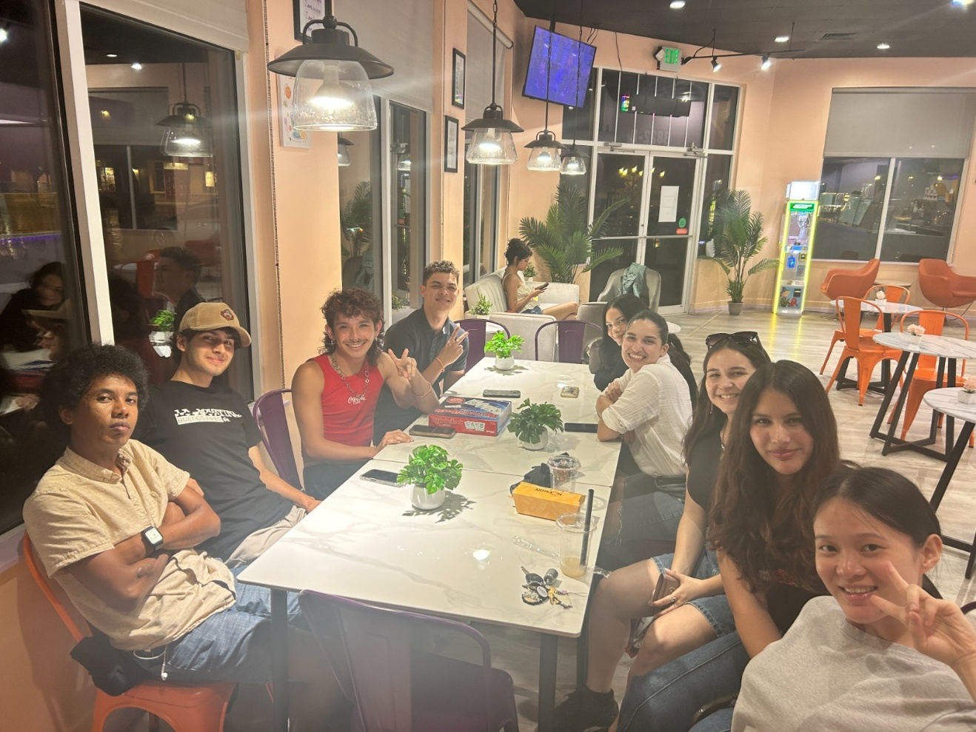

CIP Weekday Activities

 | Monday, July 7th – Coffee Talk – 6:30-9:00pm
 | Socialize with LAs and ELI friends at Teastori! Play games, speak English, and drink a coffee, tea, or dessert! Take bus 37.  The Coffee Talk location changes each week.  Address: 3550 SW 34th St, Gainesville, FL 32608
 | Tuesday, July 8th – Volleyball – 6:30-9:00pm
 | Play volleyball and hang out at Lexington Crossing Apartments Phase 2 Volleyball Courts with us! No experience necessary! You can also watch, socialize or play other games if you don’t want to play volleyball. Take bus 35.  Address: 3700 SW 27th St, Gainesville, FL 32608
 | Wednesday, July 9th – Soccer – 6:30-9:00pm
 | Come play Soccer on campus at Flavet Field on campus! No experience necessary! You can also watch, socialize or play other games if you don’t want to play soccer.  Address: Woodlawn Dr, Gainesville, FL 32603
 | Thursday, July 10th – Cabana Beach Pool Party – 6:00pm – 8:30pm  Hang out with ELI friends at the pool! Bring a bathing suit and a towel and have lots of fun swimming and playing games in this super large pool at Cabana Beach Apartments.  Address: 1601 SW 51st Terrace, Gainesville, FL 32607
 | Friday, July 11th– Reitz Game Room – 6:30pm – 9:00pm
 | Hang out with friends in the Reitz Game Room! You can go bowling, play pool, and play board games! Bring your Gator1 ID for cheaper rates. Many Fridays are Gator Nights so bring your ID to check in and see all the fun themed activities the Reitz may have planned for you this week in addition to the game room!  Address: 655 Reitz Union Drive, Gainesville, FL 32611

Weekend Event


Haile Market and Santa Fe Zoo – 9:00am to 1:00pm

This weekend, explore the cute and quaint Haile neighborhood! Their Saturday market has plenty of homemade goods, crafts, and local produce for sale. Bring some money to spend if you would like to! After the market, we will head to the small Santa Fe Teaching Zoo that has lots of birds, monkeys, and other animals to see! Entry costs 6 dollars with your Gator1 ID card.

You must sign up to attend this activity: Sign up here!

Selling Transportation Tickets for St. Augustine Beach & Town Trip happening on 7/19.

Explore the oldest city in the United States after spending the afternoon at the beach! Tickets are for sale from Tate in Matherly 211 for 25 dollars exact cash. You can purchase tickets Monday - Thursday from 9:00am to 1:30pm. Get your ticket before they sell out! Space is limited!

*Tate teaches a class from 11:00am to 12:05 pm so she will not be able to sell tickets during that hour.

Birthdays!
Students |  | Staff

None this week!



Other CIP Reminders

Conversation Partners (CPs)
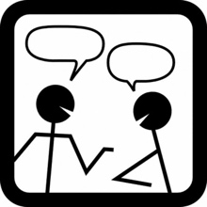 | Want to meet with a fluent English speaker and make a new friend? Sign up for a CP! If you choose to sign up, you must meet with your partner for one hour a week. It can take up to two weeks to get a partner from when you sign up. Please sign up here!
Please email Joey at conversationpartners@eli.ufl.edu for any issues, questions or concerns or visit her in the CIP Office during office hours.

CIP Passports
Don’t forget to get your CIP Passport hole punched from the activity leaders at the event (not after). We don’t hole punch passports after the event. Redeem your completed passport for a small gift, a photo for the ELI Instagram, and your name published in the ELI weekly!  Need a new CIP Passport? Stop by the CIP Office | 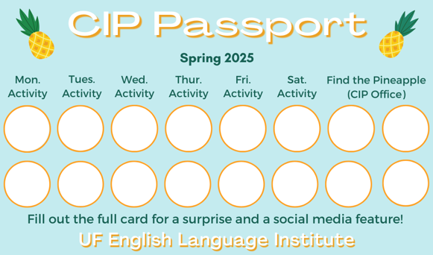

Find the Pineapple
Remember the CIP Pineapple is hidden in a new place every Monday in the CIP office. Stop by and find it for hole punches!

Notes from the Office
Apartment Leases: In the Summer, many student leases end on July 31st. The ELI semester ends on August 9th, so you may need to find another place to stay for a little while! It is important to know the exact date that your apartment lease ends so you can make plans. If you’re not sure when it ends, ask your apartment office.
If you need help finding a place to stay in the short term (like a hotel or Airbnb), someone to take over your lease, or a new apartment, talk to Christine in Matherly 223. If you will leave the ELI after this semester and need another person to take over your lease, Christine can help with that also.
People out: Christine will be out on July 7th.

Grammar

Q: Why is English spelling so weird? Words are not spelled the same way they sound.

A : You're right! English spelling is very hard to learn because it doesn’t always follow clear rules. Sometimes I don’t even know how to spell certain words—and I’m an English teacher! (I always get the word rhythm wrong.) The strange spelling comes from the long history of the English language. Let me explain.

English began in the British Isles, which were conquered many times throughout history. First, Germanic tribes came and spoke their own language. This language later became Old English. Then the Romans came. They brought Latin and a new alphabet. People started using the Latin alphabet to write English, but Latin didn’t have all the same sounds as English. So, people had to put Latin letters together (like th and gh) to represent English sounds.

Later, the Normans invaded the British Isles. They spoke French, and they added around 10,000 French words to English. Many of these words kept their French spelling, like ballet and champagne. During the Renaissance, many Latin words also entered English—like debt, which comes from the Latin word debitum.

At one point, the way people pronounced English words changed a lot—but the spelling didn’t change. Blood is an example of a word that changed its pronunciation but kept its original spelling.

So, you can see that the English has an interesting history. Unfortunately, this rich history has led to a very confusing system of spelling!


Joke of the Week

Q: Why don’t scientists trust atoms?
A: Because they make up everything!

Student Voices
 | Every semester, we have amazing student writers, so we take your writing and publish it in an online collection called Student Voices. In past semesters, students have written paragraphs, essays, creative stories, recipes, letters, obituaries, poetry, and more. You can see past editions of Student Voices (https://eli.ufl.edu/news-publications/, scroll to the bottom of the page) for inspiration.

To submit your writing, please email Thomas Dolce at tomdolce@ufl.edu. Please include your name and class. The last day to submit a piece of writing is July 18th. We can’t wait to read your writing!

Request for Submissions
I need students, LAs, instructors, staff, and administrators to help me write the Weekly!
- Write a paragraph about your experiences this semester. You could write about an ELI activity, a Gainesville event, a fabulous local restaurant, or tell us about a place or event in your country that we should visit.
- Send me grammar questions for me to put in the Weekly.
- Send me manners and culture questions for me to put in the Weekly.
- Send me jokes to put in the Weekly.


Send your paragraphs and/or questions to Jen Ramos (jenramos@ufl.edu) Use the subject heading: ELI Weekly.



