The ELI Weekly

A Day at Santa Fe Zoo

By Lu Huang, RW60
This weekend we went to the Santa Fe Zoo. It’s a small but very interesting zoo. It is located on
the campus of Santa Fe. It’s the only zoo in the United States that is certified by the Association
of Zoos and Aquariums and located on a college campus. The Santa Fe Zoo has 70 species and
over 200 individual animals in its collection, including Barred Owls, White-Throated Capuchins,
Bald Eagles, Caracals, Red Ruffed Lemurs, and Matschie’s Tree Kangaroos.

We saw the smallest golden gibbon and the smallest black gibbon fighting with each other. They
chased each other around the enclosure for several laps. In the end, the golden gibbon slid down
the bamboo forest from a rope and ran away in a panic. The black gibbon quickly caught up and
kept chasing. The whole process was very exciting and kept everyone’s attention. They were like
fitness experts at a gym — they could climb and swing with just their arms without any effort,
which was amazing to watch!

The Santa Fe Zoo is designed in a very thoughtful way. The animals have large living spaces.
They not only have outdoor areas but some of them also have comfortable indoor spaces. Maybe
because the weather was too hot that day, most of the animals were lying lazily in their favorite
outdoor spots, sleeping. I wished I could be one of them—be cared by professional keepers,
playing with their family every day, resting outside when it’s warm, and hiding in a little house
when they needed privacy. No worries about the world, just eating and sleeping all day. But who
knows? Maybe they want to go out and feel the world, to go on adventures!
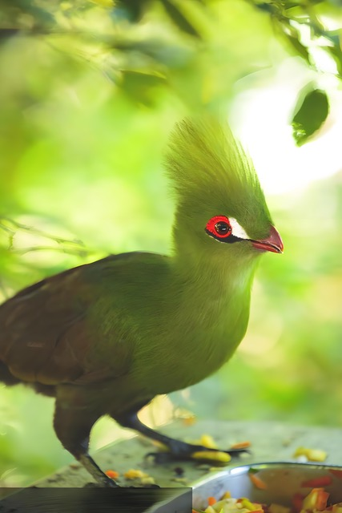
My favorite animal was the Guinea Turaco. It comes from the tropical rainforests of West Africa.

To me, its appearance didn’t even look real — it was like a painting! The Guinea Turaco’s body is mainly bright emerald green with blue, and it shines with a metallic glow under the sunlight. Its neat hairstyle looks like it was specially designed by a hairdresser. Its eyes look like they have beautiful red and white gradient eye shadow, and its beak is as if painted with bright lipstick. The Guinea Turaco flew from one tree stump to another, tilting its head curiously to observe everyone. It looked more beautiful when it was flying— when it spread its wings, there was red on the lower part of the wings, like it were wearing a big red cape. I heard that in West African culture, this bird symbolizes happiness and good luck.

Photo of the Week: Soccer
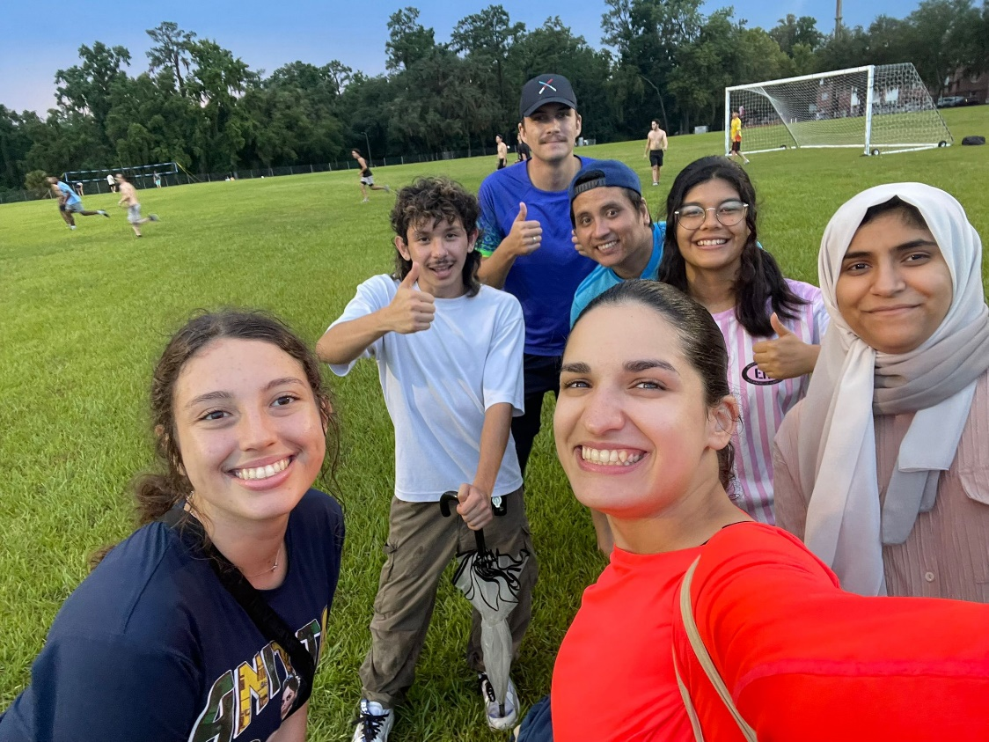

Weekend Activity: None this week! Study for Finals!

CIP Weekday Activities

 | Monday, July 14th – Coffee Talk – 6:30-9:00pm
 | Socialize with LAs and ELI friends at Panera on Newberry Road! Play games, speak English, and drink a coffee, tea, or dessert! Take bus 5.  The Coffee Talk location changes each week.  Address: 6017 W Newberry Rd, Gainesville, FL 32605
 | Tuesday, July 15th – Volleyball – 6:30-9:00pm
 | Play volleyball and hang out at Lexington Crossing Apartments Phase 2 Volleyball Courts with us! No experience necessary! You can also watch, socialize or play other games if you don’t want to play volleyball. Take bus 35.  Address: 3700 SW 27th St, Gainesville, FL 32608
 | Wednesday, July 16th – Soccer – 6:30-9:00pm
 | Come play Soccer on campus at Flavet Field on campus! No experience necessary! You can also watch, socialize or play other games if you don’t want to play soccer.  Address: Woodlawn Dr, Gainesville, FL 32603
 | Thursday, July 17th – Cabana Beach Pool Party– 6:00pm – 8:30pm  Hang out with ELI friends at the pool! Bring a bathing suit and a towel and have lots of fun swimming and playing games in this super large pool at Cabana Beach Apartments. Take bus 20 or 21.  Address: 1601 SW 51st Terrace, Gainesville, FL 32607
 | Friday, July 18th– Reitz Game Room – 6:30pm – 9:00pm
 | Hang out with friends in the Reitz Game Room! You can go bowling, play pool, and play board games! Bring your Gator1 ID for cheaper rates. Many Fridays are Gator Nights so bring your ID to check in and see all the fun themed activities the Reitz may have planned for you this week in addition to the game room!  Address: 655 Reitz Union Drive, Gainesville, FL 32611

Weekend Event:

None this week! Study for your final exams!
What are some ways you plan on studying?



Birthdays!
Students |  | Staff
Michal Alkatani | July 22 | None this week
Lu Huang | July 22
Ye Seul Han | July 27
Jose Toro Trochez | July 27



Happy Birthday!

Other CIP Reminders

Conversation Partners (CPs)
 | Want to meet with a fluent English speaker and make a new friend? Sign up for a CP! If you choose to sign up, you must meet with your partner for one hour a week. It can take up to two weeks to get a partner from when you sign up. Please sign up here!
Please email Joey at conversationpartners@eli.ufl.edu for any issues, questions or concerns or visit her in the CIP Office during office hours.

CIP Passports
Don’t forget to get your CIP Passport hole punched from the activity leaders at the event (not after). We don’t hole punch passports after the event. Redeem your completed passport for a small gift, a photo for the ELI Instagram, and your name published in the ELI weekly!  Need a new CIP Passport? Stop by the CIP Office | 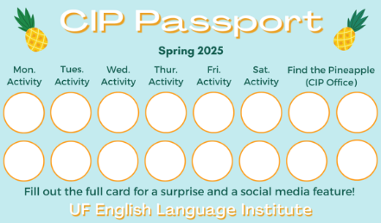

Find the Pineapple
Remember the CIP Pineapple is hidden in a new place every Monday in the CIP office. Stop by and find it for hole punches!

Notes from the Office
Apartment Leases: In the Summer, many student leases end on July 31st. The ELI semester ends on August 9th, so you may need to find another place to stay for a little while! It is important to know the exact date that your apartment lease ends so you can make plans. If you’re not sure when it ends, ask your apartment office.
If you need help finding a place to stay in the short term (like a hotel or Airbnb), someone to take over your lease, or a new apartment, talk to Christine in Matherly 223. If you will leave the ELI after this semester and need another person to take over your lease, Christine can help with that also.
People out: Daryl will be out of the office July 22nd to July 30th

New for Part-Time Students: Starting this Fall 2025 term, F-2 dependents and visitors on the B visa or ESTA visa waiver can take up to 18 hours of classes per week. This means that those students can take any combination of classes, including Reading/Writing and Listening/Speaking.
Charges Due: Every ELI student should log in to ONE.uf.edu and look at the “Campus Finances (Bursar)” tile to see if you owe any fees to the university. For example, you may need to pay for services you received at the Student Health Care Center or printing in a library. If you have a scholarship, it will not pay these charges.
Check your I-20s: If you are traveling during the break (for example, leaving the US and coming back), make sure your I-20 is signed. Also check the expiration date. You can make an appointment with Daryl to sign your I-20 or to renew your I-20 before it expires.
Course Evaluations: Soon we will be doing final course evaluations. This is your opportunity to provide feedback for your classes. Please go to this link https://bit.ly/4048gmH to review the evaluations so that you know how to fill them out when they are distributed in class. Your teachers and Language Assistants value your responses.

Final Exams: Final Exams start the week of July 28. Final exams cannot be made up if you miss them, so you must be in class on the day of your finals. All reading exams are on Monday, August 4th. Grammar Exams and Listening Exams are on Tuesday, August 5th. Ask your teacher when your final writing exam will be. Good luck!
Commencement Info: Our ELI Commencement ceremony will take place in the Career Connections Center in the Retiz Union, Level 1, at 10am on Friday, August 8th.

Grammar

Q: I always hear people use the -ing form of a word? Why? Is it a verb?

Oh, that’s such a great question! There are 3 different ways we use -ing words:
- As a verb:

For example, I was going to sleep when my phone rang

I am going to study this weekend.

- As a noun:

We use the base form of a verb + ing as a noun:

Camping is fun.

I love watching movies.

- As an adjective:

I took an exciting trip to Miami last weekend.

I heard some upsetting news this morning.


Joke of the Week

Q: How delivery drivers feel about sending a package twice?
A: They resent it!

Request for Submissions
I need students, LAs, instructors, staff, and administrators to help me write the Weekly!
- Write a paragraph about your experiences this semester. You could write about an ELI activity, a Gainesville event, a fabulous local restaurant, or tell us about a place or event in your country that we should visit.
- Send me grammar questions for me to put in the Weekly.
- Send me manners and culture questions for me to put in the Weekly.
- Send me jokes to put in the Weekly.


Send your paragraphs and/or questions to Jen Ramos (jenramos@ufl.edu) Use the subject heading: ELI Weekly.

