The ELI Weekly

Out and About: Community Gardens
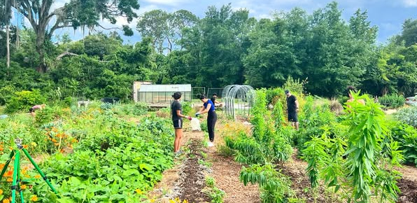
This Saturday, you’ll have an opportunity to work in a community garden through the Green Bridges Program. Do you have community gardens in your country? A community garden is a piece of land that is tended by a group of people in a neighborhood. In some community gardens, people who sign up to tend the garden are given their own piece of land to grow fruit, vegetables, or plants, while in others, the entire garden is cultivated collectively, meaning everyone works together to care for the garden and share its produce.

Gainesville has 12 community gardens in different parks and neighborhoods around the city and one located on UF campus: UF Organic Gardens Cooperative, where UF students, employees, or anyone in the community can rent a plot to grow flowers or vegetables organically. Organic gardens do not allow gardeners to use any chemical fertilizers or pesticides.

The American Community Gardening Association estimates that there are 18,000 community gardens throughout the United States. Do you have community gardens in your country?
Want to learn more? Here is a 12-minute video about the history of community gardens in a major U.S. city: Boston, Massachusetts https://youtu.be/FWJM1TNcvIE?si=Nt0agk3BXNG62HSM

Weekend Event

Saturday, July 11th – Volunteer Day: Green Bridges Gardening – 9:00am to 11:00am

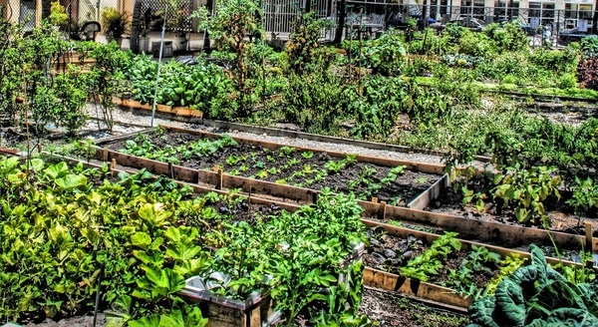Volunteer by helping your community and the environment with this fun gardening project that counts towards a Green Bridges certificate! During the workday, volunteers will be introduced to the garden space and work together on gardening tasks. Activities may include hands-on work such as planting, while volunteers learn how to care for and help maintain the community garden. Meet at Norman Parking Garage or outside the Garden if you have your own ride. If you are meeting at Norman Parking garage for a ride, please arrive to Norman by 8:45am. Please sign up in both cases.

Sign up here!

Address: 911 Northwest 5th Avenue, Gainesville, Florida 32601

Green Bridges

Take part in this environmental, sustainability, and leadership development program that one of our alumni, Jeftey Saint Fleur, has planned for us! Our first workshop was a huge success! There are 3 more Green Bridges events this semester, and if you attend 3 of the 4, you will get a special certificate of achievement for your involvement. The next event will be our Volunteer Day activity at a local community garden where we will learn about and help with composting and garden sustainability on July 11th. The final event will be another Matherly Hall workshop with the topic and date TBD. It will be directly after classes in late July. Stay tuned for more info. If you would like to get involved beyond these events, please speak with Tate about finding more individual Green Bridges opportunities and she will help you get connected with Jeftey.

CIP Weekday Activities
 | Monday, July 6th – Coffee Talk at Kava Gator– 6:30-9:00pm
 | Socialize with LAs and ELI friends at Kava! Play games, speak English, and try the different coffee and teas of this fun downtown location. Take bus 1 or 5.  The location will change each week.  Address: 185 E University Ave, Gainesville, FL 32601
 | Tuesday, July 7th – Volleyball – 6:30-9:00pm
 | Play volleyball and hang out at Lexington Crossing Apartments Phase 2 Volleyball Courts with us! No experience necessary! You can also watch, socialize or play other games if you don’t want to play volleyball. Take bus 35.  Address: 3700 SW 27th St, Gainesville, FL 32608
 | Wednesday, July 8th – Skate Station Funworks – 6:00 – 9:00pm
 | Roller skate with your ELI friends! Skating is only 6 dollars on Wednesday. Bring extra money if you want to buy food, do go karting, or other activities. Meet inside Skate Station. Take bus 23 or 75. Anyone under 18 needs to leave by 8pm for Skate Station’s adult night.  Address: 1311 NW 76th Blvd, Gainesville, FL 32606

CIP Photo of the Week: Volleyball

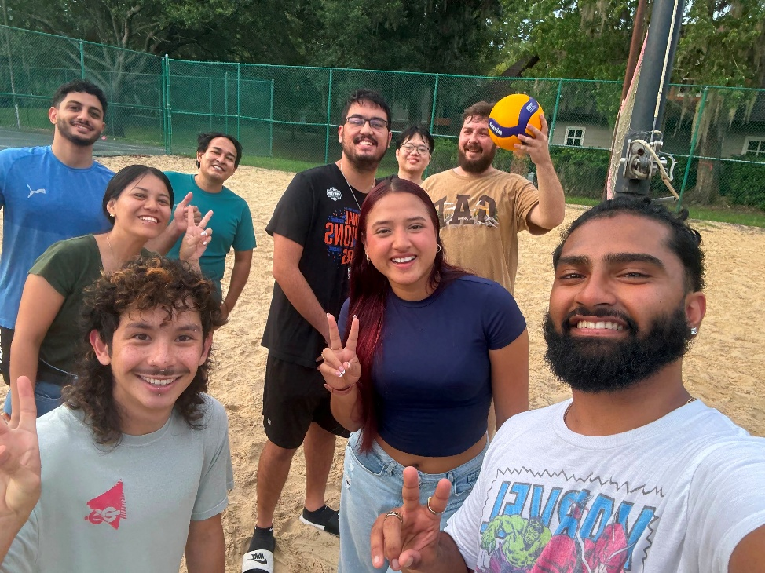

Other CIP Reminders

Conversation Partners (CPs)

Want to meet with a fluent English speaker and make a new friend? Sign up for a CP! If you choose to sign up, you must meet with your partner for one hour a week. It can take up to two weeks to get a partner from when you sign up. Sign up here!
Returning students, you will not automatically be paired again if you had a CP last semester. Please make sure to sign up again here for the Fall semester if you did not request a Fall partner in your end of term evaluation from last semester.
Please email Elijah at conversationpartners@eli.ufl.edu for any issues, questions or concerns or visit her in the CIP Office during office hours.

CIP Passports
Don’t forget to get your CIP Passport hole punched from the activity leaders at the event (not after). We don’t hole punch passports after the event. Redeem your completed passport for a small gift, a photo for the ELI Instagram, and your name published in the ELI weekly! | 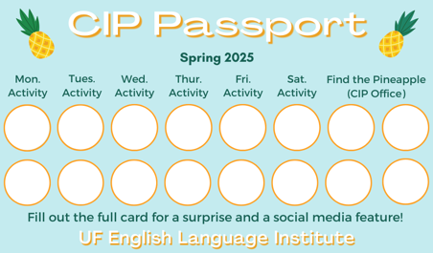

Need a new CIP Passport? Stop by the CIP Office.

Find the Pineapple
Remember the CIP Pineapple is hidden in a new place every Monday in the CIP office. Stop by and find it for hole punches!
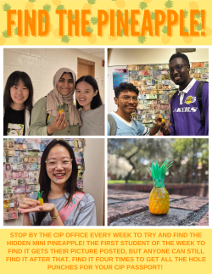

Notes from the Office:

None this week!

Birthdays!
Students |  | Staff
None this week! |  | None this week!


Manners & Culture

Q: Do all Americans leave their families when they are 18 to live independently?

Great question! No, not all American move away from home when they are 18. Some stay with their family and attend a college or university close to home. Some get a job and stay at home to save money on rent. Some do a combination of both school and work. Others move away for university and live in a dorm or an apartment. Some start at a college close to home and then transfer to a school that is farther away. Families take these decisions very seriously and look for the best, most practical option. Higher education can be very expensive in the United States. The average cost of completing a bachelor’s degree is about $108,000 (total for 4 years).

Joke of the Week

Q: What did one flag say to the other?
A: Nothing. It just waved!


Student Voices

This Photo by Unknown Author is licensed under CC BY-ND
Every semester, we have amazing student writers, so we take your writing and publish it in an online collection called Student Voices. In past semesters, students have written paragraphs, essays, creative stories, recipes, letters, obituaries, poetry, and more. You can see past editions of Student Voices (https://eli.ufl.edu/news-publications/, scroll to the bottom of the page) for inspiration.

We encourage you to submit anything of your work that you wish to see published. It can be from any class or something you have written on your own but ask your teachers for help editing! You can email it to Megan Forbes (mforbes@eli.ufl.edu) or to your teacher. Please include your name and class on your submission. The deadline for submissions is Friday, July 17th.

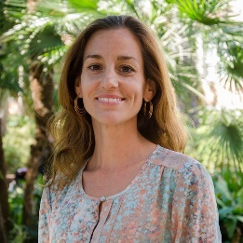 | I need students, LAs, instructors, staff, and administrators to help me write the Weekly!  - Write a paragraph about your experiences this semester. You could write about an ELI activity, a Gainesville event, a fabulous local restaurant, or tell us about a place or event in your country that we should visit.  - Send me grammar questions for me to put in the Weekly.  - Send me manners and culture questions for me to put in the Weekly.  - Send me jokes to put in the Weekly.

Send your paragraphs and/or questions to Jen Ramos (jenramos@ufl.edu) Use the subject heading: ELI Weekly.



